

New Zealand Diploma in System Administration Level 6

IAC601: Infrastructure as Code

Assessment/Aromatawai - Assessment 1  
Version 1 Credits 12

Practical Assessment



|  |  |  |  |
| --- | --- | --- | --- |
|  | Submission | FER1 | FER2 |
| Result | Click or tap here to enter text. | Click or tap here to enter text. | Click or tap here to enter text. |
| Date | Click or tap to enter a date. | Click or tap to enter a date. | Click or tap to enter a date. |
| Assessor’s Signature |  |  |  |

|  |  |
| --- | --- |
| Student Name | Hui(Spark) ZHENG |
| Student ID | AEU3000774 |
| Student Signature | Spark |
| Assessor | Click or tap here to enter text. |

Assessor’s Feedback

|  |
| --- |
| Submission |
| Click or tap here to enter text. |

|  |
| --- |
| FER1 |
| Click or tap here to enter text. |

|  |
| --- |
| FER2 |
| Click or tap here to enter text. |

Contents

Part 1 5

Task 1: Planning for Pre-Deployment Processes 5

Task 2: Analysis and Evaluation of Legal and Regulatory Requirements 12

Task 3: Plan, Design and Create a Deployment Script 14

Task 4: Pre- and Post-Deployment Implementation for a new client machine 18

Task 5: Version Control with GitHub Repository 40

Part 2 44

Task 1: Planning and Design of Cloud Infrastructure 44

Task 2: Analysis and Evaluation of Legal and Regulatory Requirements 46

Task 3: Scripts Design and Development 48

Task 4: Deployment Services to the Azure Platform and Testing 59

Task 5: GitHub Repository 77

References 80

# Part 1

## Task 1: Planning for Pre-Deployment Processes

1. **Prepare a Windows Server that already has the ADDS, DHCP and DNS roles configured.**

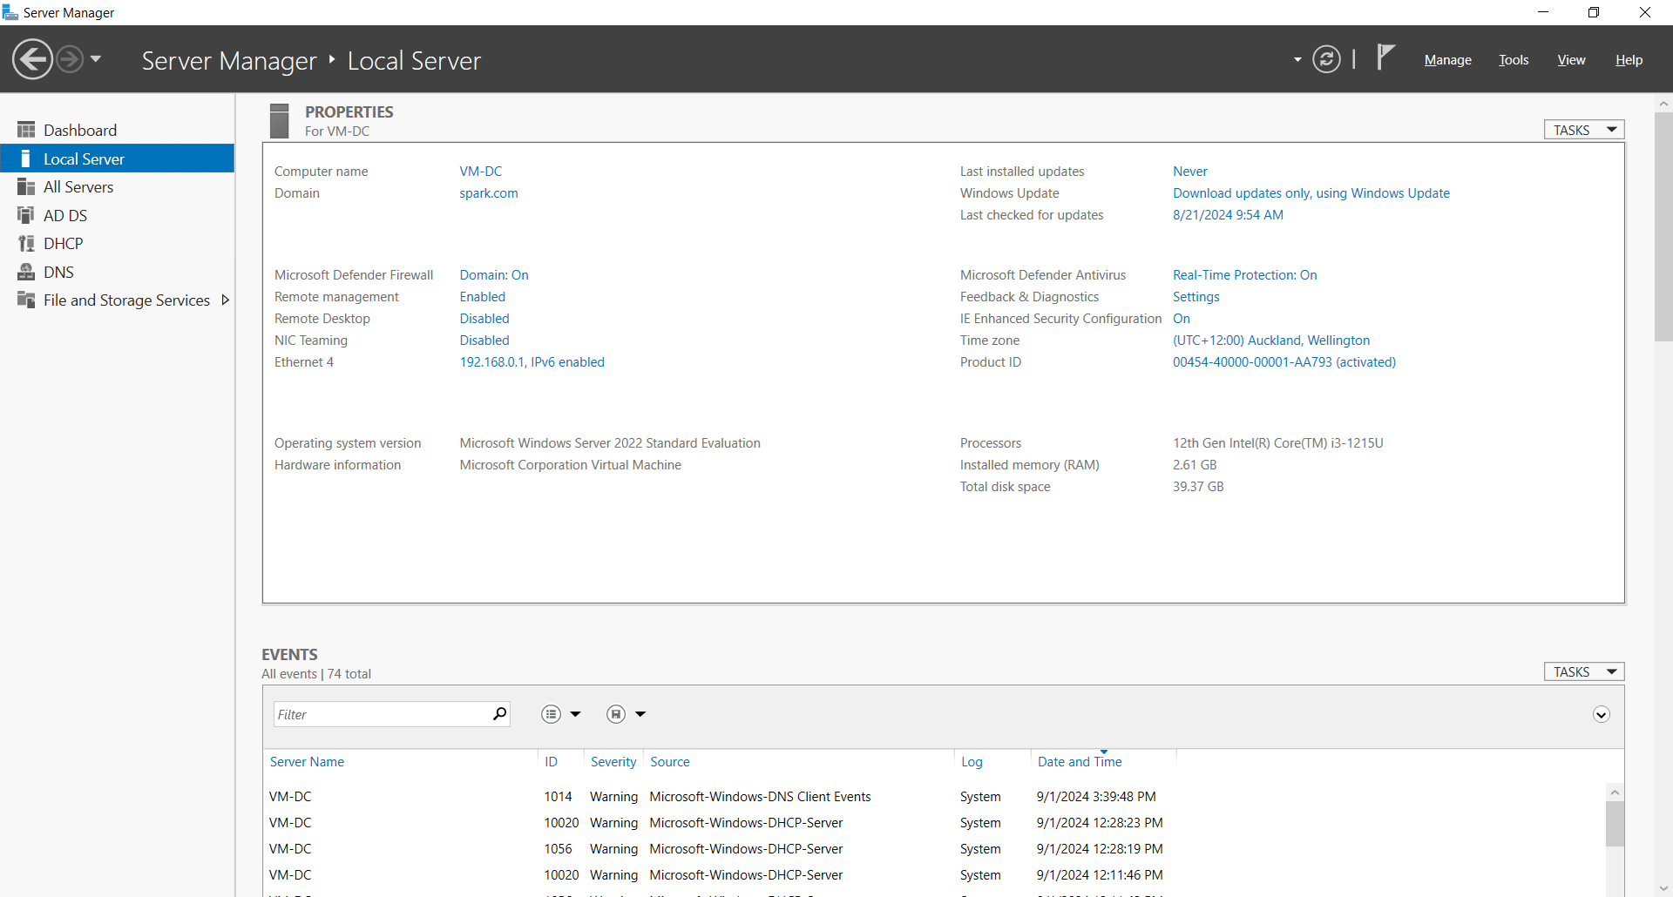

1. **PowerShell Script for Installation**

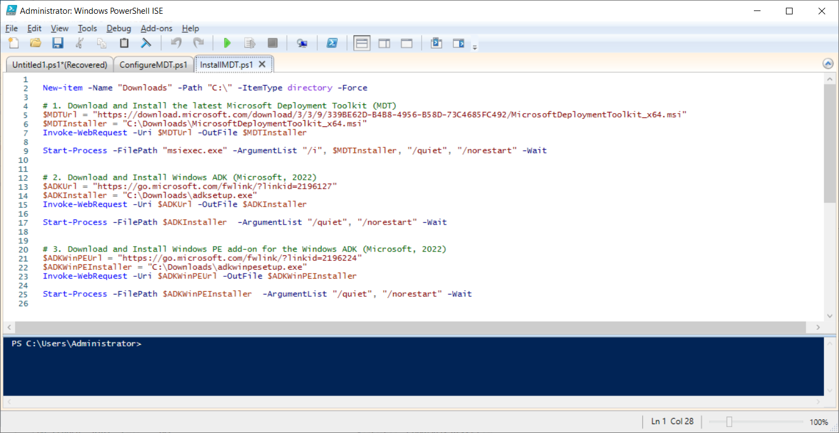

1. **Install MDT with PowerShell Script**

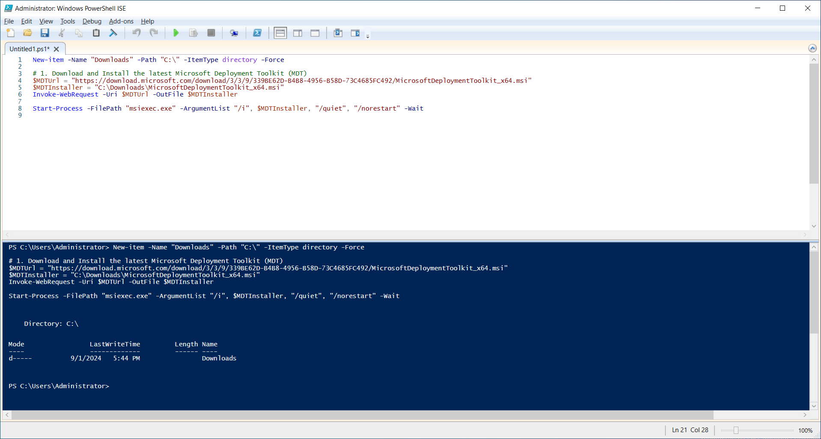

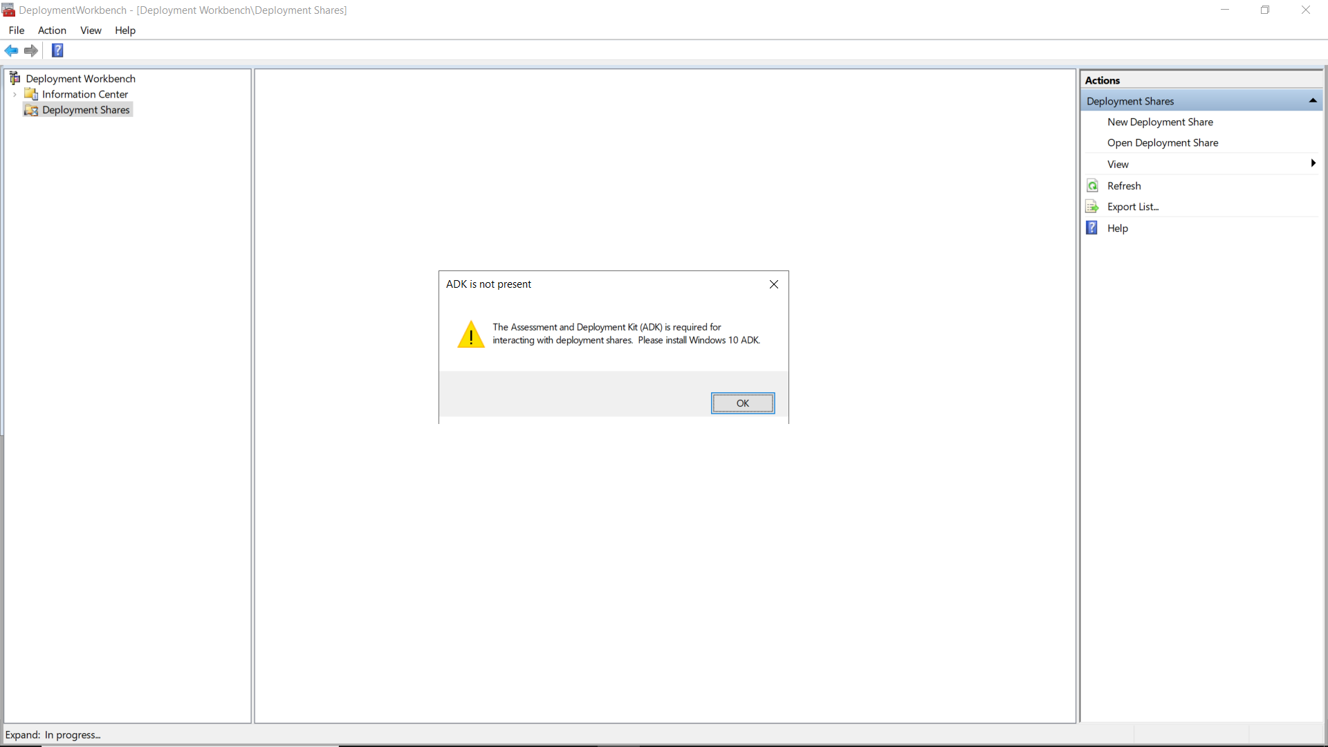

1. **Install Windows ADK**

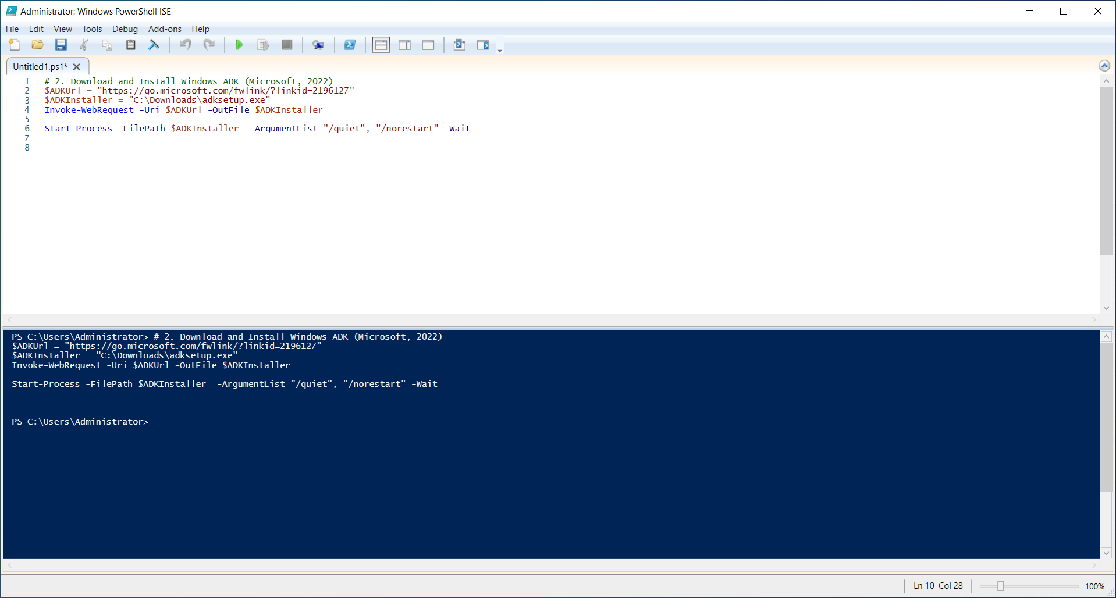

1. **Install Windows PE add-on for the Windows ADK**

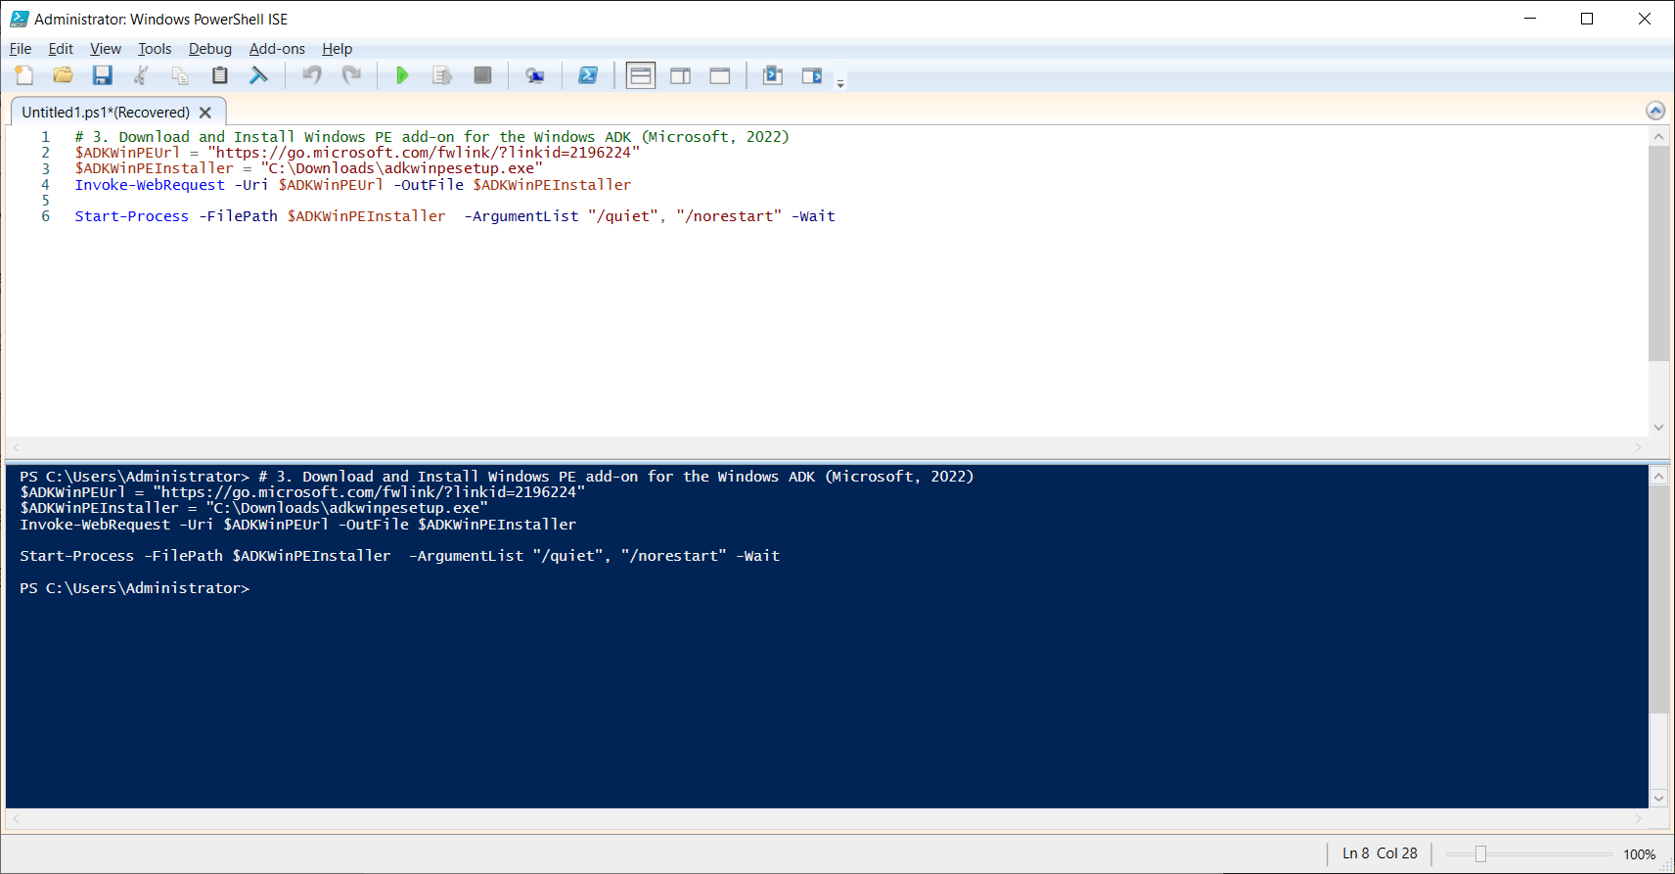

1. **Check installation in Control Panel list:**

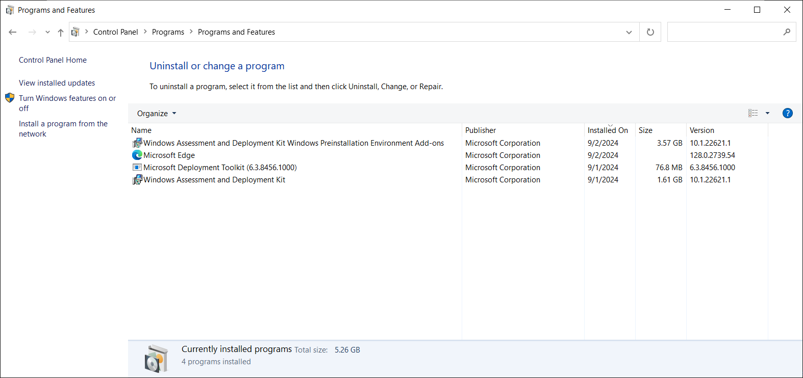

1. **Check MDT after Windows ADK and PE add-on installed.**

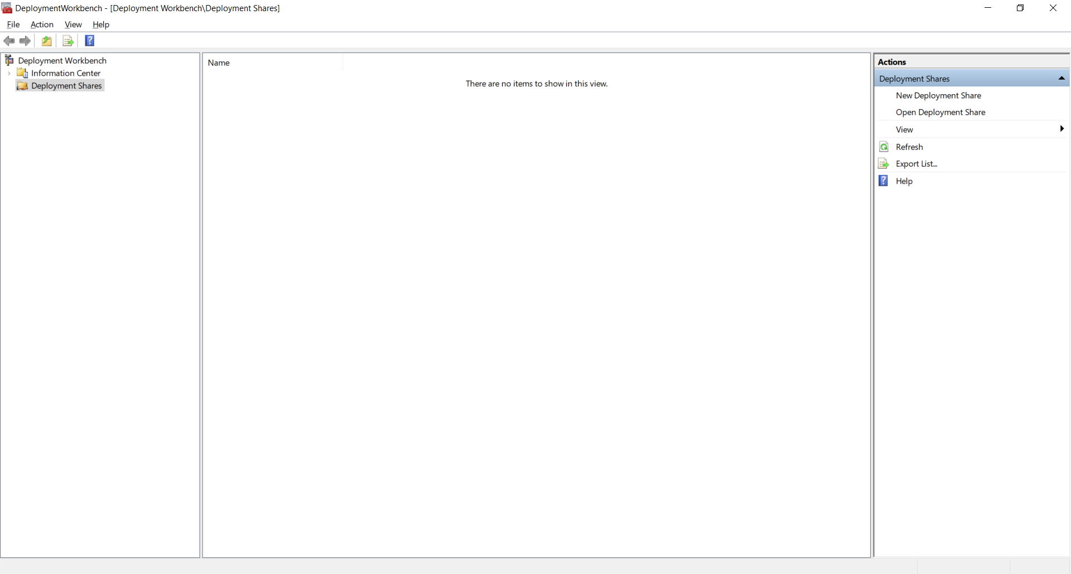

1. **Download Windows 11 image and mount it to the Server**

* Link of download Windows 11 (Microsoft, n.d.)

<https://go.microsoft.com/fwlink/?linkid=2171764>

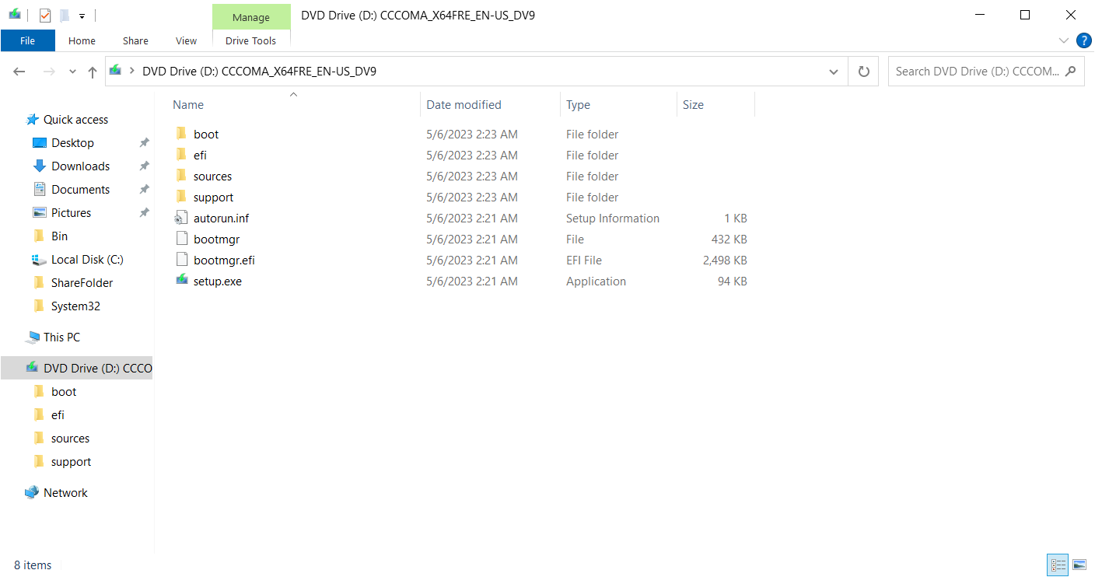

1. **Download Applications: Google Chrome, VLC and Adobe Acrobat Reader.**

* Link of download Google Chrome:

https://dl.google.com/tag/s/appguid%3D%7B8A69D345-D564-463C-AFF1-A69D9E530F96%7D%26iid%3D%7B8760FC7E-F333-738A-2267-71EB73676E42%7D%26lang%3Den%26browser%3D5%26usagestats%3D0%26appname%3DGoogle%2520Chrome%26needsadmin%3Dtrue%26ap%3Dx64-stable-statsdef_0%26brand%3DGCEA/dl/chrome/install/googlechromestandaloneenterprise64.msi

* Link of download VLC (VideoLAN, n.d.):

https://get.videolan.org/vlc/3.0.17.4/win32/vlc-3.0.17.4-win32.exe

* Link of download Adobe Acrobat Reader (Adobe, n.d.):

https://get.adobe.com/reader/enterprise/.

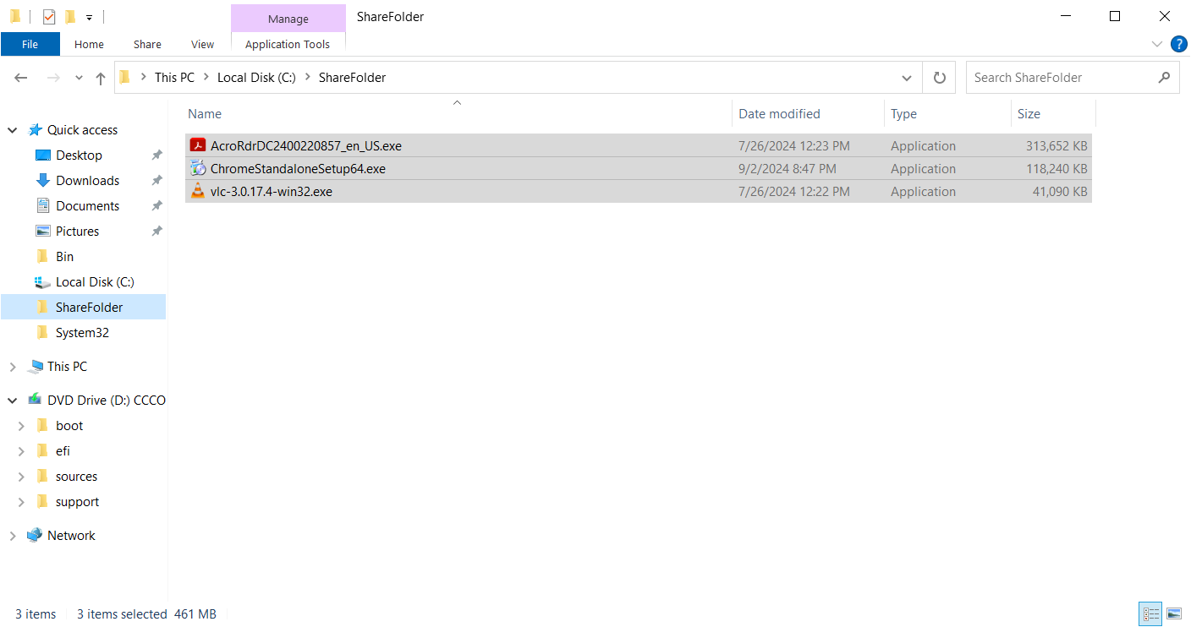

10. Check the PowerShell script on the GitHub website

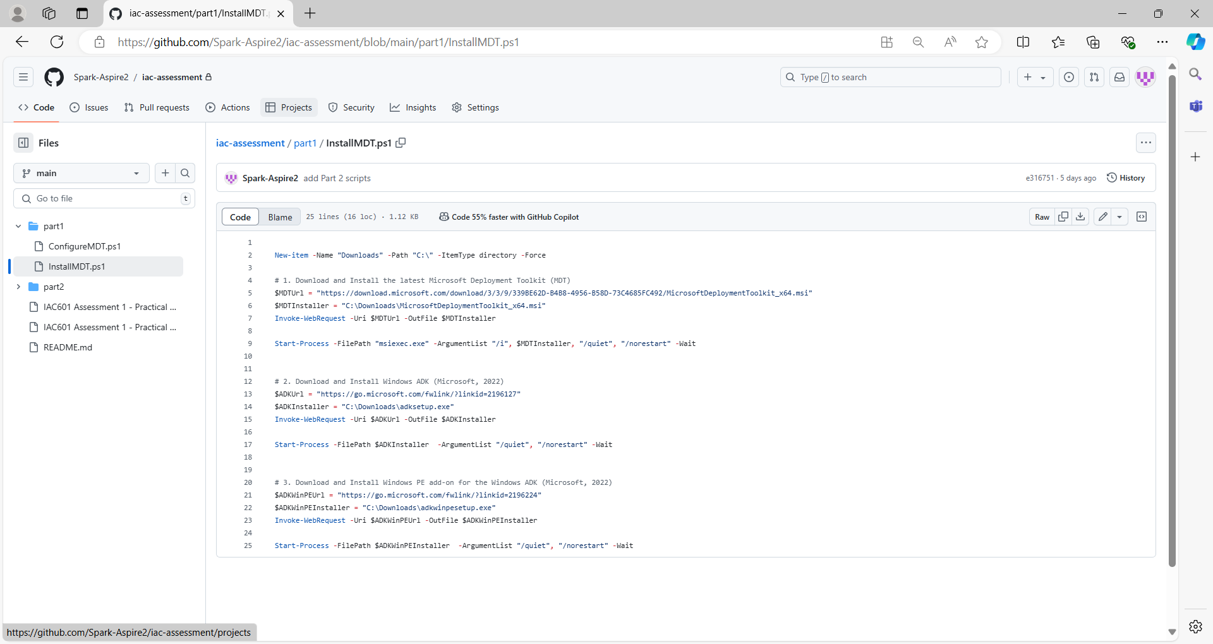

## Task 2: Analysis and Evaluation of Legal and Regulatory Requirements

There are several primary legal and regulatory requirements in New Zealand, including Privacy Act 2020(Privacy Act 2020. 2024), Copyright Act 1994(Copyright Act 1994. 2023), Fair Trading Act 1986(Fair Trading Act 1986. 2024), Health Information Privacy Code 2020(Health Information Privacy Code 2020. 2022), and New Zealand Information Security Manual (New Zealand Information Security Manual. 2024), etc.

To use Microsoft Deployment Toolkit (MDT) to deploy Windows 11 and applications automatically involves those legal and regulatory requirements listed above. These requirements ensure that the deployment process is compliance with software licenses, data protection, and security regulations.

1. **Software license compliance.** 
   * + - During the implementation, to ensure all software installed, including Windows 11, Google Chrome, VLC Media Player, and Adobe Acrobat Reader, is properly licensed for use by Media Labs under Copyright Act 1994 and Fair Trading Act 1986.
       - For Media Labs, licenses are confirmed before deployment. A record of all software licenses, proof of purchase and download links is maintained and the usage and installation of software on each client machine is documented to demonstrate compliance.
2. **Data protection and privacy.** 
   * + - Under Privacy Act 2020 and Health Information Privacy Code 2020, it includes ensuring that no personal data is unlawfully processed during the deployment, and appropriate measures are in place to secure any personal data that may be involved.
       - During deployment, all personal data is minimized, protected, and only used for the necessary purposes, and data is encrypted and is not leaked or improperly accessed. MDT and deployment scripts is configured to anonymize to avoid storing any user-specific data in deployment logs or capturing user data during the deployment process.
3. **Security and compliance standards.** 
   * + - Under New Zealand Information Security Manual, deployment processes should include measures that align with these standards, like secure transmission of data and maintaining system integrity, protecting against cybersecurity with security patches and updates to prevent vulnerabilities, managing firewall rules, ensuring security policies are enforced, and managing system settings to prevent unauthorized changes.
       - During deployment, PowerShell script is configured to update Windows 11 and all other applications with the latest patches to avoid vulnerabilities.

## Task 3: Plan, Design and Create a Deployment Script

**1. The PowerShell script for MDT deployment**

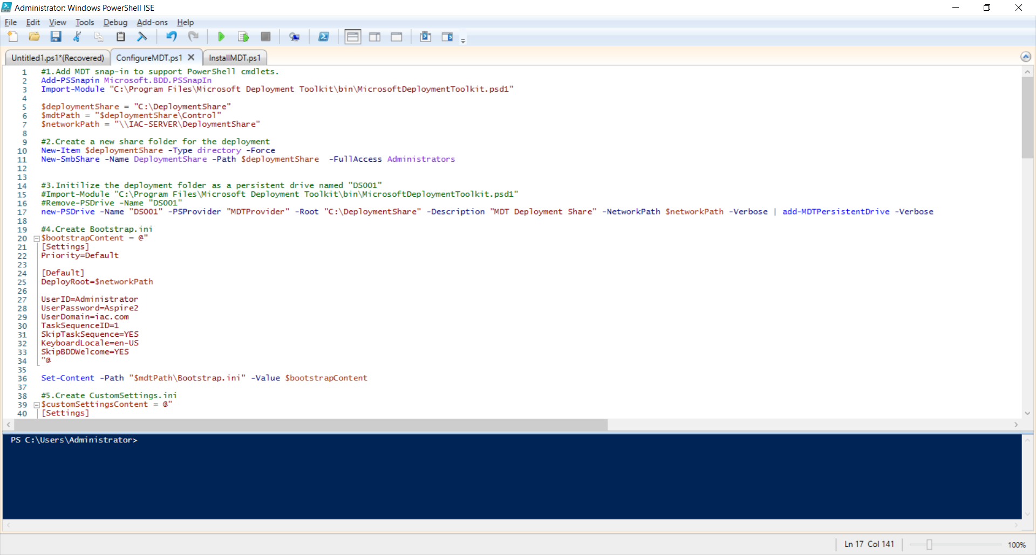

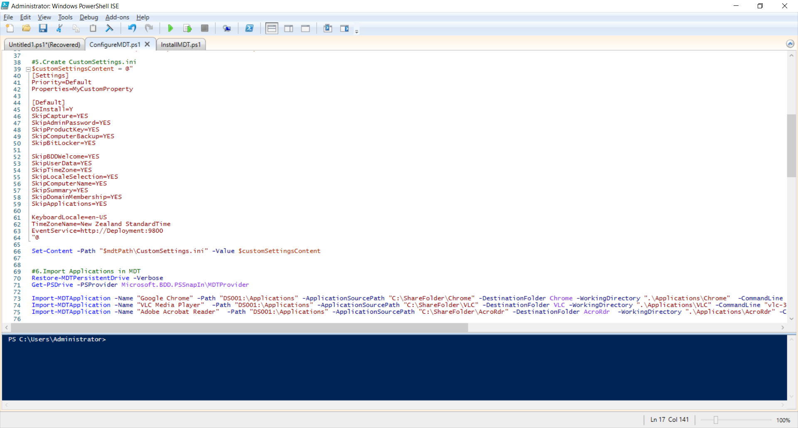

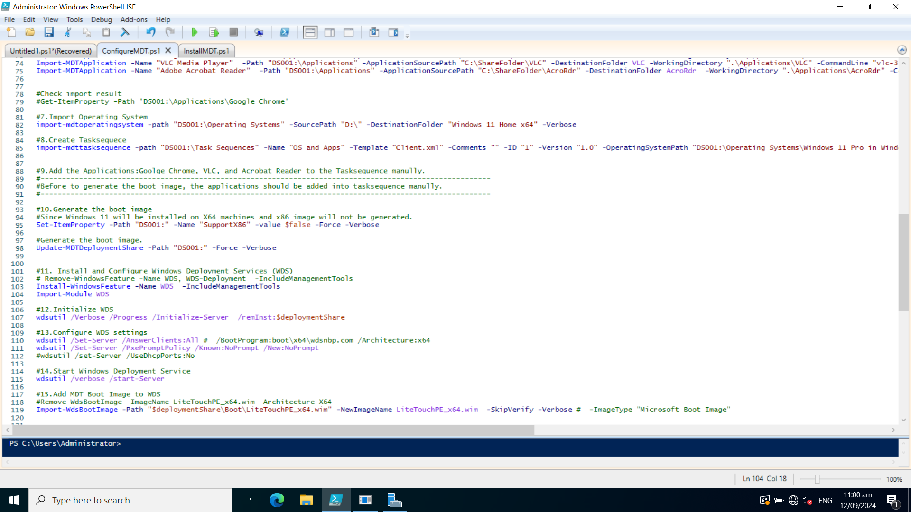

**2. Check the PowerShell script on the GitHub website**

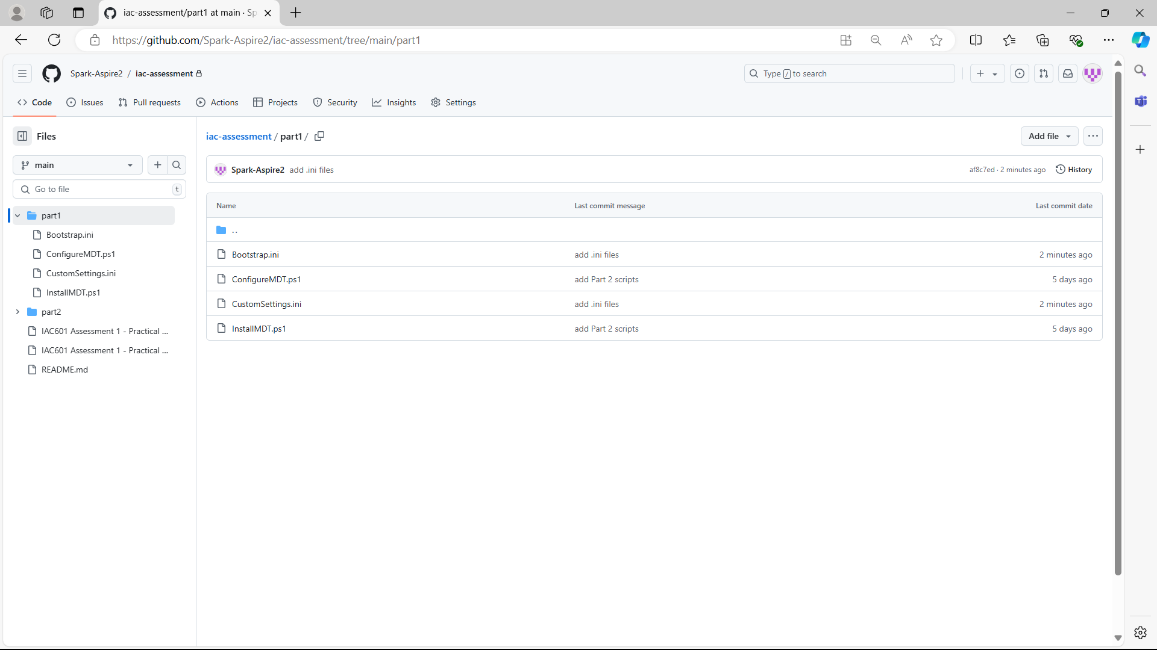

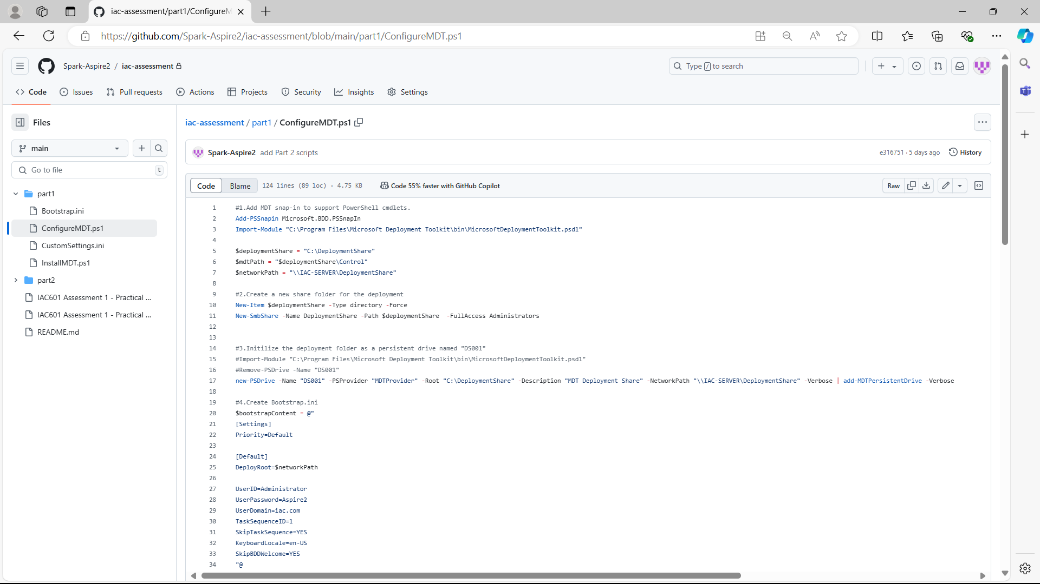

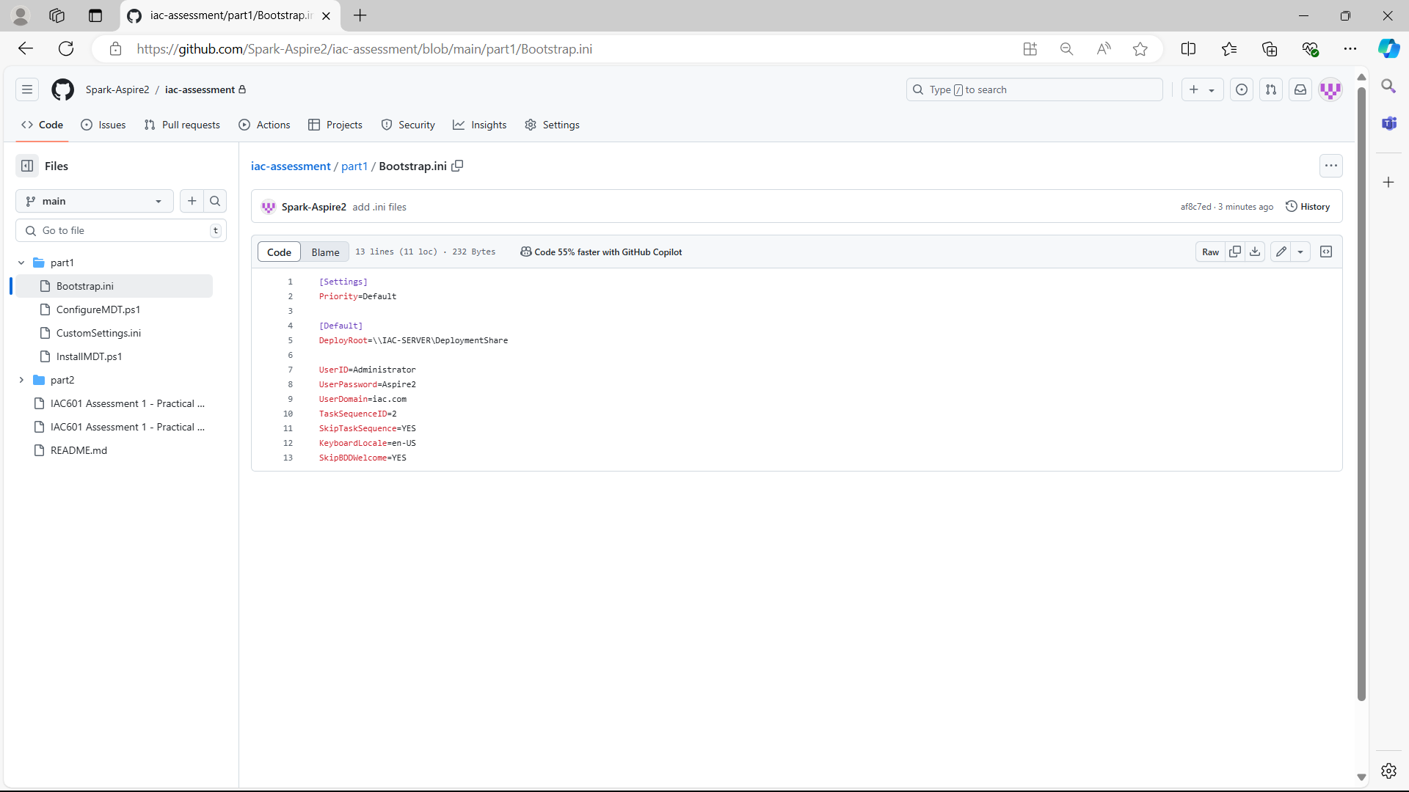

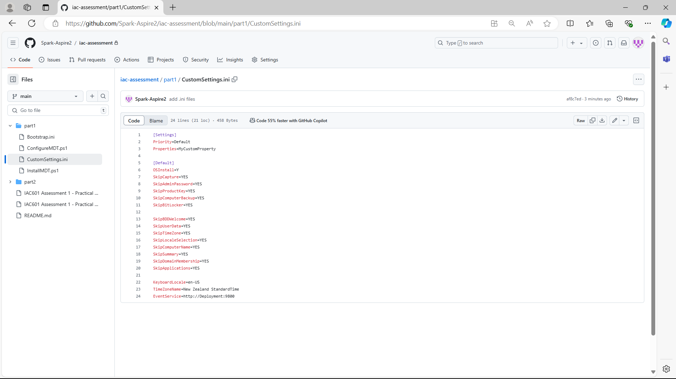

## Task 4: Pre- and Post-Deployment Implementation for a new client machine

**1. Execute the deployment PowerShell script step by step:**

* **Add MDT snap-in to support PowerShell cmdlets and create a new share folder for the deployment**

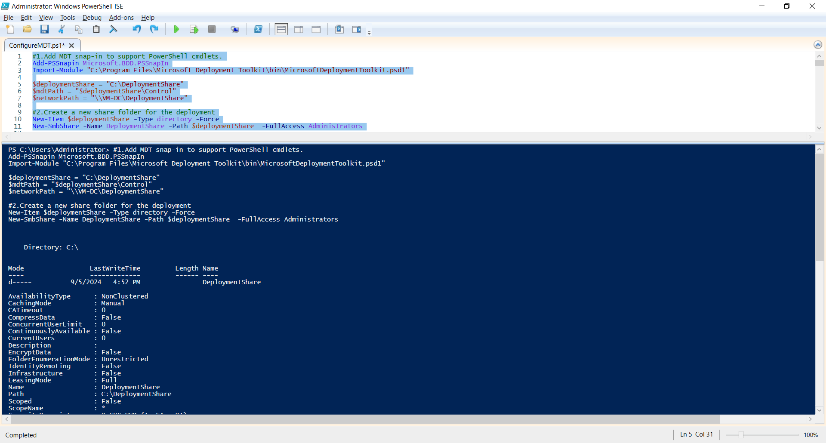

* **Initialize the deployment folder as a persistent drive named "DS00**

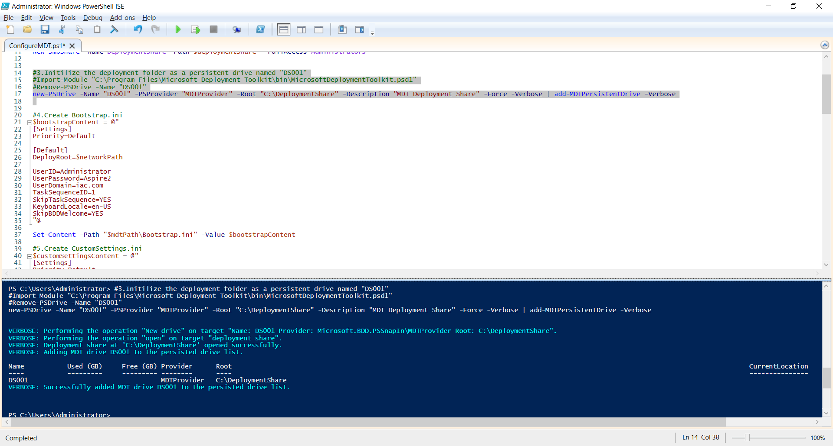

* **Create Bootstrap.ini**

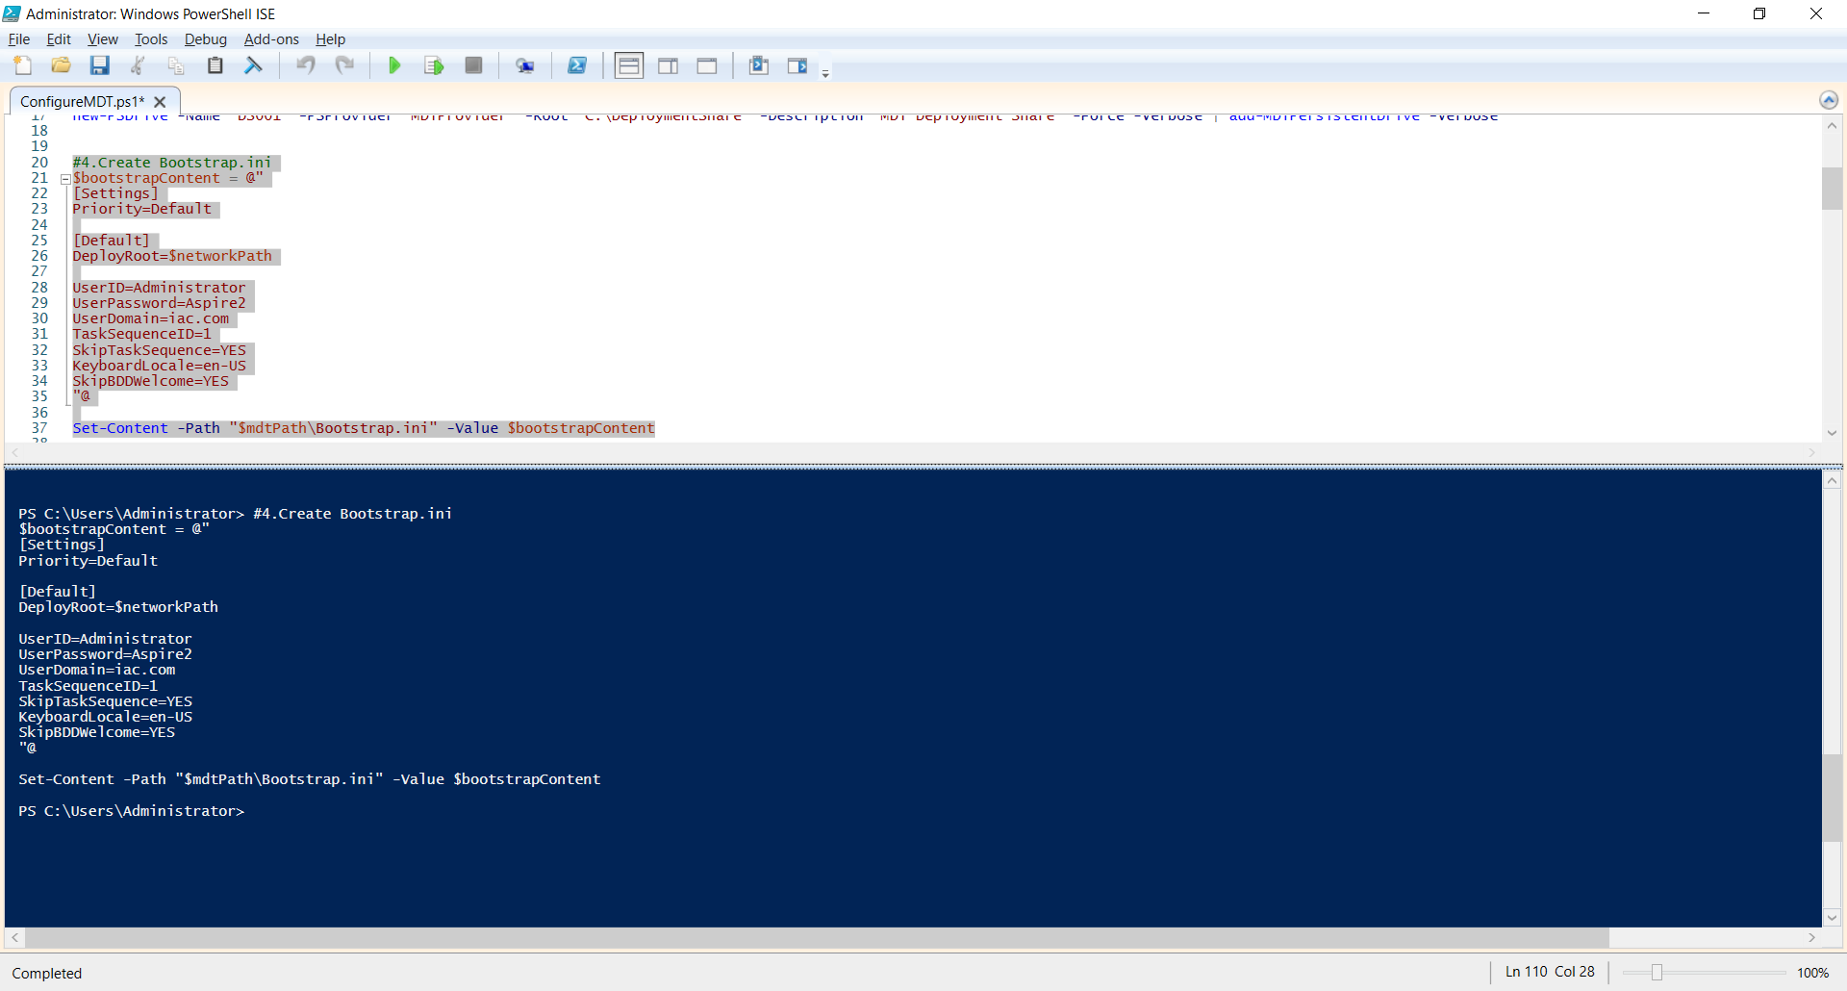

* **Create CustomSettings.ini**

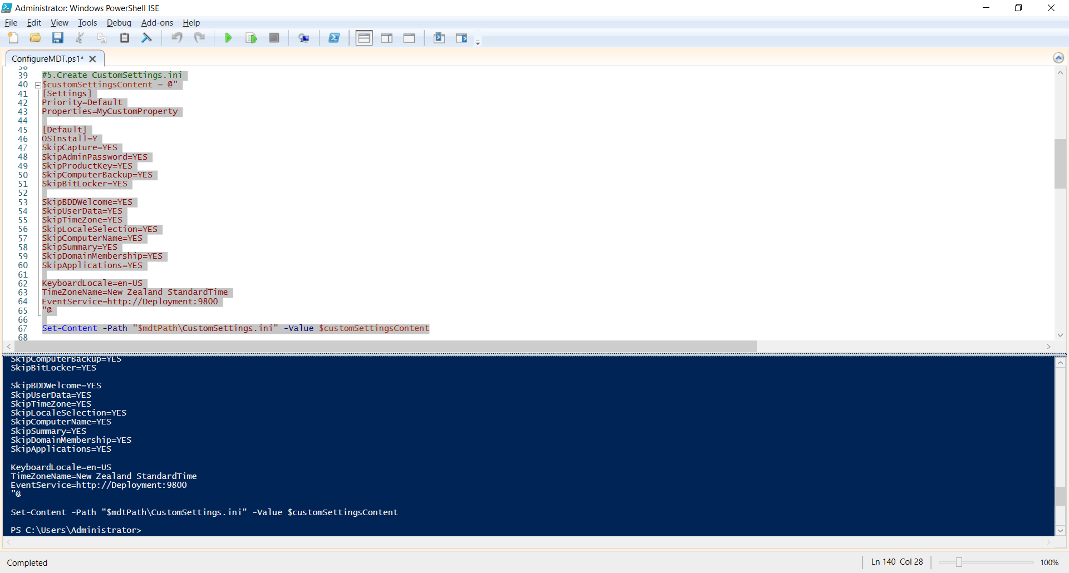

* **Import Applications (Chrome, VLC and Acrobat Reader) into MDT**

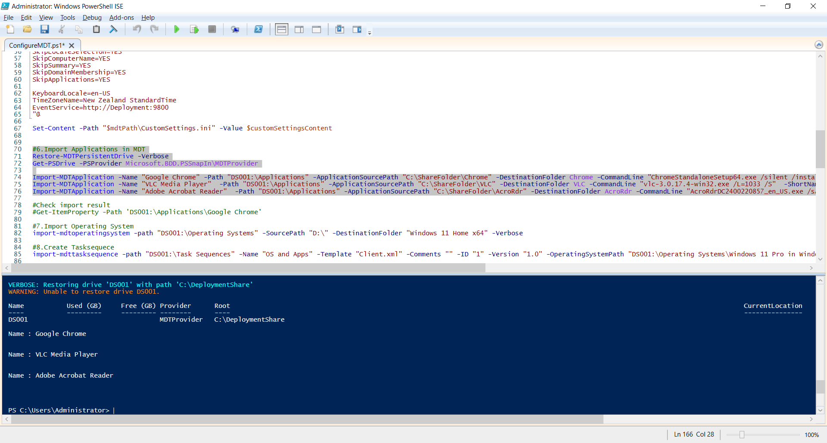

* **Check imported applications on the MDT management console:**

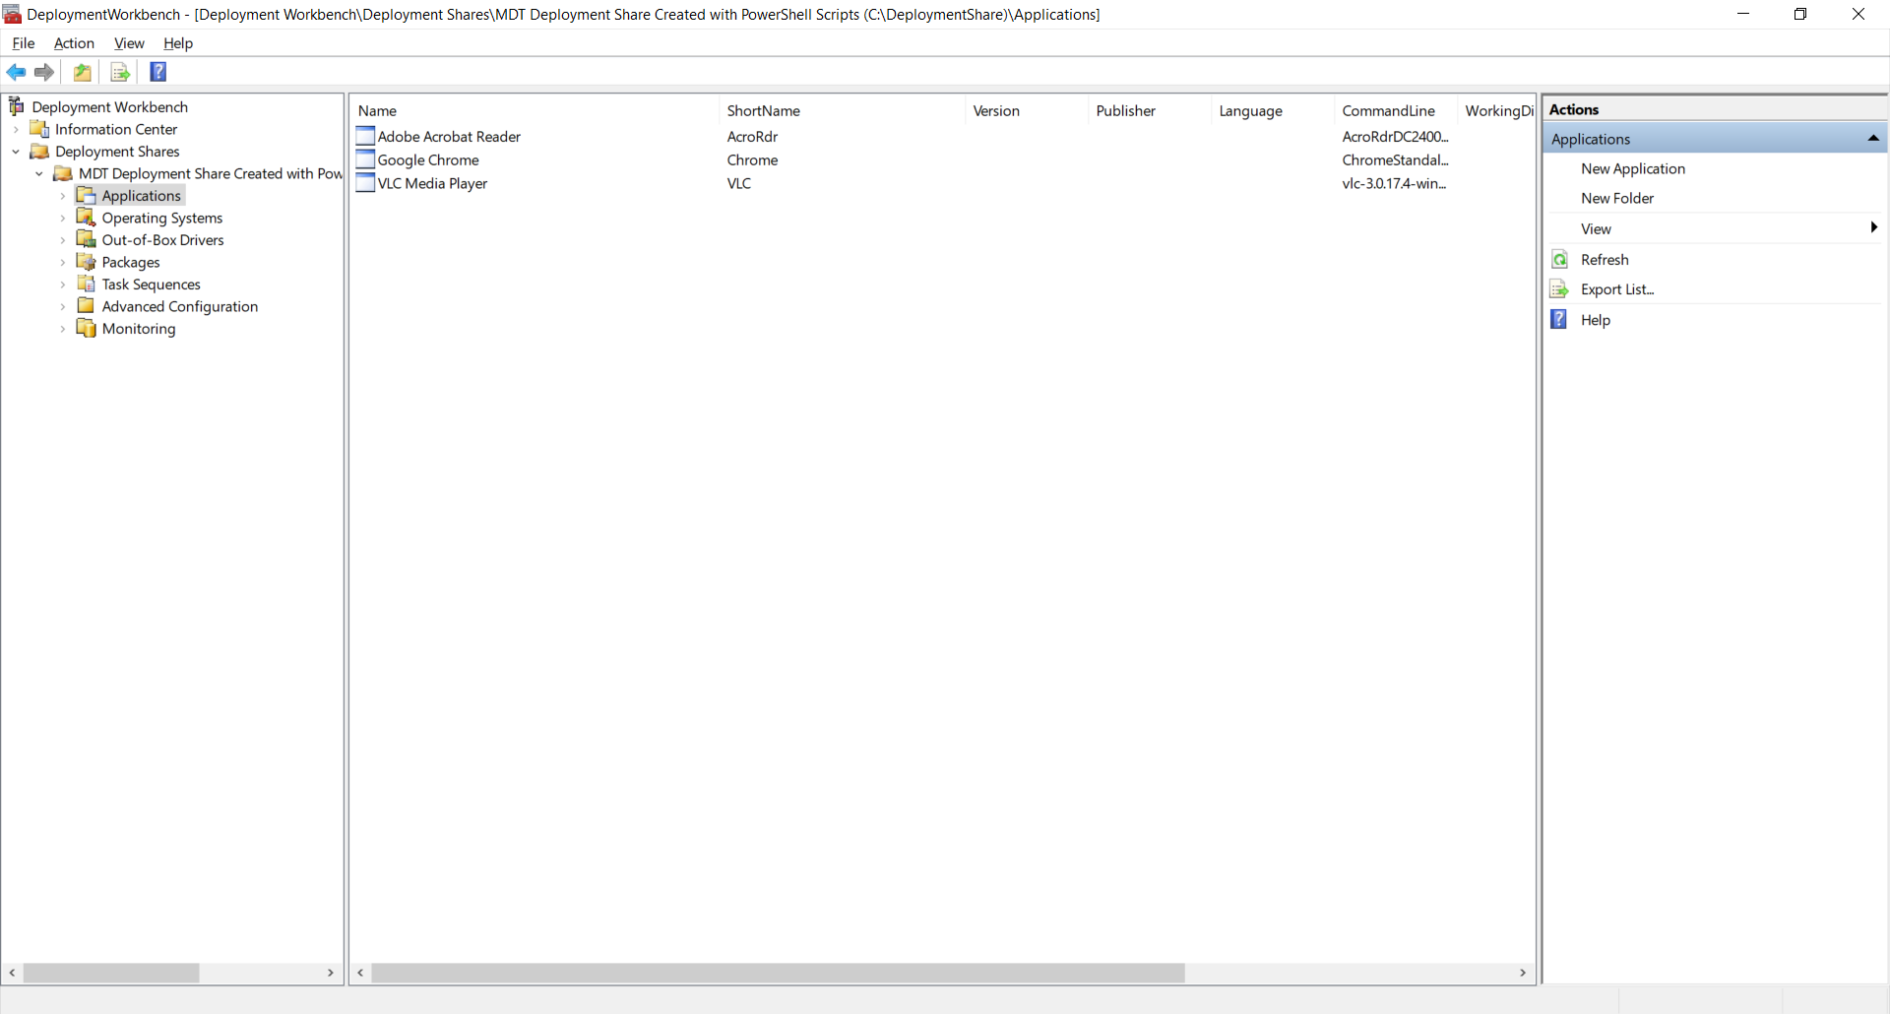

* **Import Operating System**

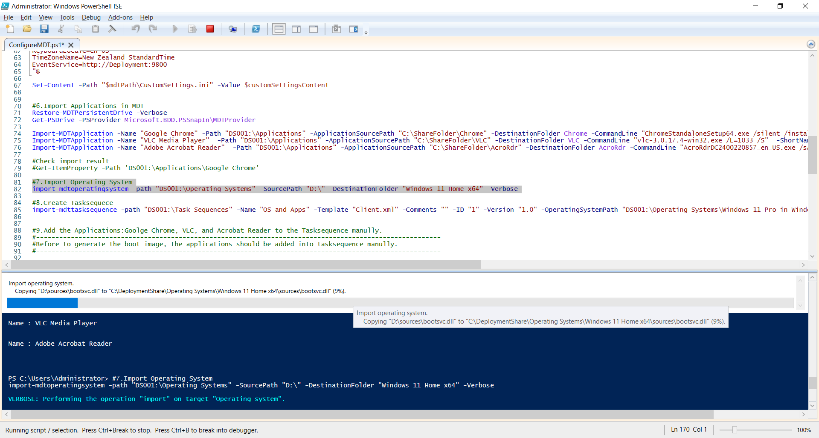

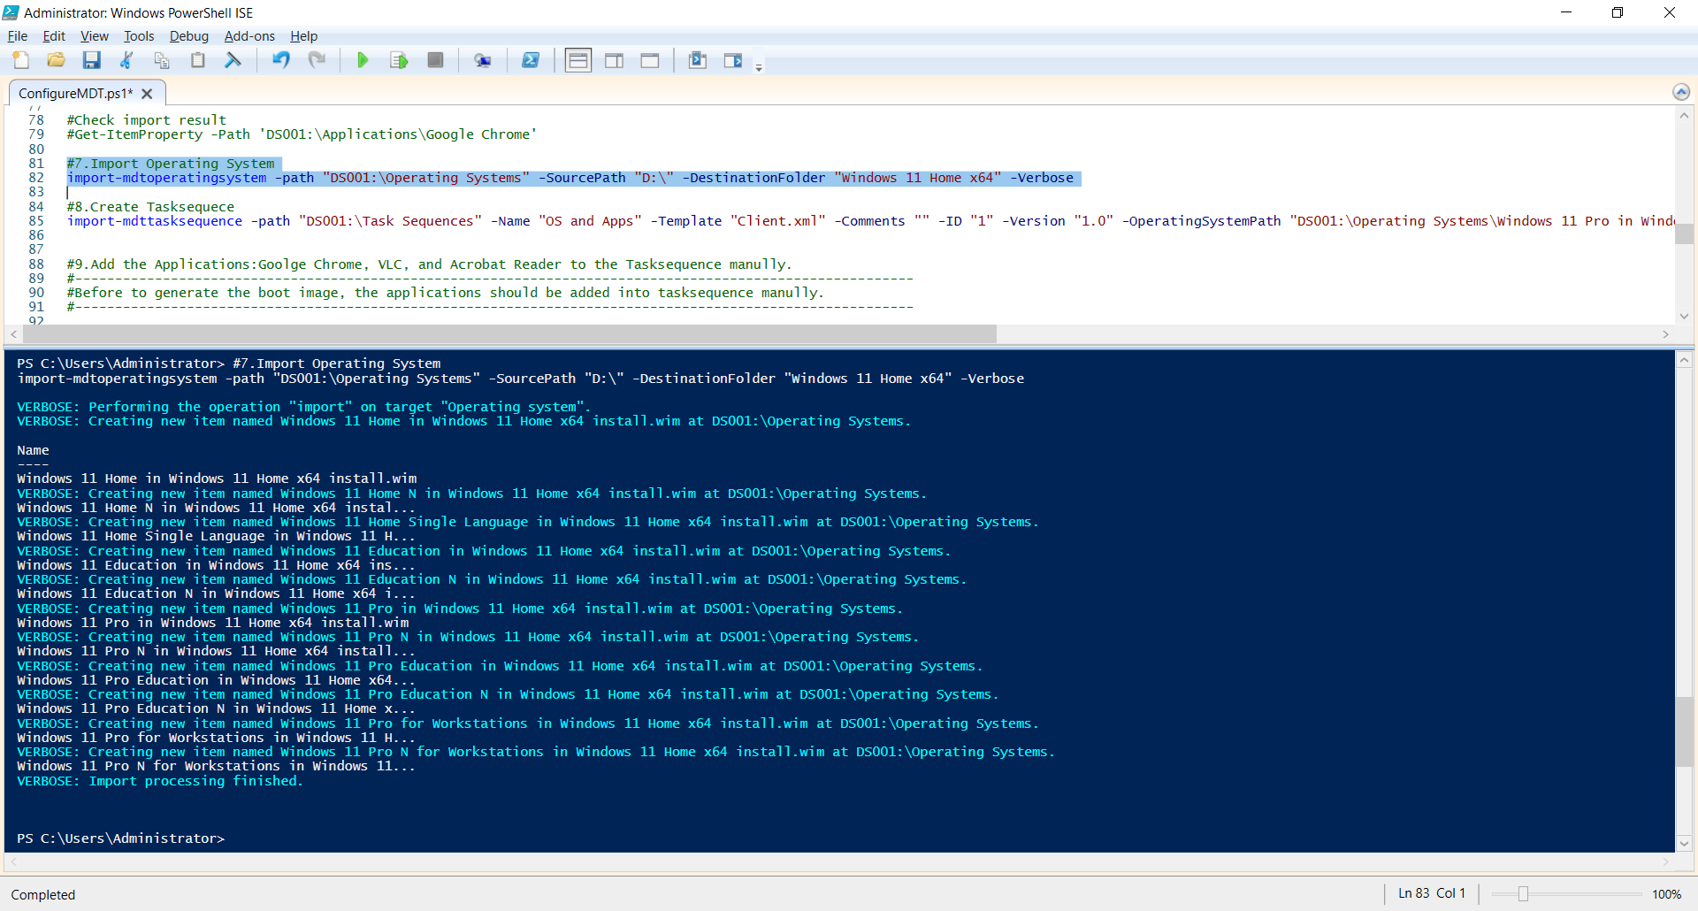

* **Check imported Windows 11 on the MDT management Console.**

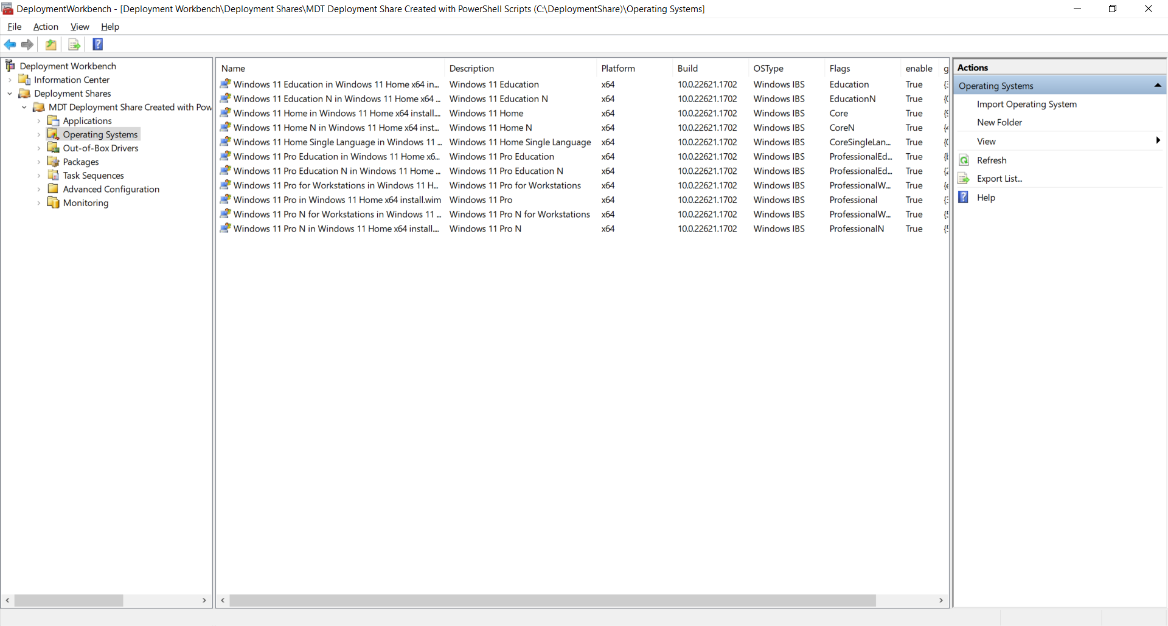

* **Create Tasksequece**

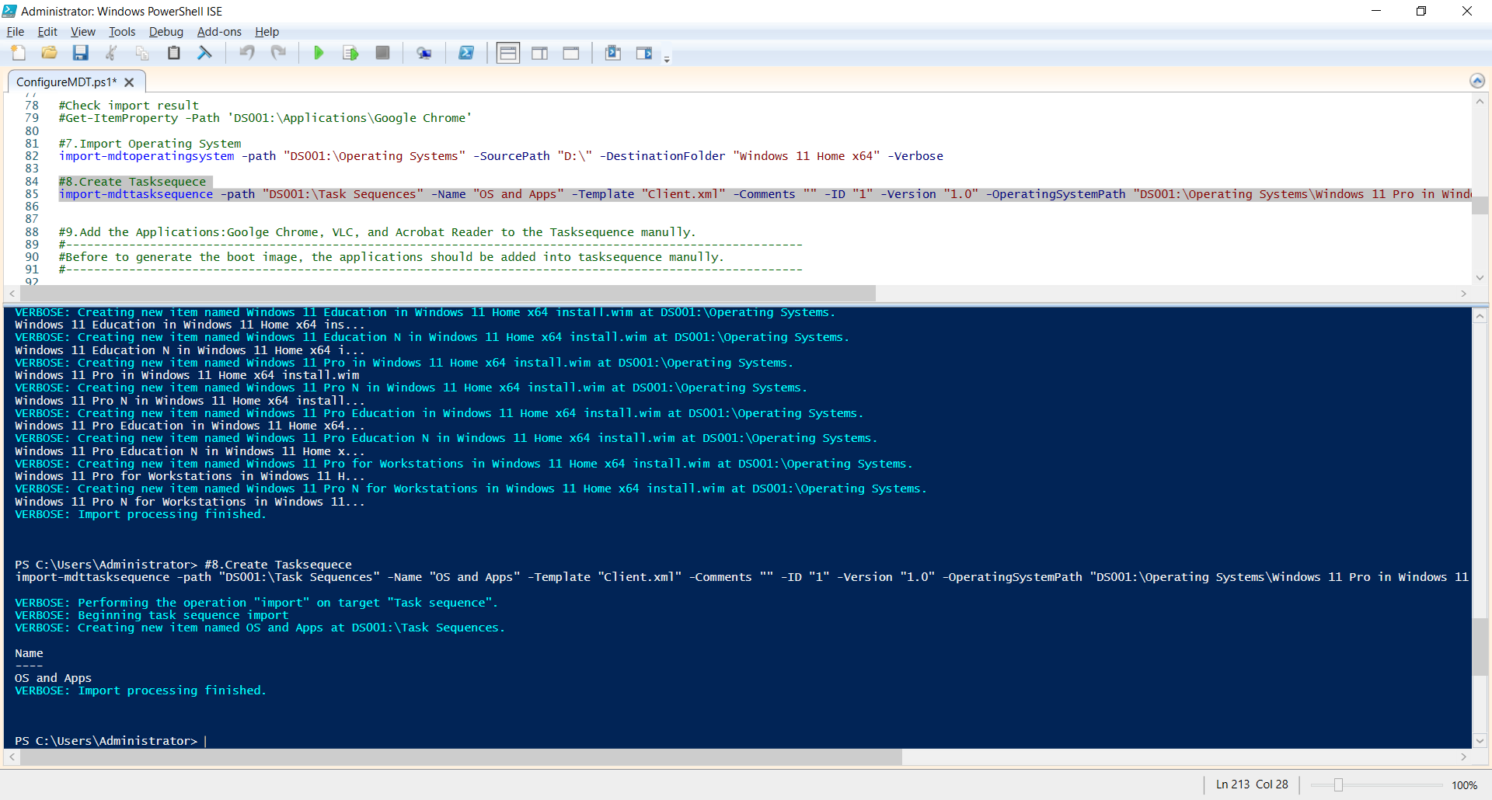

* **Add the Applications: Google Chrome, VLC, and Acrobat Reader to the Tasksequence manually.**
* **Generate the boot image**

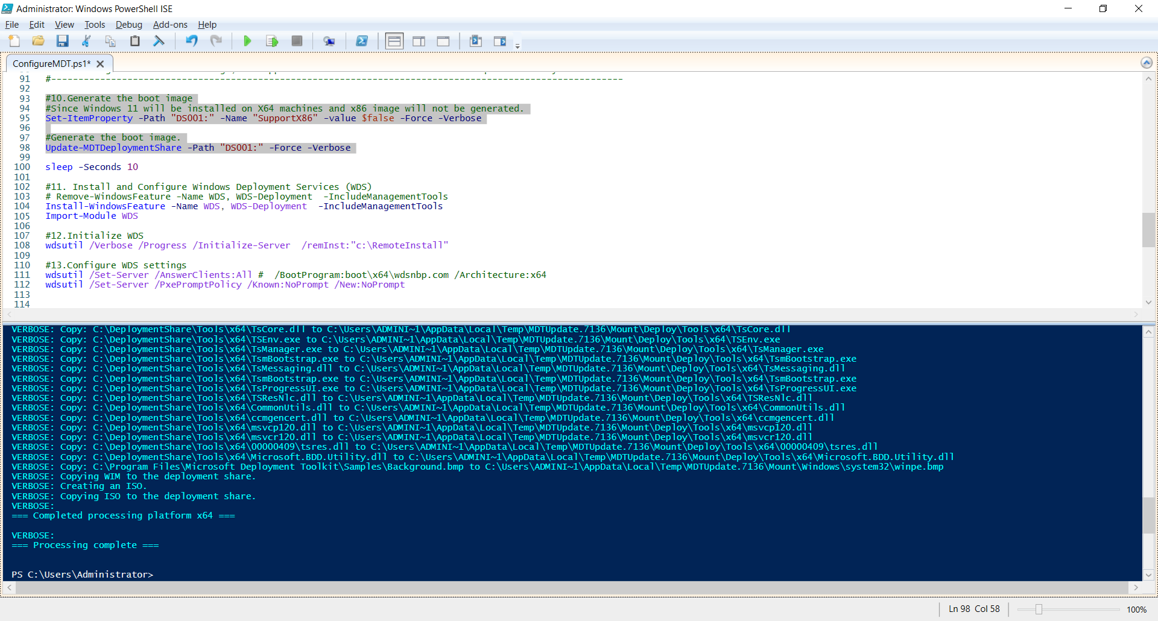

* **Install and Configure Windows Deployment Services (WDS)**

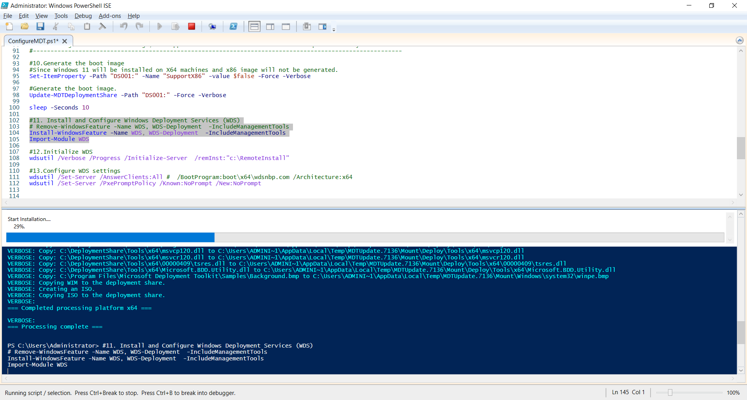

* **Initialize WDS**

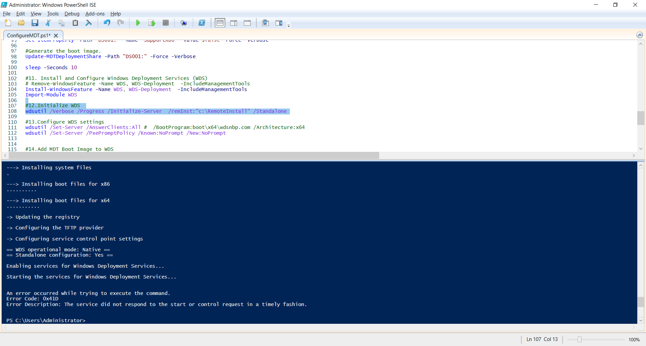

* **Configure WDS settings**

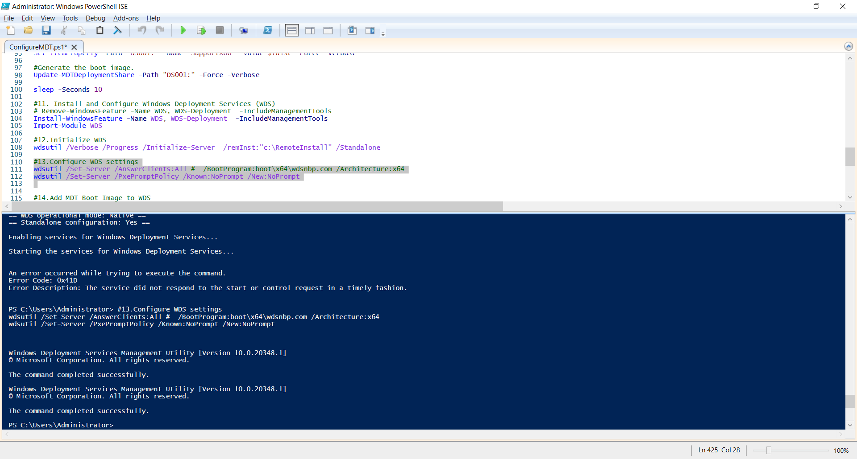

* **Start Windows Deployment Service**

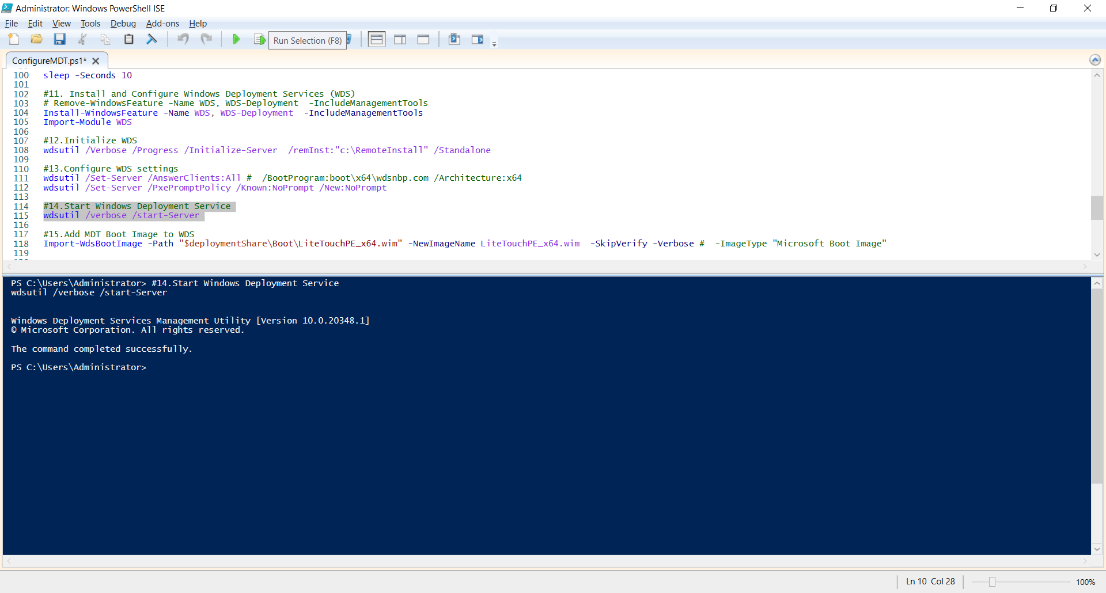

* **Add MDT Boot Image to WDS**

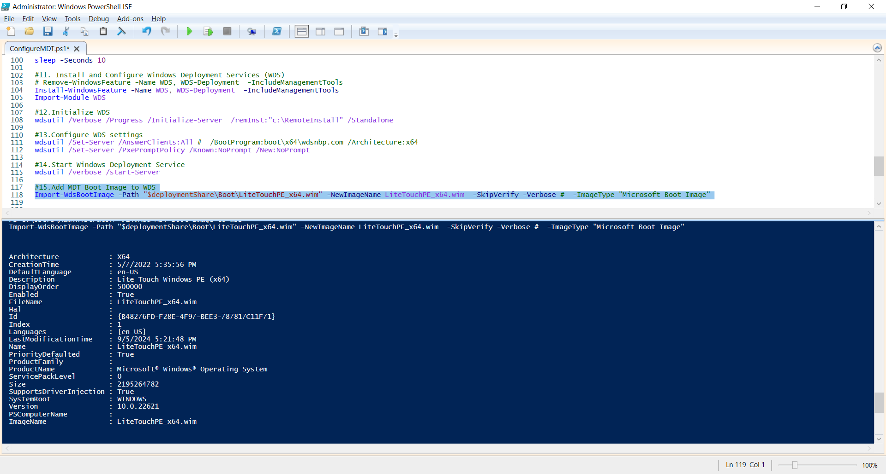

**2 . Set parameters for the client virtual machine**

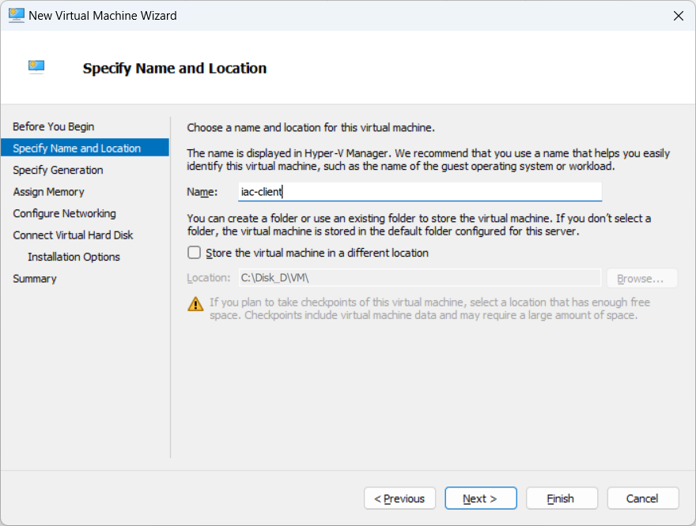

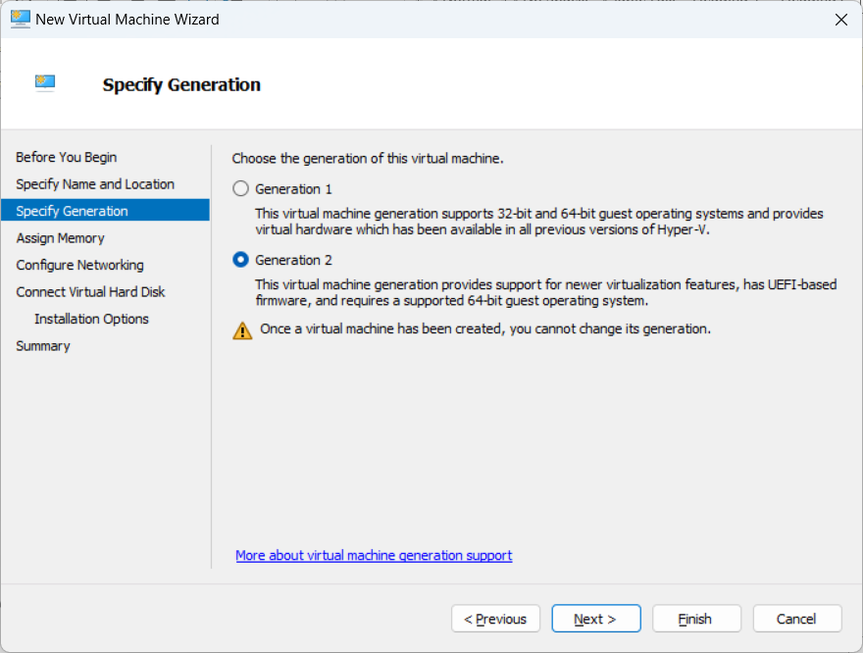

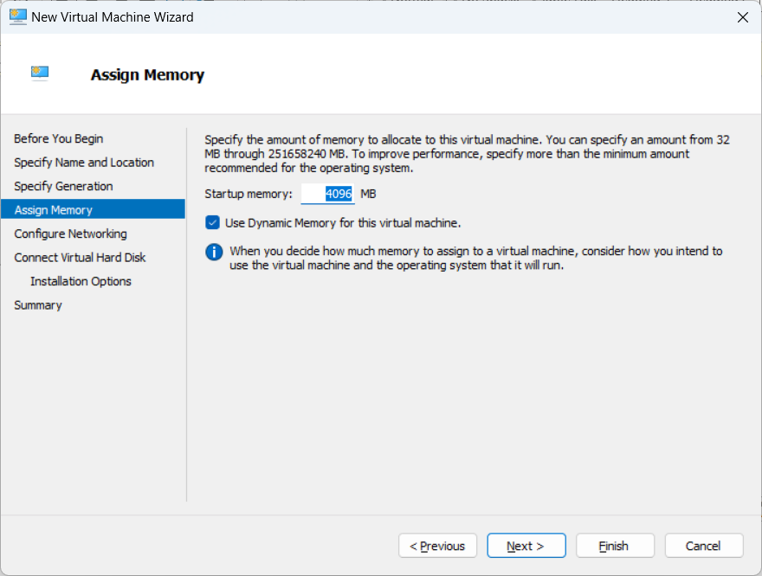

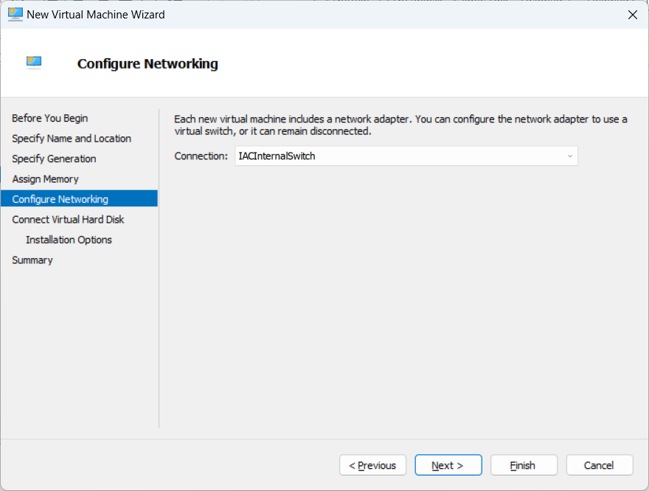

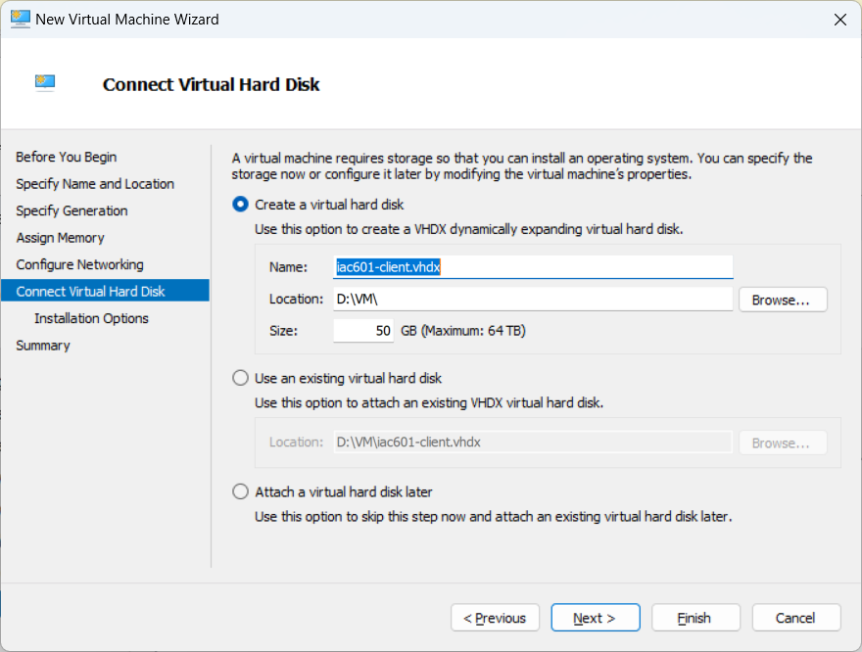

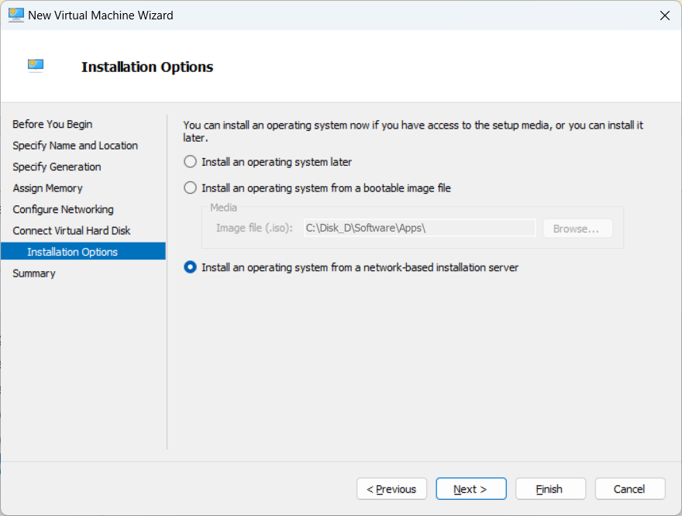

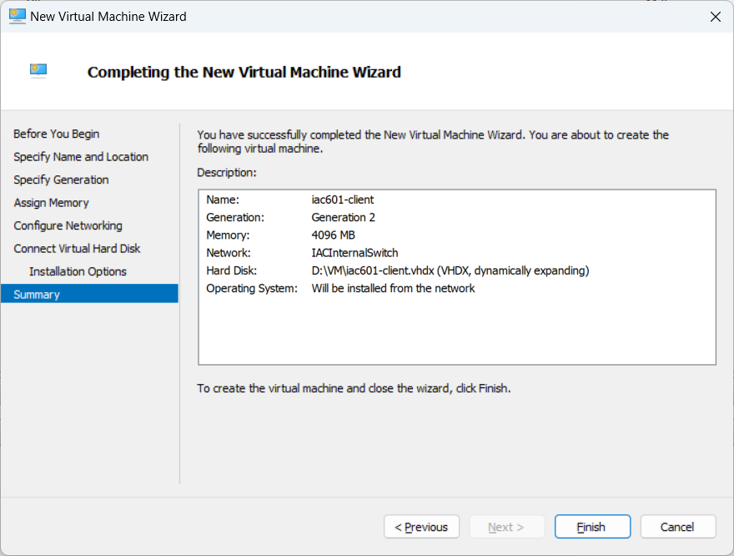

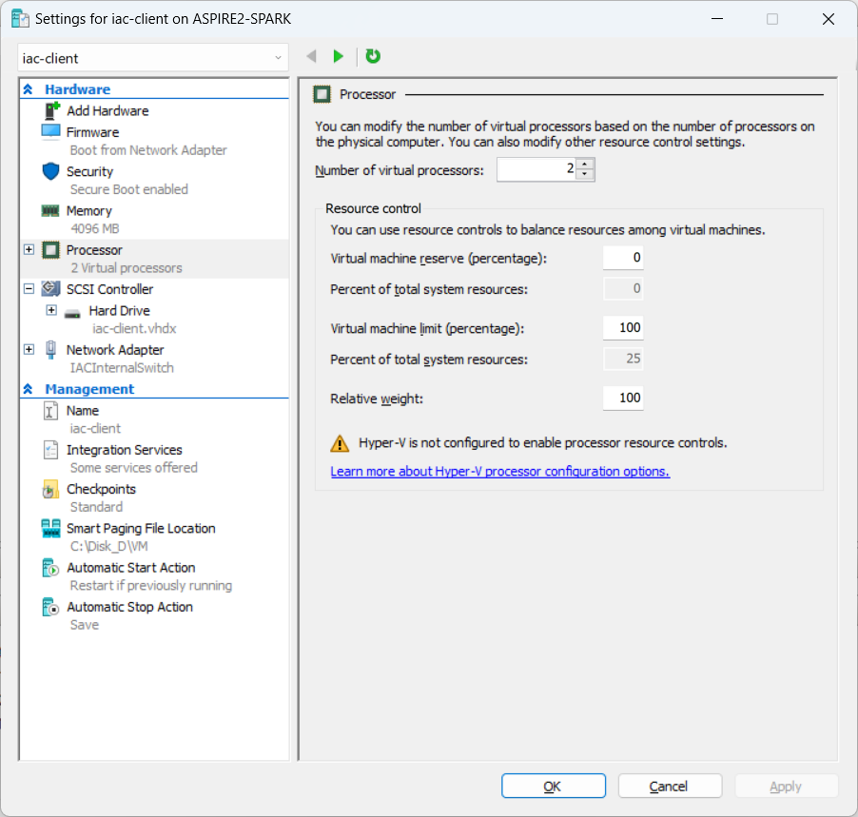

**3. Turn on the client machine and Windows Deployment is starting automatically.**

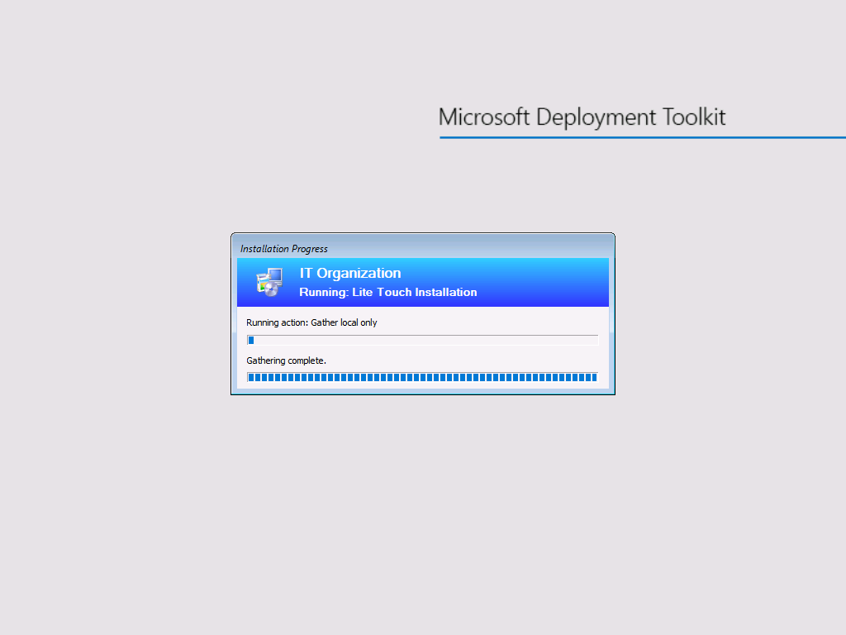

* **Windows 11 Pro is installing**

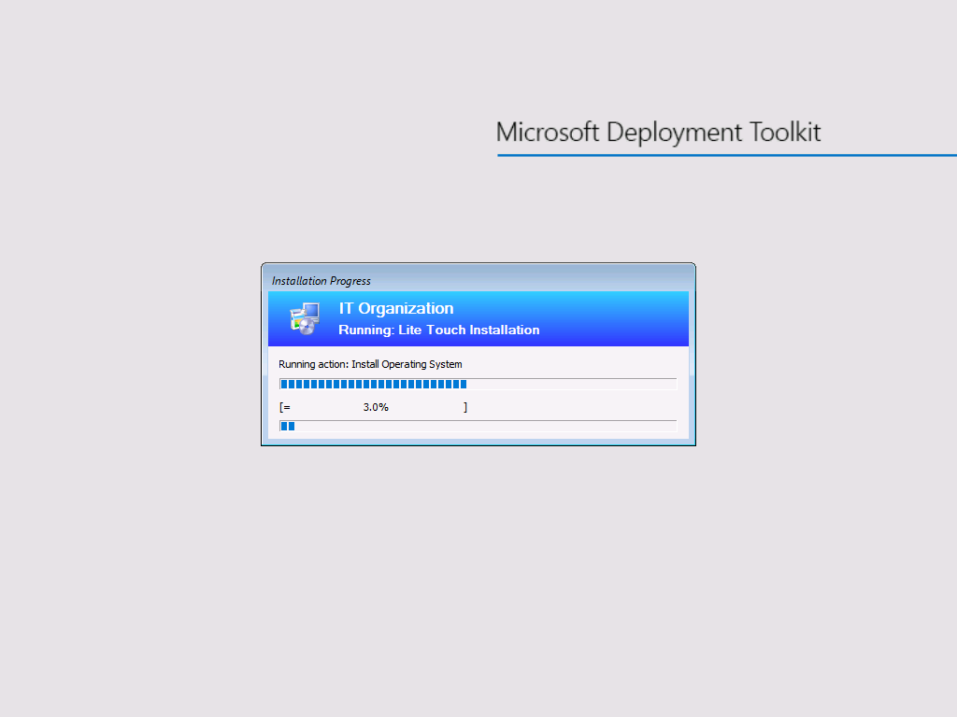

* **Windows 11 Pro is installed automatically.**

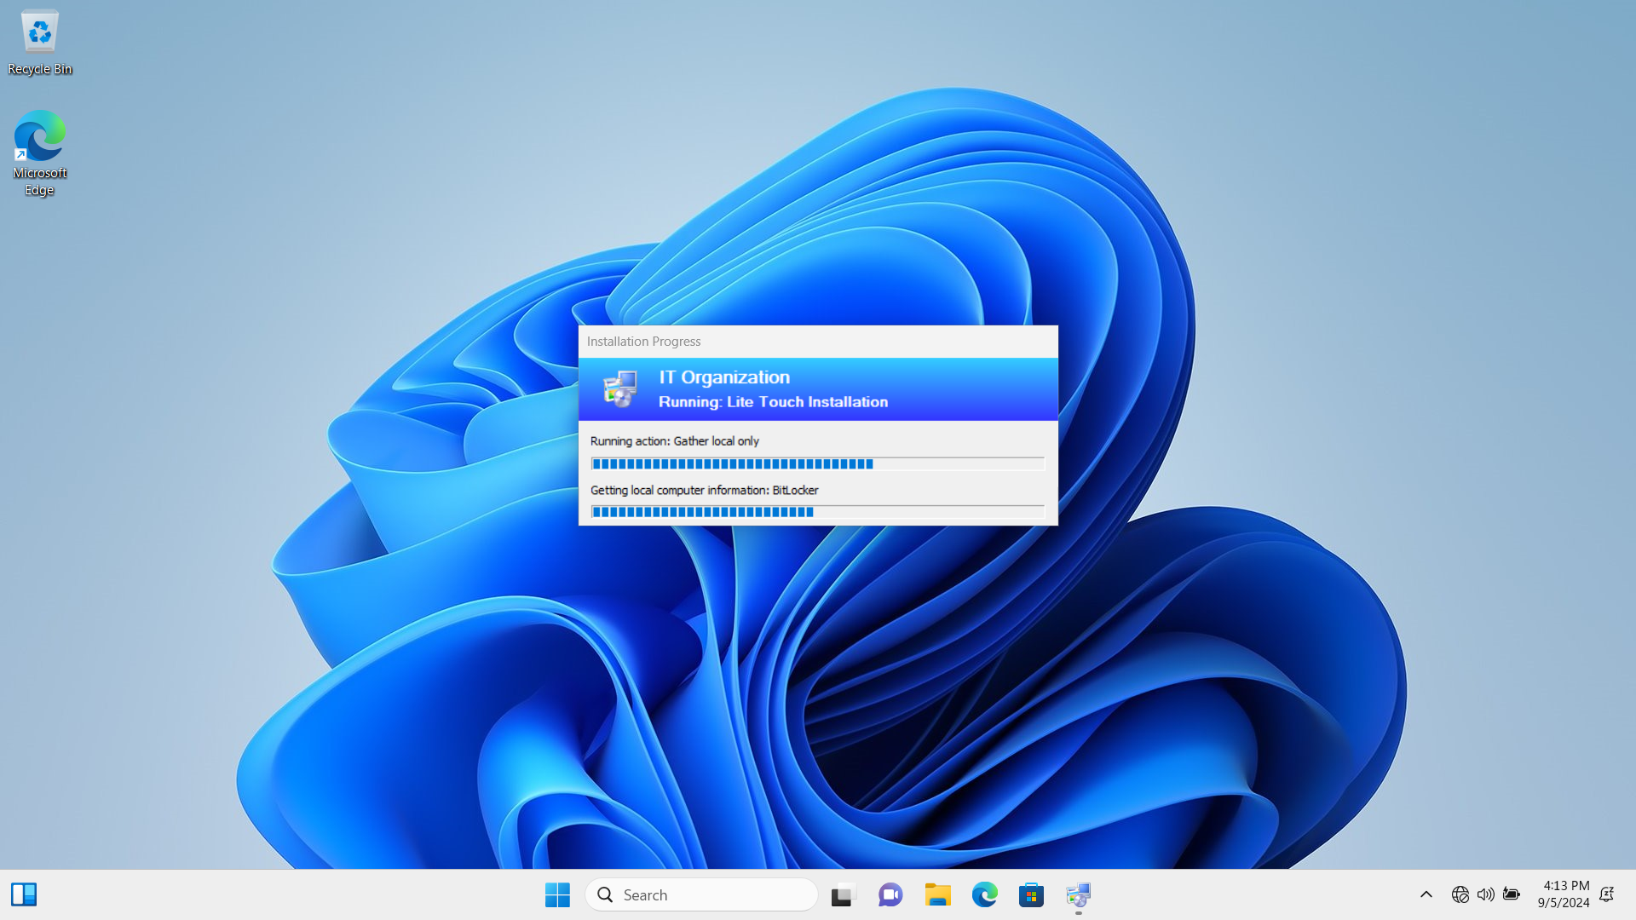

* **Google Chrome is installing.**

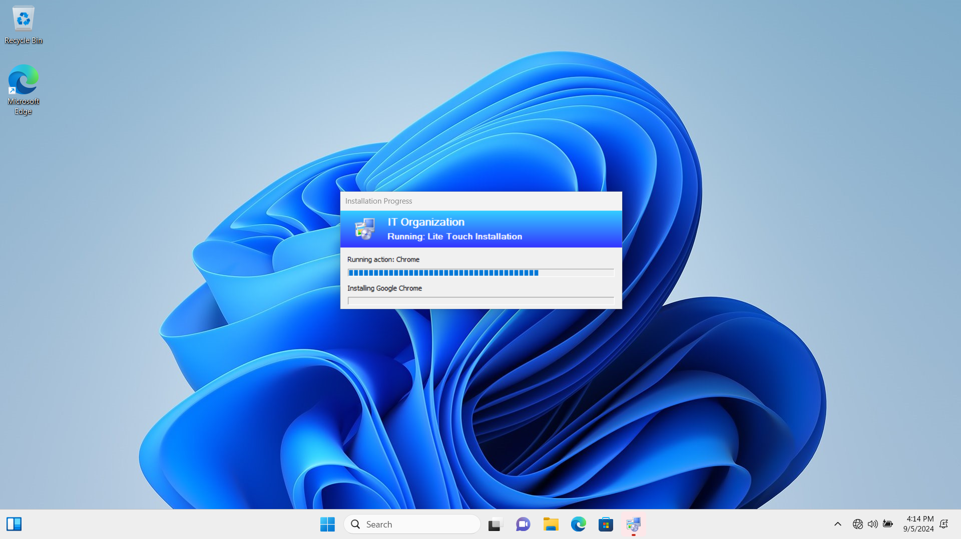

* **Acrobat Reader is installing.**

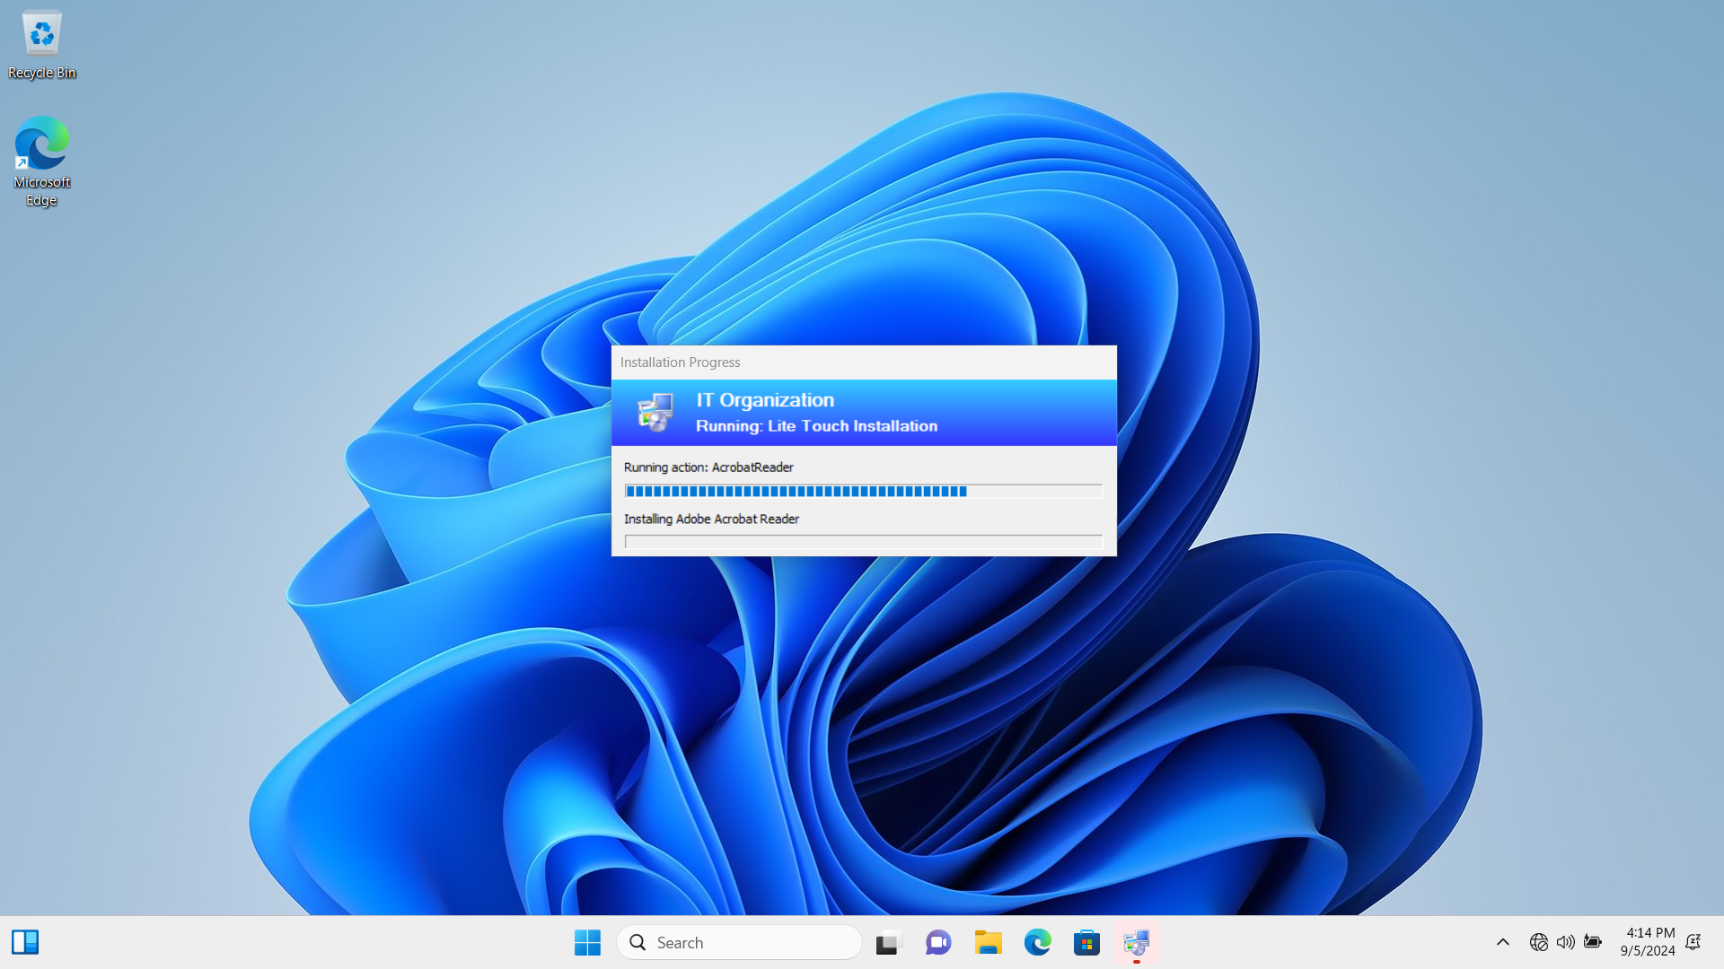

* **VLC is installing.**

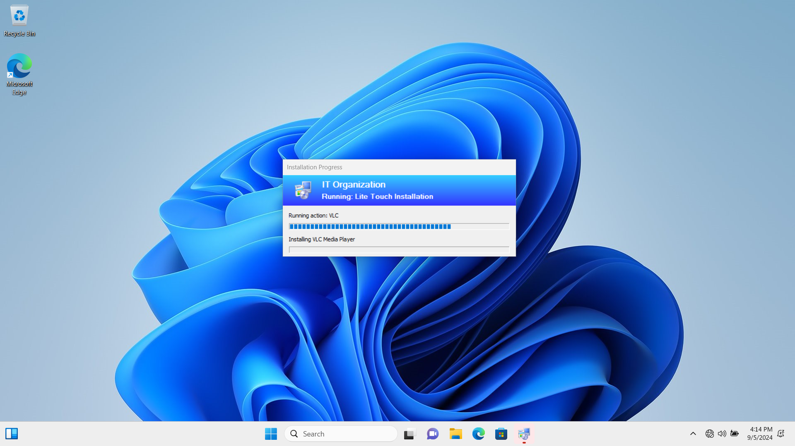

* **Google Chrome, Acrobat Reader, and VLC are installed automatically, and we can find the icons of them on Desktop.**

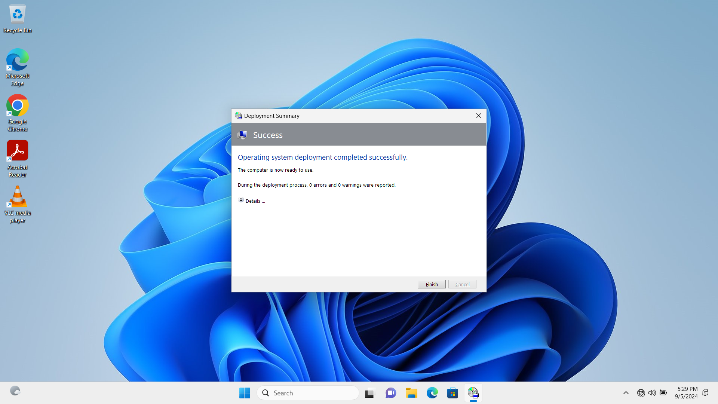

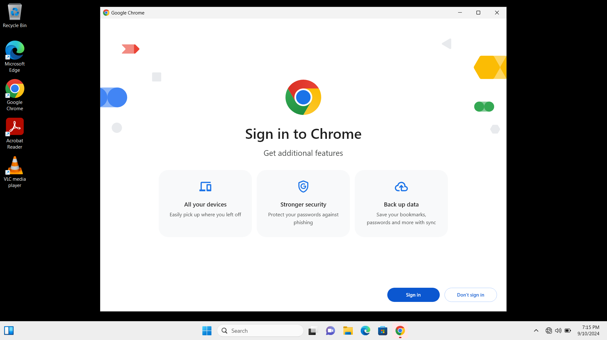

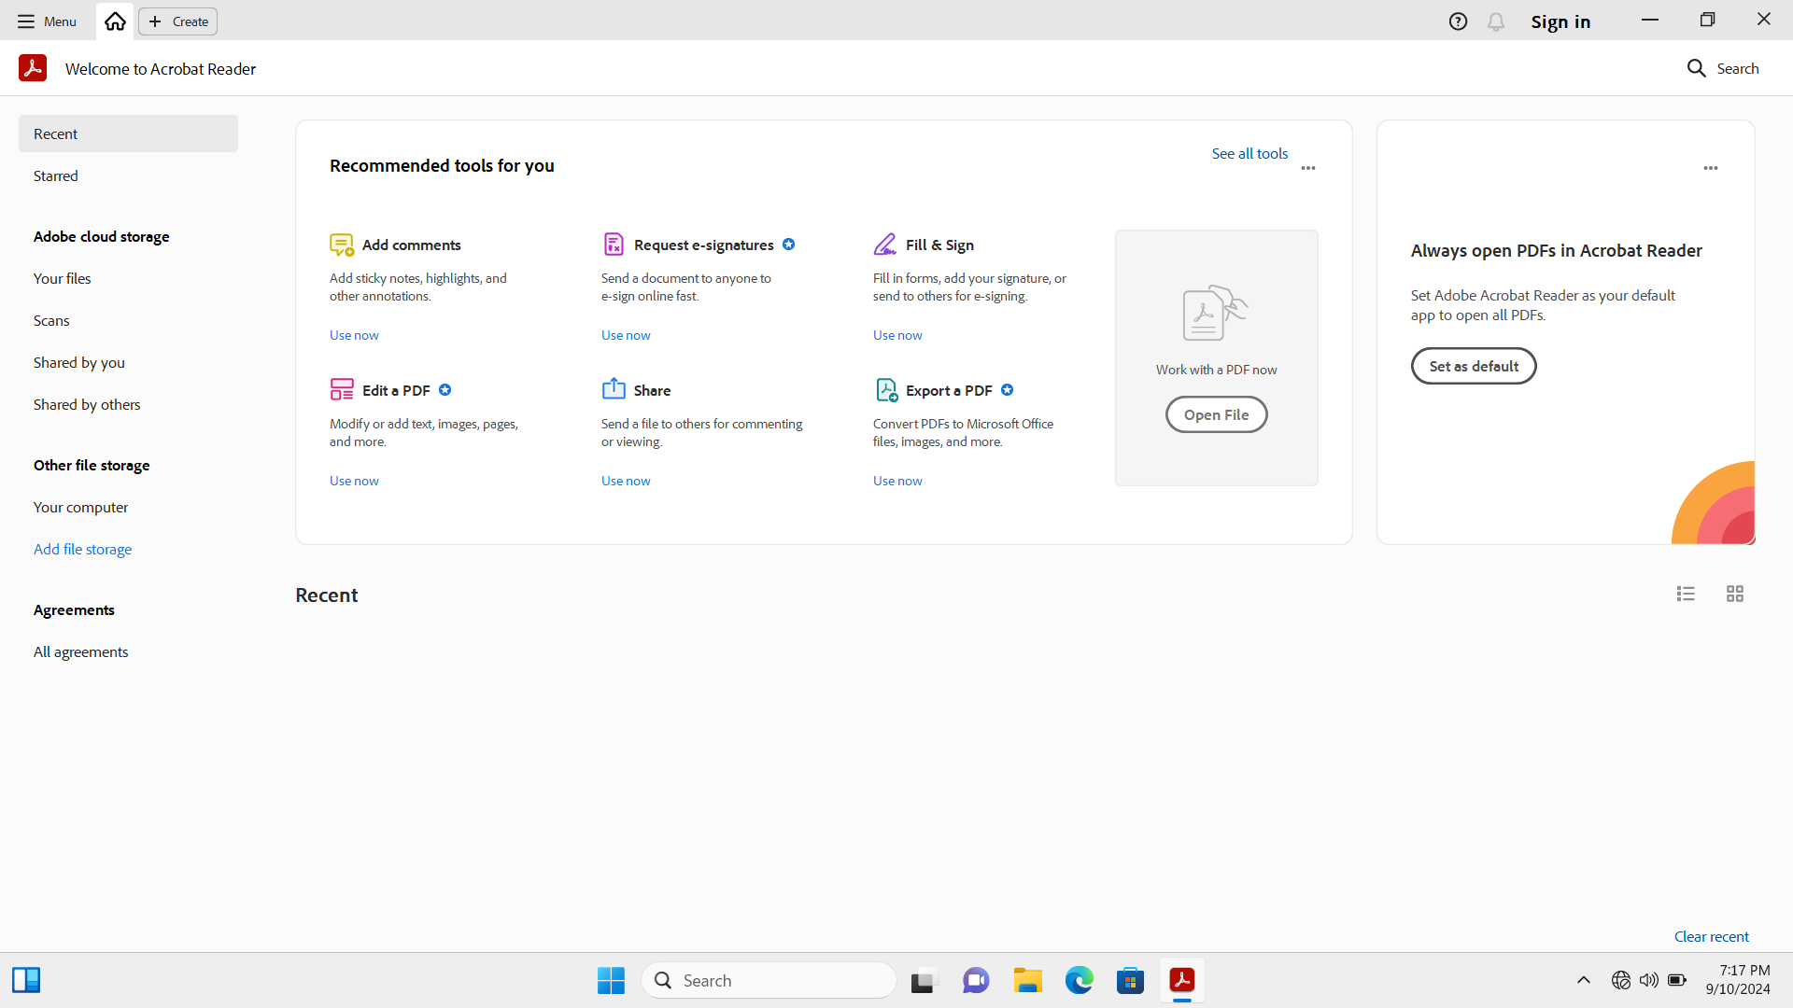

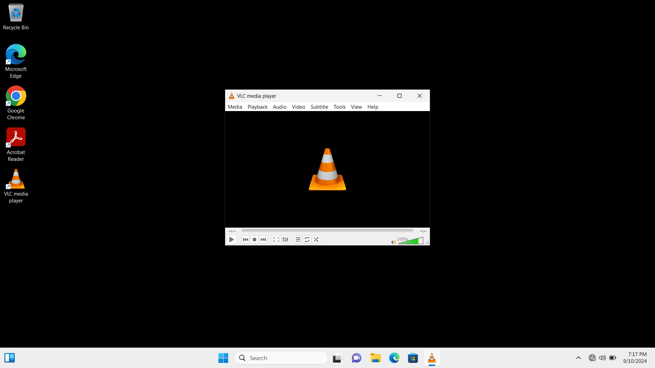

## Task 5: Version Control with GitHub Repository

**1. Create a new repository:**

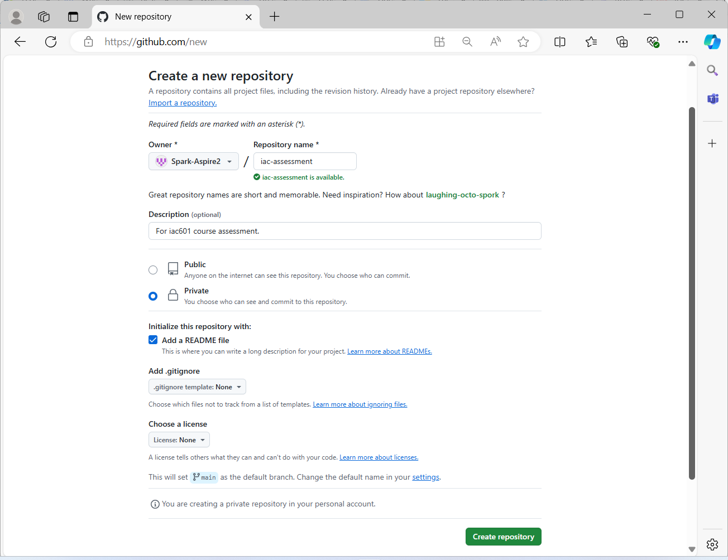

**2. Clone the Github repository to the local machine:**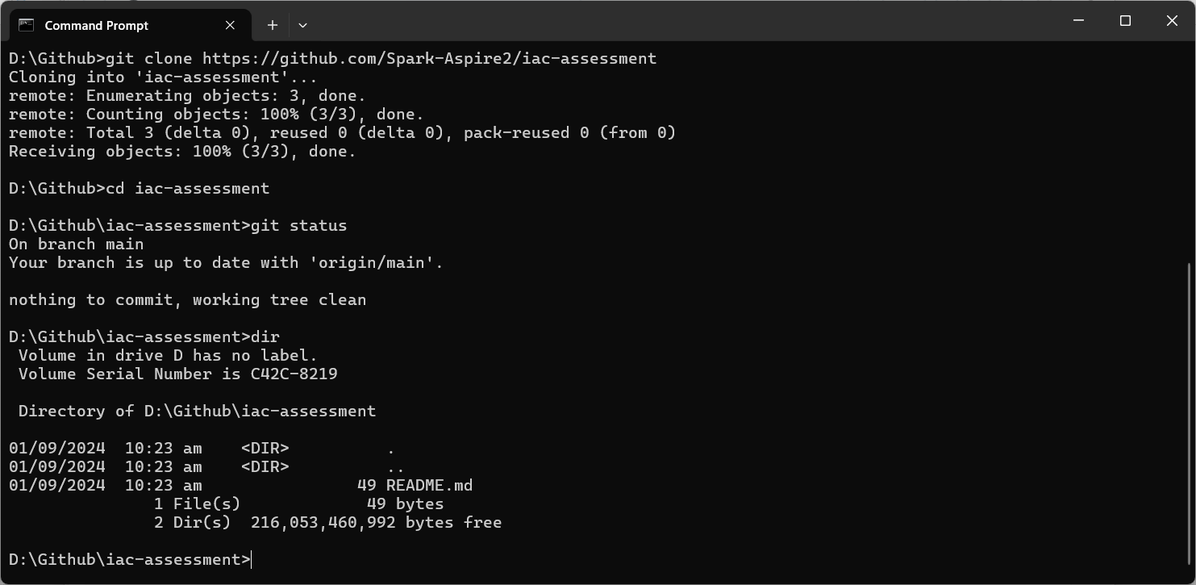

**3. Upload the latest documentation and PowerShell scripts to Github repository:**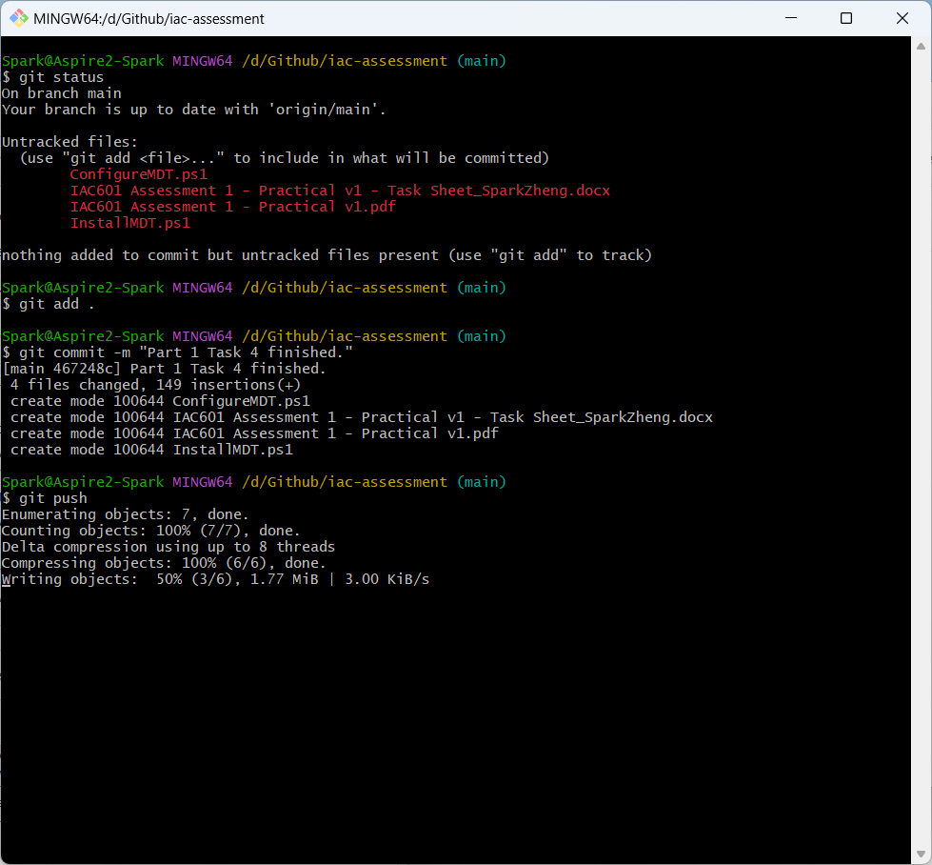

**4. Check results on the website of GitHub:**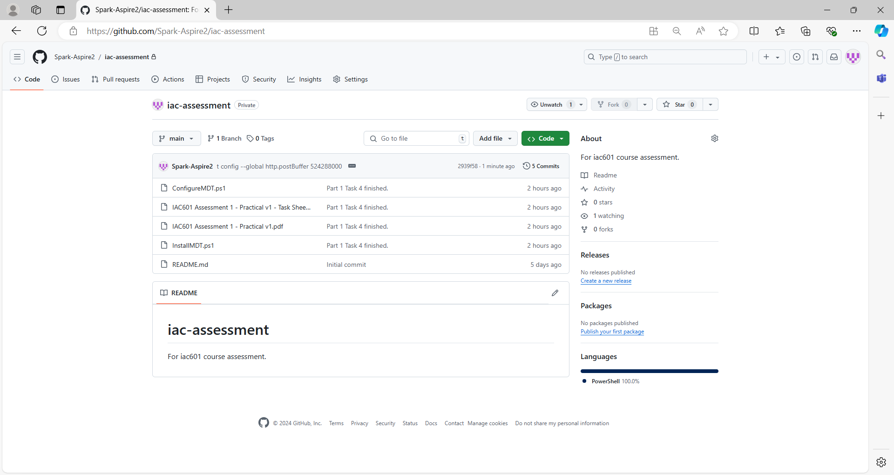

# Part 2

## Task 1: Planning and Design of Cloud Infrastructure

**1. Resource needed by Media Labs to make a pilot test:**

* Azure Virtual Machine (VM):

A Windows Server 2022 VM configured with a public IP for RDP access and associated with a network interface, network security group, and virtual network.

* Azure MySQL Database:

Deployed within the same resource group, using a DNS zone and subnet within the virtual network. Backup retention is configured for 7 days.

**Resource list includes:**

* 1 resource group
* 1 virtual network
* 2 subnets, one for hosting Windows Server 2022, the other for hosting MySQL Server
* 1 public IP address
* 1 network interface card
* 1 dns zone
* 1 network security group to limit RDP access
* 1 virtual machine, for Windows Server 2022
* 1 mysql flexible server

**2. Cloud infrastructure diagram:**

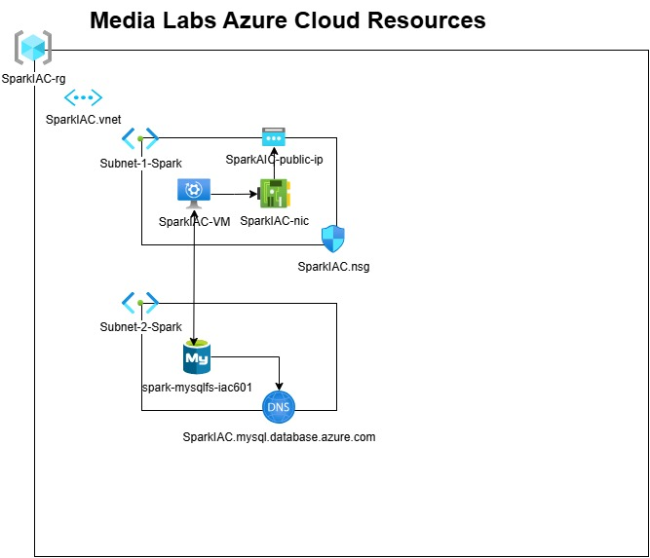

## Task 2: Analysis and Evaluation of Legal and Regulatory Requirements

There are several primary legal and regulatory requirements in New Zealand, including Privacy Act 2020(Privacy Act 2020. 2024), Copyright Act 1994(Copyright Act 1994. 2023), Fair Trading Act 1986(Fair Trading Act 1986. 2024), Health Information Privacy Code 2020(Health Information Privacy Code 2020. 2022), and New Zealand Information Security Manual (New Zealand Information Security Manual. 2024), etc.

To use terraform scripts to deploy Azure Windows Server 2022 and MySQL flexible server automatically involves those legal and regulatory requirements listed above. These requirements ensure that the deployment process is compliance with software licenses, data protection, and security regulations.

1. **Software license compliance.** 
   * + - During the implementation, to ensure all software installed, including Windows Server 2022, MySQL Server, and MySQL workbench, is properly licensed for use by Media Labs under Copyright Act 1994 and Fair Trading Act 1986.
       - For Media Labs, licenses are confirmed before deployment. A record of all software licenses, proof of purchase and download links is maintained and the usage and installation of software on Azure Cloud virtual machines is documented to demonstrate compliance.
2. **Data protection and privacy.** 
   * + - Under Privacy Act 2020 and Health Information Privacy Code 2020, it includes ensuring that no personal data is unlawfully processed during the deployment, and appropriate measures are in place to secure any personal data that may be involved.
       - During deployment, all personal data is minimized, protected, and only used for the necessary purposes, and data is encrypted and is not leaked or improperly accessed. Terraform scripts are configured to anonymize to avoid storing any user-specific data in deployment logs or capturing user data during the deployment process.
3. **Security and compliance standards.** 
   * + - Under New Zealand Information Security Manual, deployment processes should include measures that align with these standards, like secure transmission of data and maintaining system integrity, protecting against cybersecurity with security patches and updates to prevent vulnerabilities, managing firewall rules, ensuring security policies are enforced, and managing system settings to prevent unauthorized changes.
       - During deployment, terraform scripts are configured to use security group/rules to limit the source IP addresses and ports which can access the virtual machine on Azure Cloud. Only RDP protocol and the IP address of my laptop are granted to access the virtual machine of Windows Server 2022 and then to access MySQL Server through it.

## Task 3: Scripts Design and Development

**1. Set Provider**

########### Provider #####################

provider "azurerm" {

  skip_provider_registration = true # This is only required when the User, Service Principal, or Identity running Terraform lacks the permissions to register Azure Resource Providers.

  features {}

}

**2. Create resource group**

########### Resource Group ###############

resource "azurerm_resource_group" "rg_block" {

  name     = var.rg_name

  location = var.location

}

**3. Create Vnet**

########### Virtual Network ###############

resource "azurerm_virtual_network" "vnet_1_block" {

  name                = var.vnet_1_name

  location            = azurerm_resource_group.rg_block.location

  resource_group_name = azurerm_resource_group.rg_block.name

  address_space       = var.vnet_1_cidr

  tags = {

    environment = "test"

  }

}

1. **Create 2 subnets**

########### Virtual Network 1 - Subnet 1 ###########

resource "azurerm_subnet" "subnet_1_block" {

  name                 = "${var.vnet_1_name}-${var.subnet_1_name}"

  resource_group_name  = azurerm_resource_group.rg_block.name

  virtual_network_name = azurerm_virtual_network.vnet_1_block.name

  address_prefixes     = var.subnet_1_cidr

}

resource "azurerm_subnet" "subnet_2_block" {

  name                 = "${var.vnet_1_name}-${var.subnet_2_name}"

  resource_group_name  = azurerm_resource_group.rg_block.name

  virtual_network_name = azurerm_virtual_network.vnet_1_block.name

  address_prefixes     = var.subnet_2_cidr

  service_endpoints    = ["Microsoft.Storage"]

  delegation {

    name = "mysql_fs"

    service_delegation {

      name = "Microsoft.DBforMySQL/flexibleServers"

      actions = [

        "Microsoft.Network/virtualNetworks/subnets/join/action",

      ]

    }

  }

}

**5. Create public IP address**

### Public  IP Address ###############

resource "azurerm_public_ip" "public_ip_1" {

  name                = var.public_ip_1_name

  resource_group_name = azurerm_resource_group.rg_block.name

  location            = azurerm_resource_group.rg_block.location

  allocation_method   = "Dynamic"

}

**6. Create network adapter**

########### Network Interface ###############

resource "azurerm_network_interface" "main_nic_1" {

  name                = var.network_interface_1_name

  location            = azurerm_resource_group.rg_block.location

  resource_group_name = azurerm_resource_group.rg_block.name

  ip_configuration {

    name                          = "nic-ip-configuration"

    subnet_id                     = azurerm_subnet.subnet_1_block.id

    private_ip_address_allocation = "Dynamic"

    public_ip_address_id          = azurerm_public_ip.public_ip_1.id

  }

}

**7. Create security rules**

########### Network Security Group ###############

resource "azurerm_network_security_group" "nsg_1_block" {

  name                = var.security_group_name

  location            = azurerm_resource_group.rg_block.location

  resource_group_name = azurerm_resource_group.rg_block.name

  # Only IP addesses of "118.92.0.0/16" are permit to access the VM.

  security_rule {

    name                       = "RDP"

    priority                   = 1000

    direction                  = "Inbound"

    access                     = "Allow"

    protocol                   = "Tcp"

    source_port_range          = "*"

    destination_port_range     = "3389"

    source_address_prefix      = "118.92.0.0/16"

    destination_address_prefix = "*"

  }

  tags = {

    environment = "test"

  }

}

resource "azurerm_network_interface_security_group_association" "nic_nsg_association" {

  network_interface_id      = azurerm_network_interface.main_nic_1.id

  network_security_group_id = azurerm_network_security_group.nsg_1_block.id

}

**8. Create DNS for MySQL database**

### Private DNS Zone ###############

resource "azurerm_private_dns_zone" "mysql_dns" {

  name                = var.mysql_dns_name

  resource_group_name = azurerm_resource_group.rg_block.name

}

### Private DNS Zone Linked with VNET ###############

resource "azurerm_private_dns_zone_virtual_network_link" "dns_network_link" {

  name                  = var.dns_network_link_name

  private_dns_zone_name = azurerm_private_dns_zone.mysql_dns.name

  virtual_network_id    = azurerm_virtual_network.vnet_1_block.id

  resource_group_name   = azurerm_resource_group.rg_block.name

}

**9. Create MySQL flexible server**

### Azure MySQL Database ###############

resource "azurerm_mysql_flexible_server" "media_labs_mysql" {

  name                   = var.mysql_server_name

  location               = azurerm_resource_group.rg_block.location

  resource_group_name    = azurerm_resource_group.rg_block.name

  administrator_login    = var.mysql_root

  administrator_password = var.mysql_password

  backup_retention_days  = 7

  delegated_subnet_id    = azurerm_subnet.subnet_2_block.id

  private_dns_zone_id    = azurerm_private_dns_zone.mysql_dns.id

  sku_name   = "GP_Standard_D2ds_v4"

  depends_on = [azurerm_private_dns_zone_virtual_network_link.dns_network_link]

}

**10. Create a virtual machine of Windows Server 2022**

########### Virtual Machine Windows Server 2019 ###############

resource "azurerm_windows_virtual_machine" "vm_1_block" {

  name                  = var.virtual_machine_1_name

  location              = azurerm_resource_group.rg_block.location

  resource_group_name   = azurerm_resource_group.rg_block.name

  network_interface_ids = [azurerm_network_interface.main_nic_1.id]

  size                  = "Standard_B1s"

  admin_username = var.admin_username

  admin_password = var.admin_password

  computer_name  = var.virtual_machine_1_name

  timezone       = var.time_zone

  os_disk {

    caching              = "ReadWrite"

    storage_account_type = "Standard_LRS"

  }

  source_image_reference {

    publisher = "MicrosoftWindowsServer"

    offer     = "WindowsServer"

    sku       = "2022-datacenter-azure-edition"

    version   = "latest"

  }

}

**11. Declaration of varibables**

### Variables Declaration ###############

variable "rg_name" {

  description = "resource group name"

  default     = "SparkIAC-rg"

}

variable "location" {

  description = "location of resource group"

  default     = "Australia East"

}

variable "vnet_1_name" {

  description = "name of network"

  default     = "SparkIAC.vnet"

}

variable "vnet_1_cidr" {

  description = "Network range"

  default     = ["10.10.0.0/16"]

}

variable "subnet_1_name" {

  description = "name of sub-network"

  default     = "Subnet-1-Spark"

}

variable "subnet_1_cidr" {

  description = "subnet range"

  default     = ["10.10.0.0/24"]

}

variable "subnet_2_name" {

  description = "name of sub-network"

  default     = "Subnet-2-Spark"

}

variable "subnet_2_cidr" {

  description = "subnet range"

  default     = ["10.10.1.0/24"]

}

variable "admin_username" {

  default = "spark"

}

variable "admin_password" {

}

variable "public_ip_1_name" {

  default = "SparkIAC-public-ip"

}

variable "network_interface_1_name" {

  default = "SparkIAC-nic"

}

variable "security_group_name" {

  default = "SparkIAC-nsg"

}

variable "virtual_machine_1_name" {

  default = "SparkIAC-vm"

}

variable "time_zone" {

  default = "New Zealand Standard Time"

}

variable "mysql_root" {

  default = "spark"

}

variable "mysql_password" {

}

variable "mysql_dns_name" {

  default = "SparkIAC.mysql.database.azure.com"

}

variable "dns_network_link_name" {

  default = "dns-network-link"

}

variable "mysql_server_name" {

  default = "Spark-mysqlfs-iac601"

}

**12. Assign values to variables**

### Default values asigned to variables ###############

rg_name                  = "SparkIAC-rg"

location                 = "Australia East"

vnet_1_name              = "SparkIAC.vnet"

subnet_1_name            = "Subnet-1-Spark"

subnet_2_name            = "Subnet-2-Spark"

public_ip_1_name         = "SparkIAC-public-ip"

network_interface_1_name = "SparkIAC-nic"

virtual_machine_1_name   = "SparkIAC-vm"

admin_username           = "spark"

admin_password           = "TestP@ssword01"

time_zone                = "New Zealand Standard Time"

mysql_server_name        = "spark-mysqlfs-iac601"

mysql_root               = "spark"

mysql_password           = "TestP@ssword01"

mysql_dns_name           = "SparkIAC.mysql.database.azure.com"

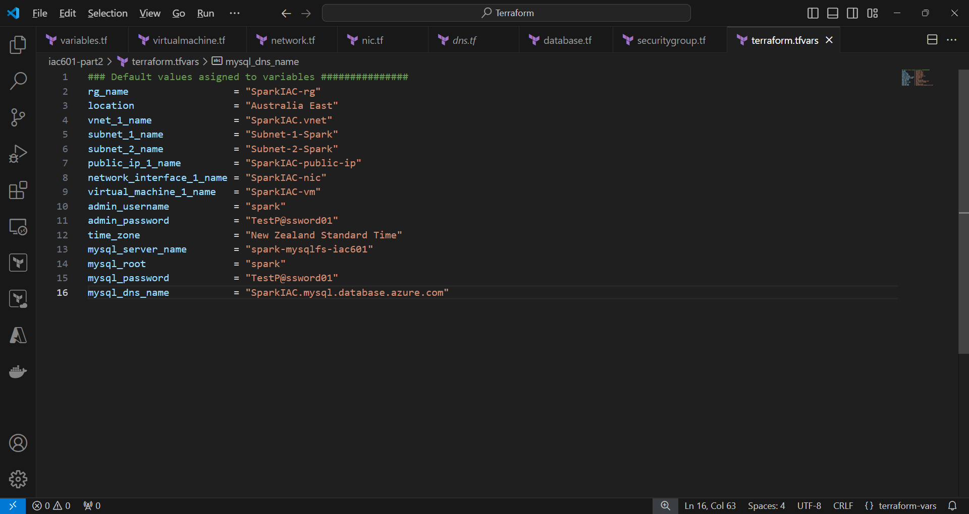

**13. Check Terraform script on the GitHub website**

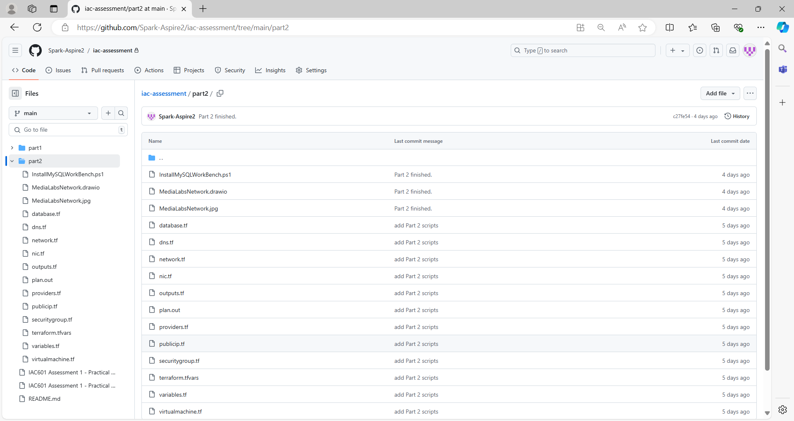

## Task 4: Deployment Services to the Azure Platform and Testing

**1. Az login**

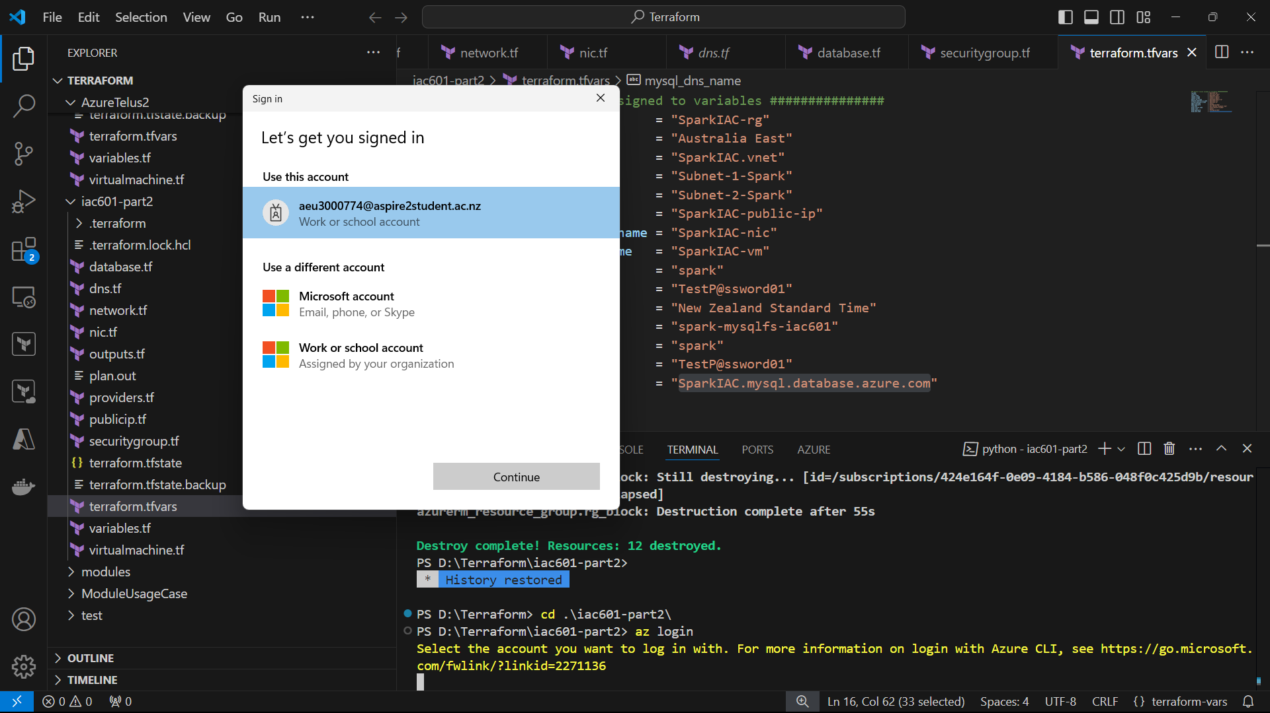

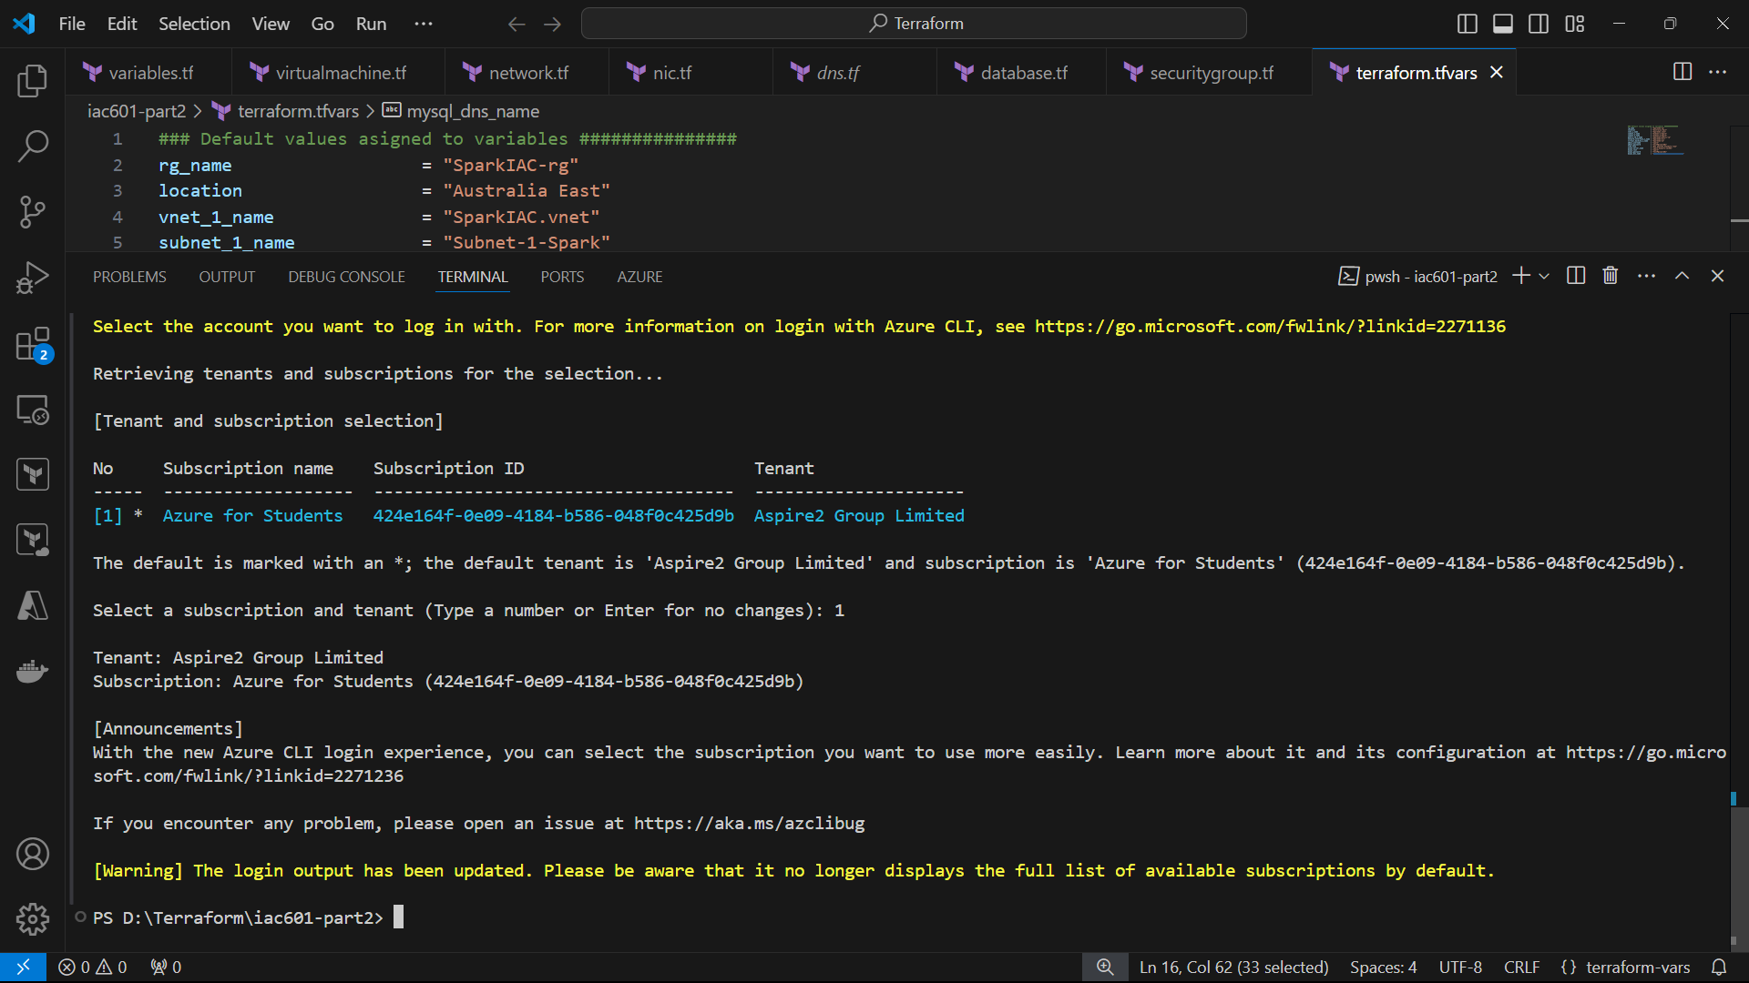

**2. Terraform init.**

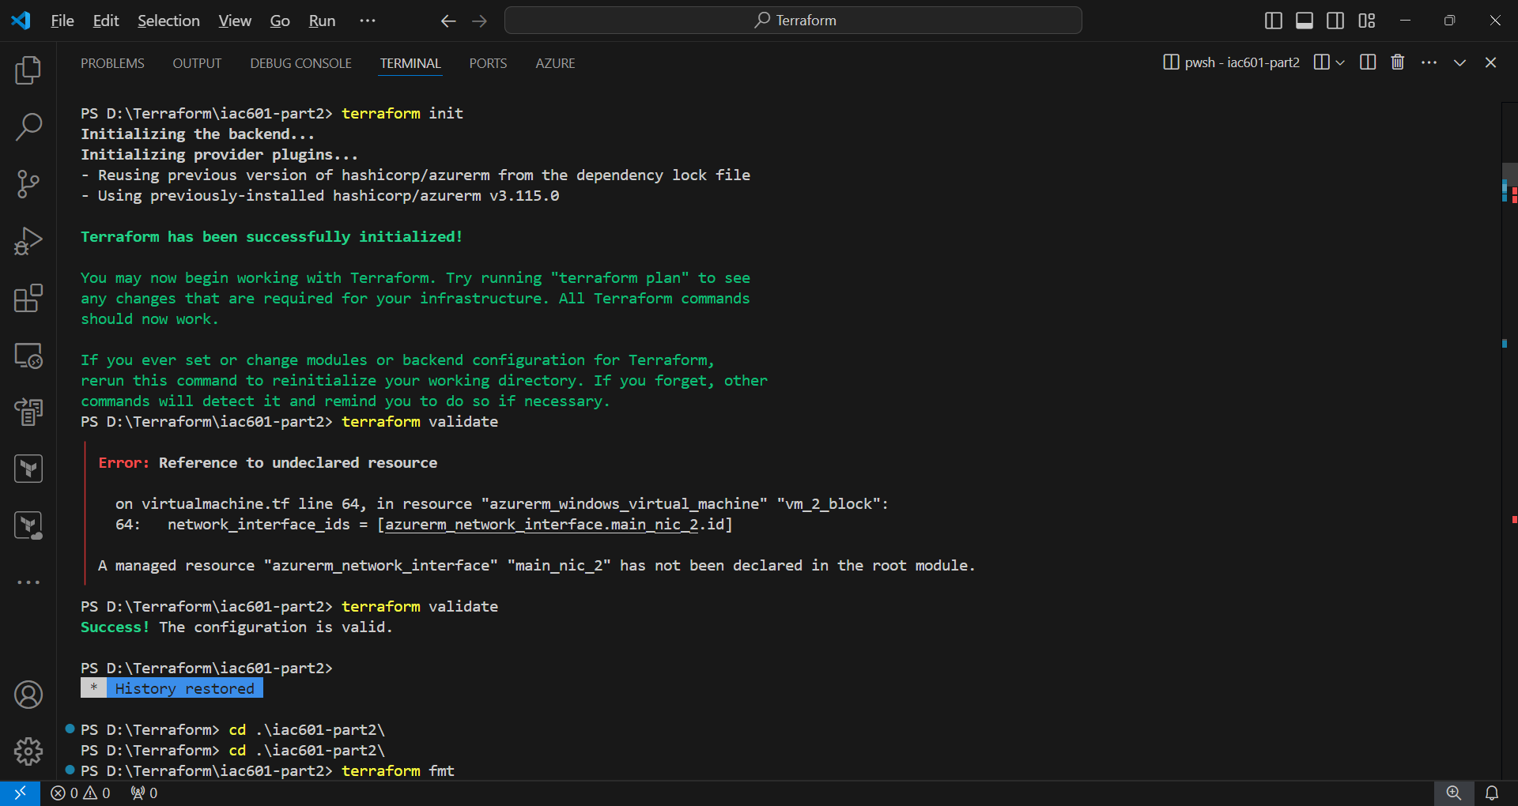

**3. Terraform validation**

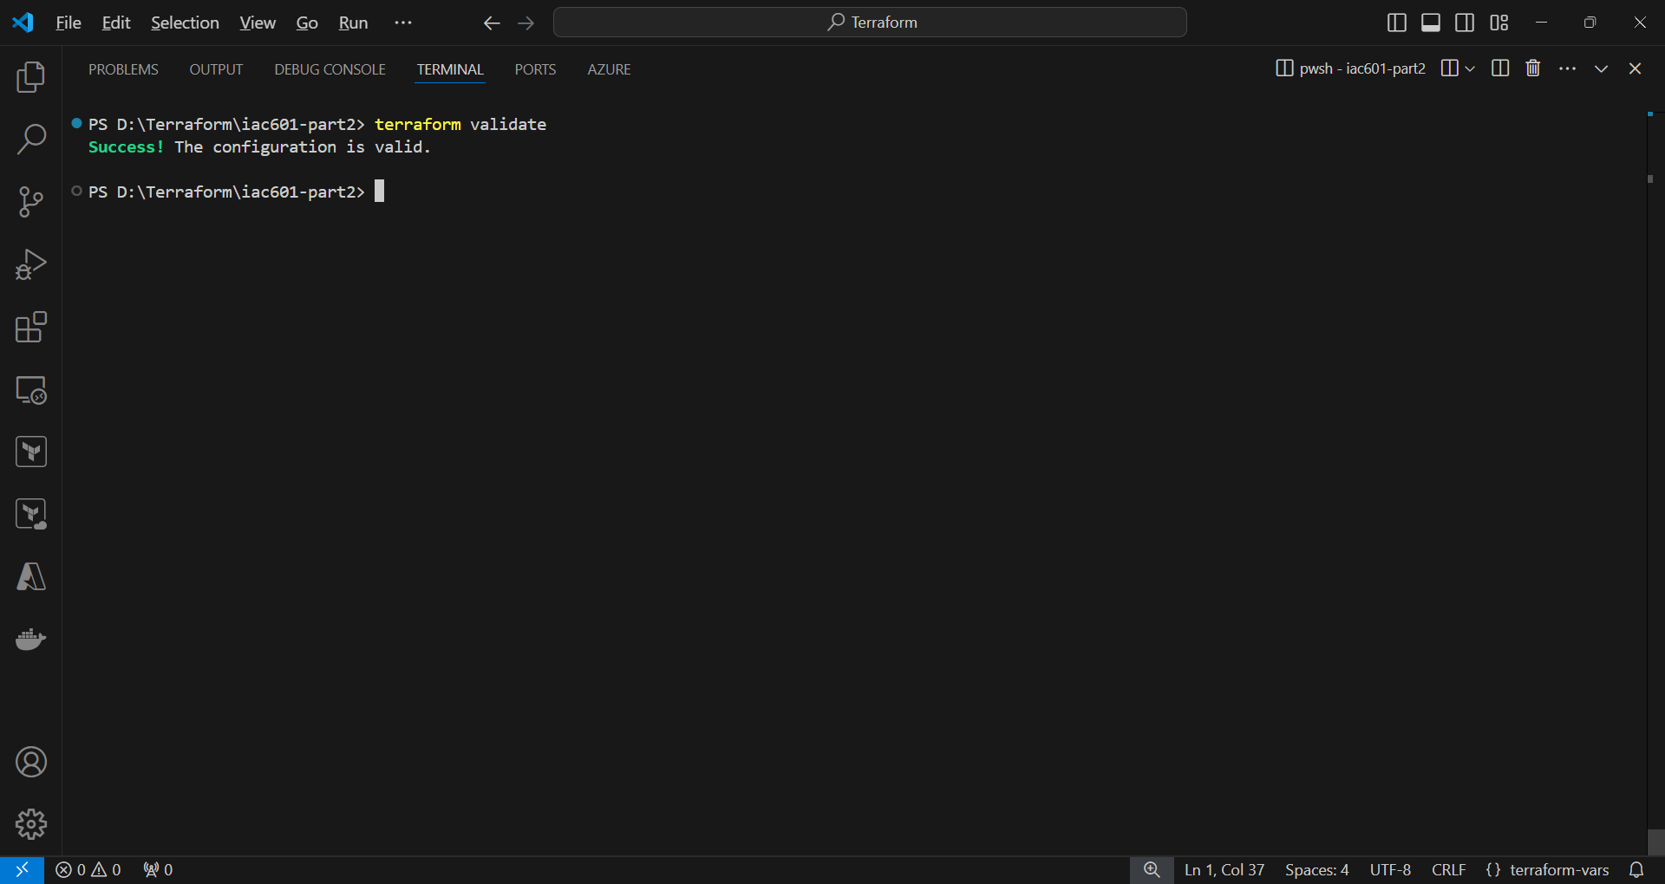

**4. Terraform plan**

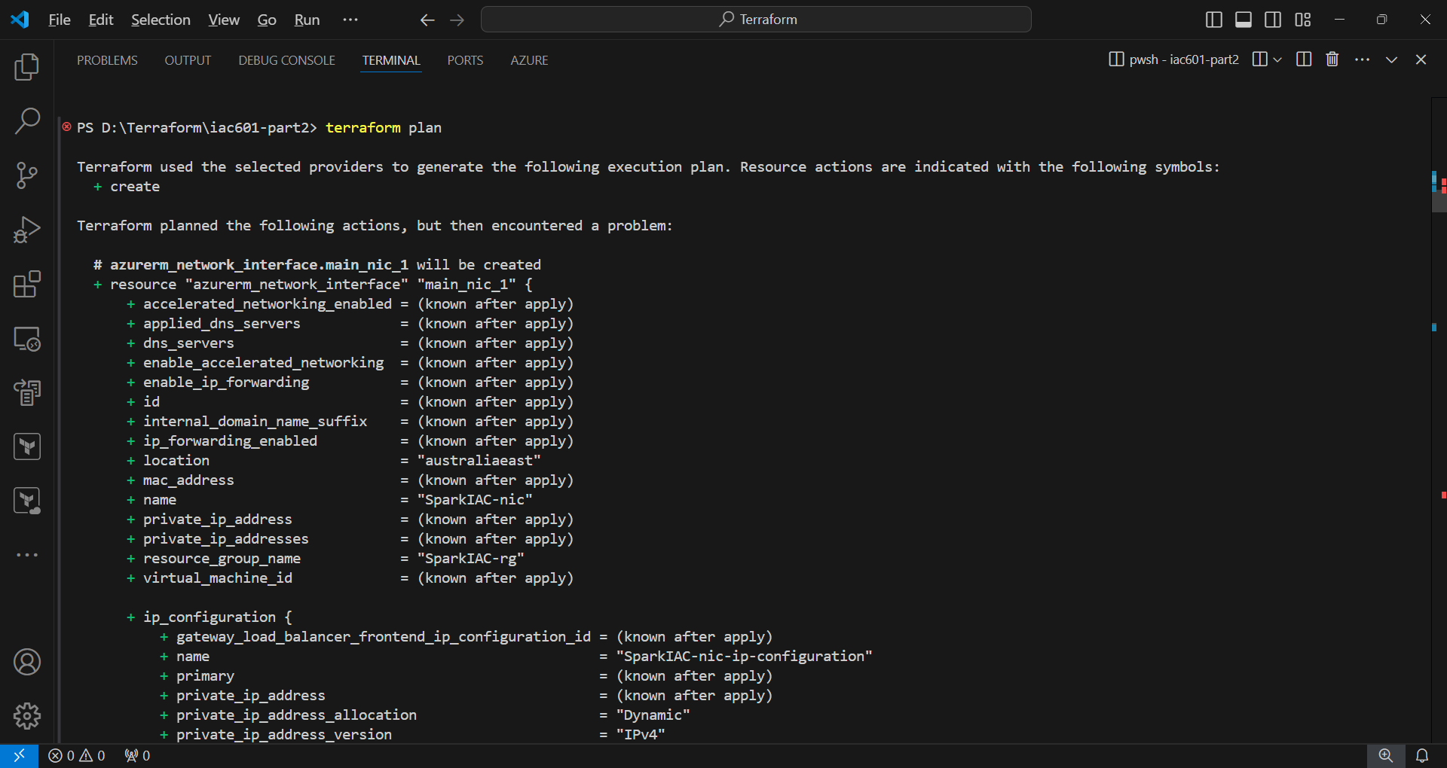

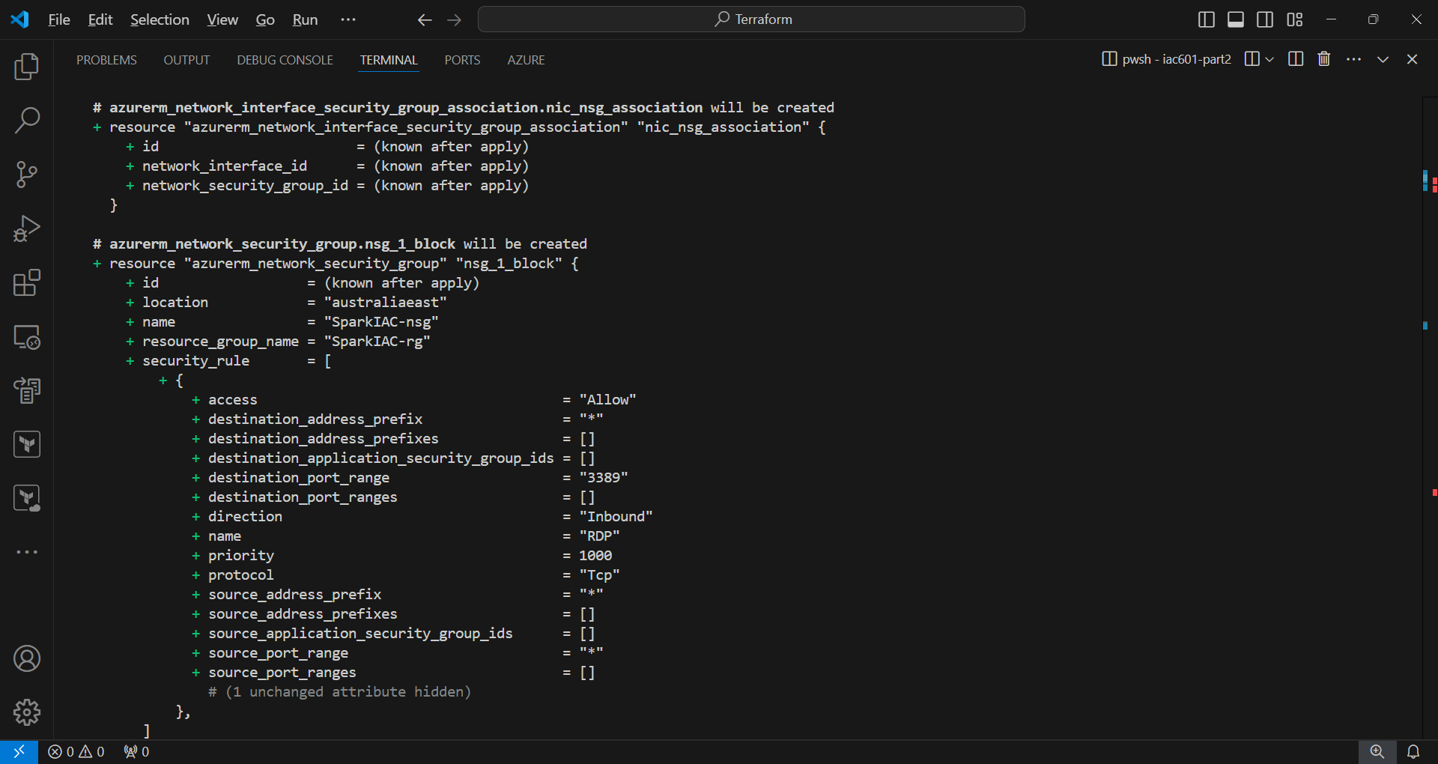

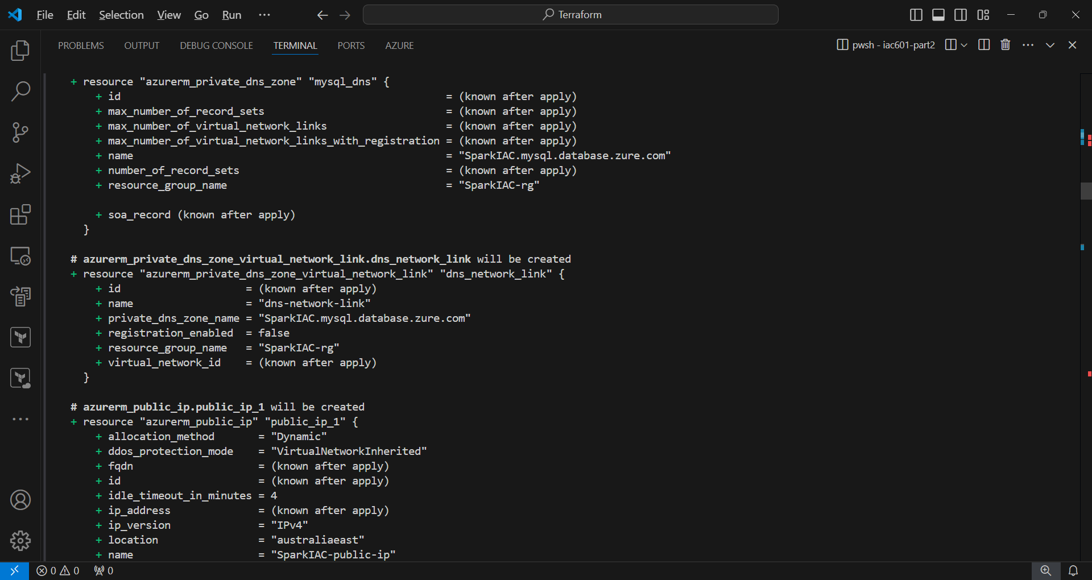

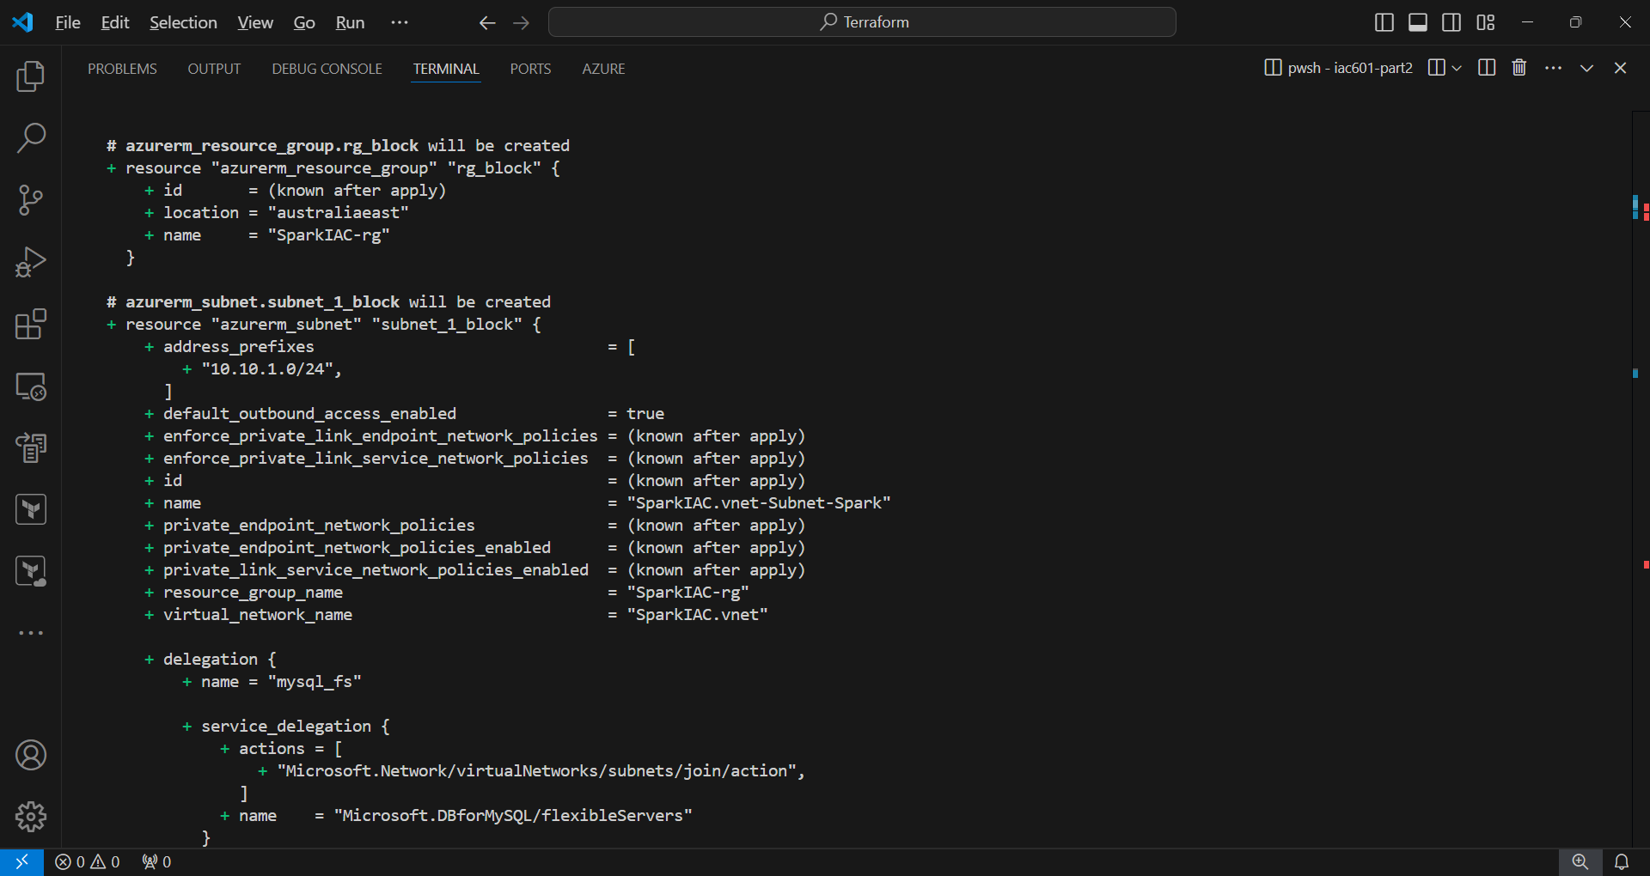

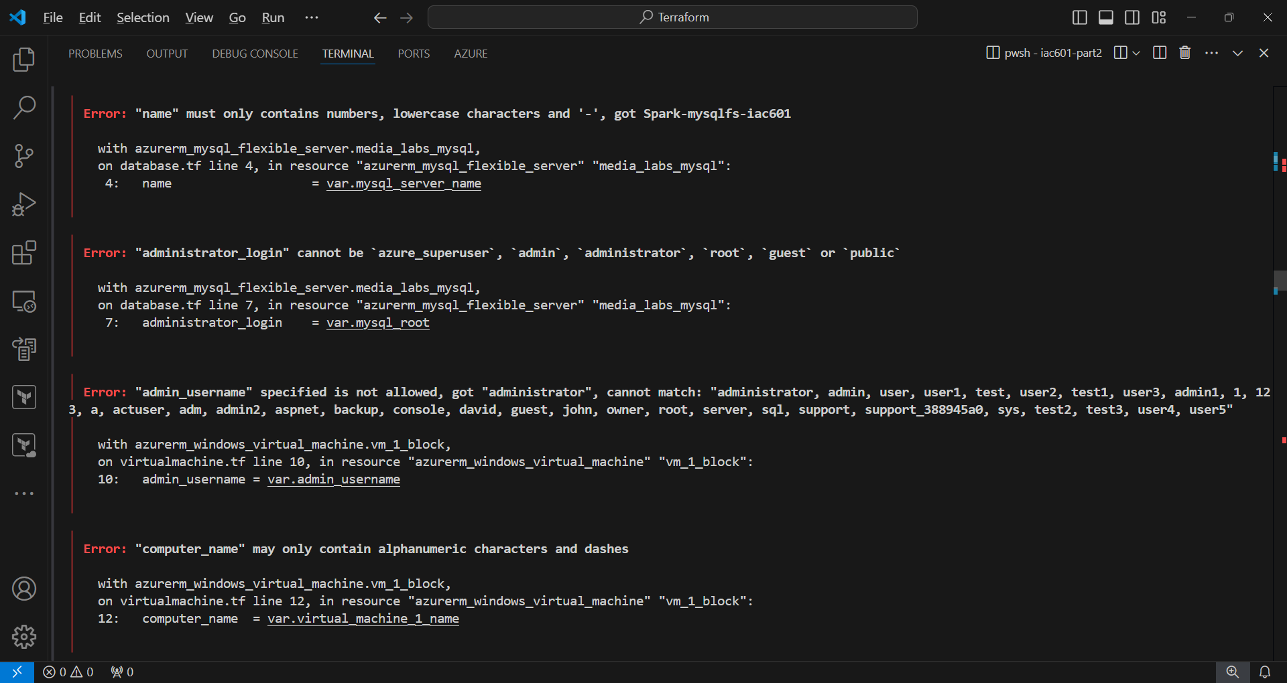

There are several errors during terraform plan.

* Virtual machine name cannot be set to “SparkIAC.vm”, so it is modified to “SparkIAC-vm”.
* For MySQL server name, only lowercase char could be used, so it is assigned with “spark-mysqlfs-iac601”

After modification, the script passed the terraform plan finally.

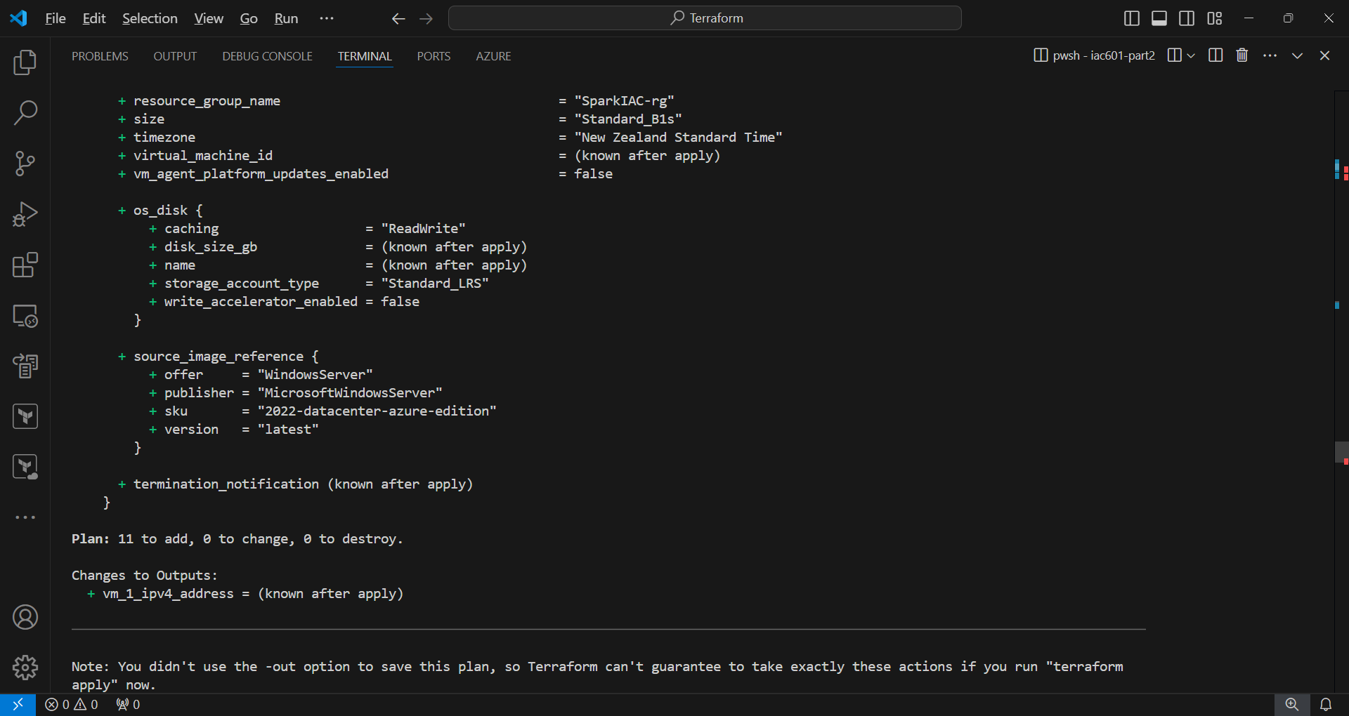

**5. Terraform apply**

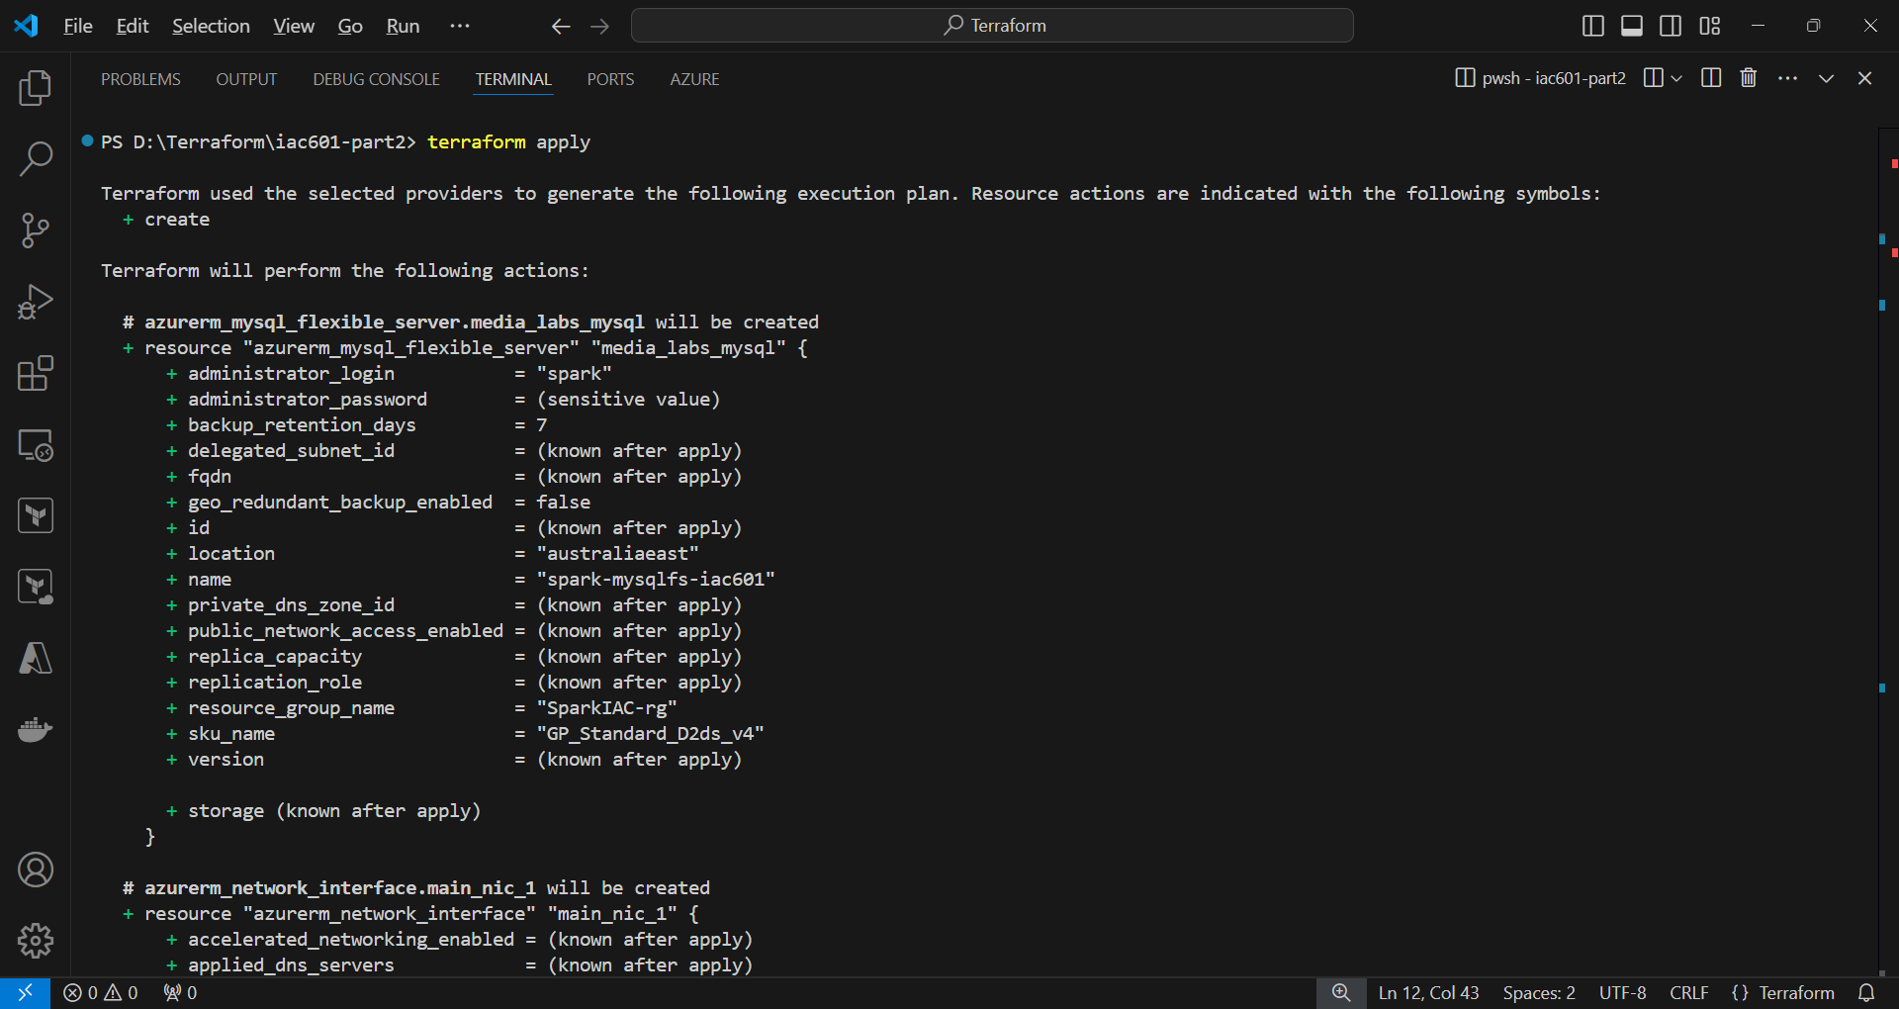

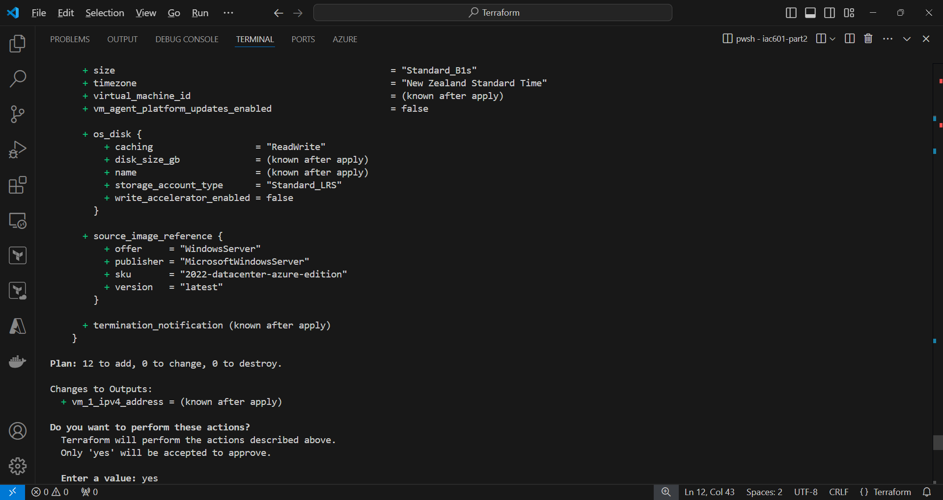

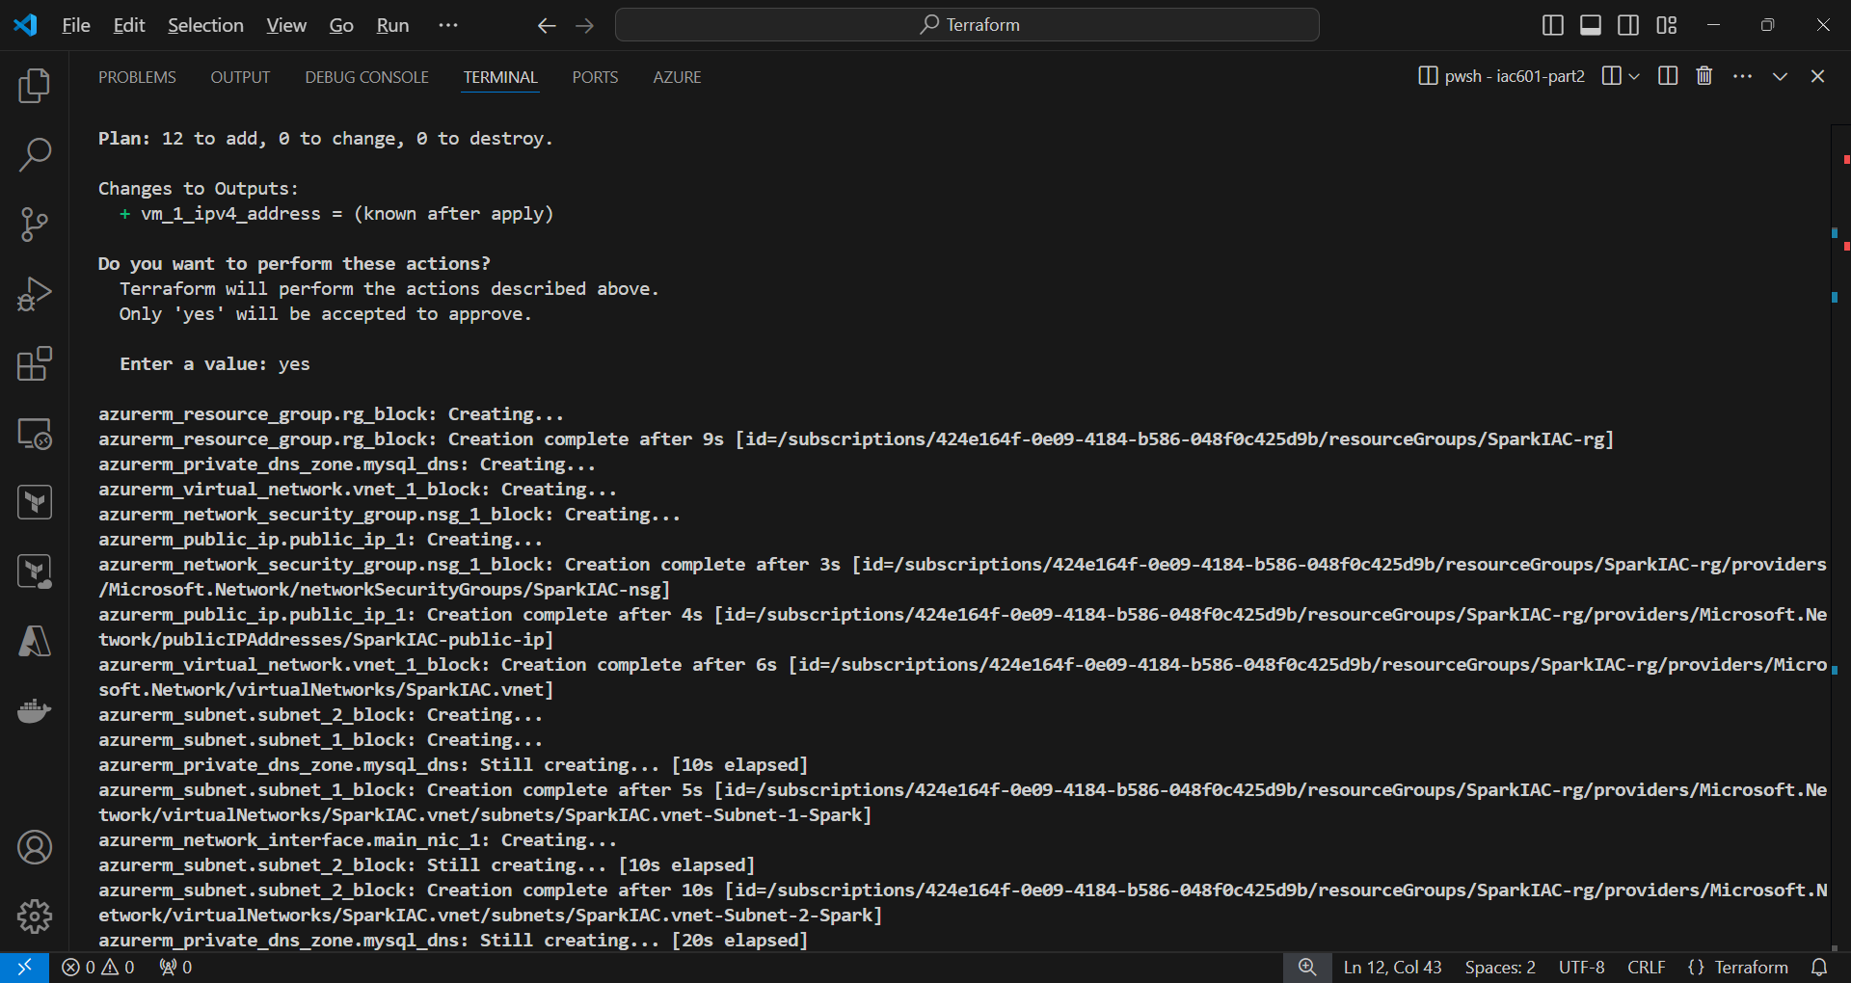

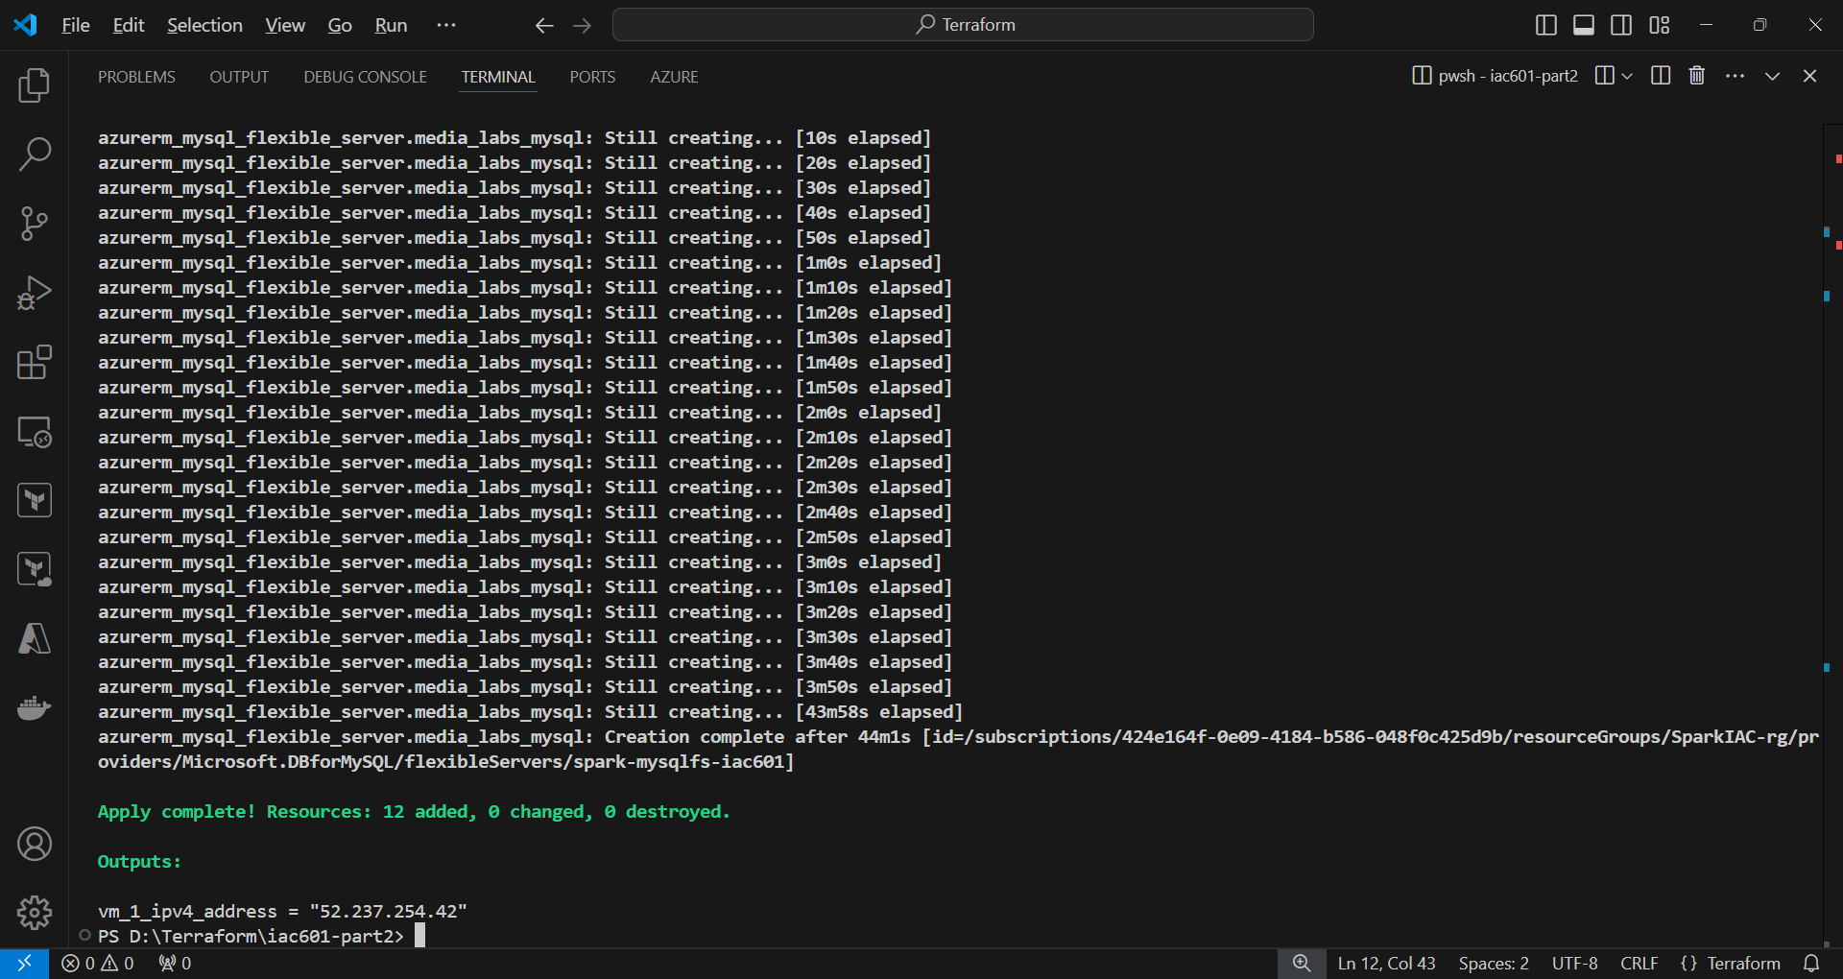

**6. Check results on the Azure portal site**

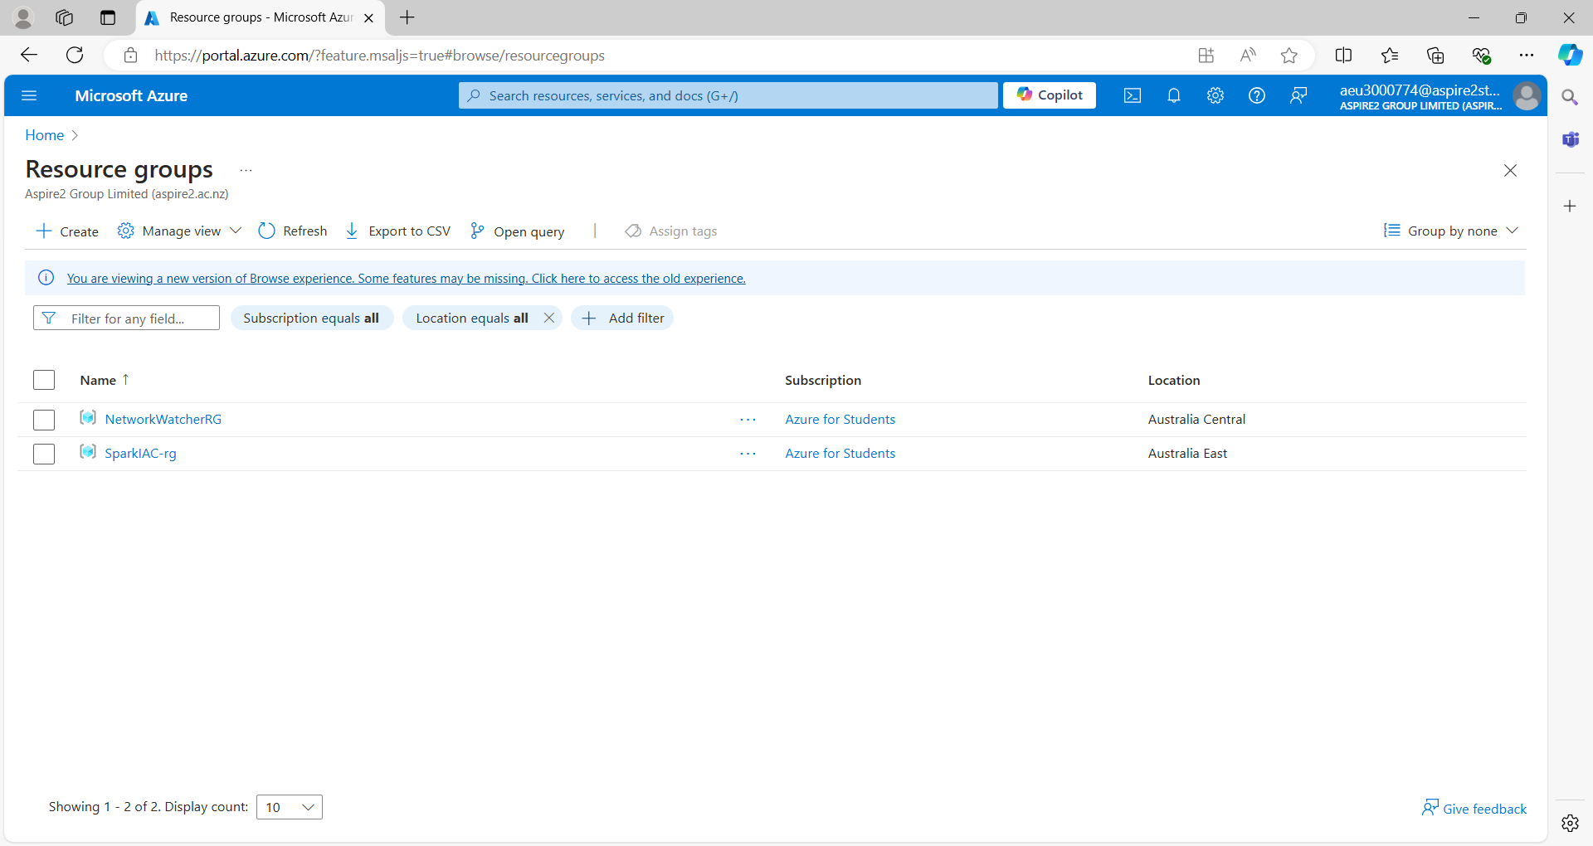

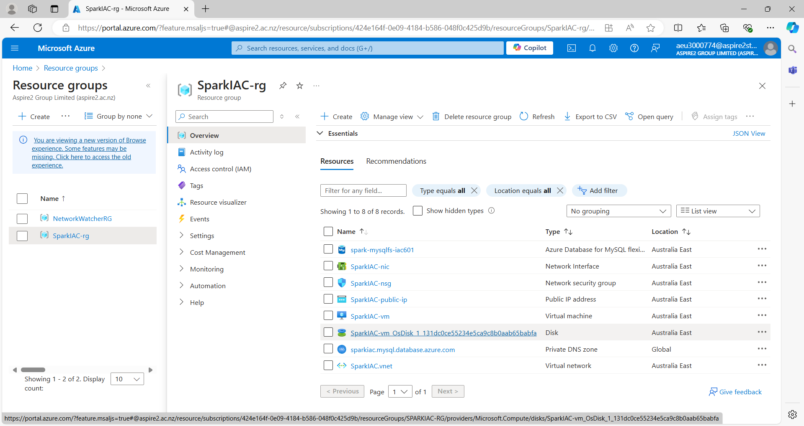

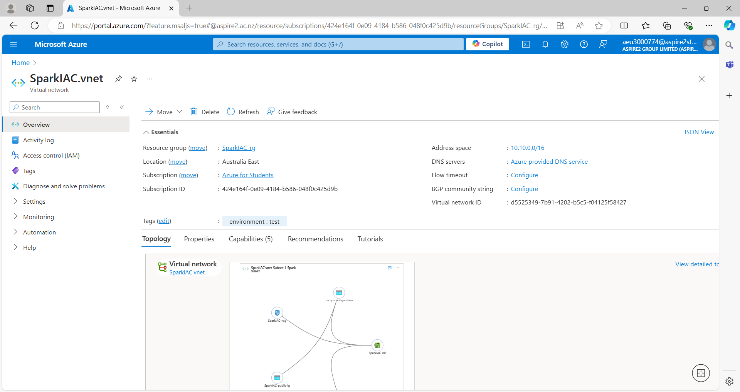

**7. Connect to the virtual machine of Windows Server 2022**

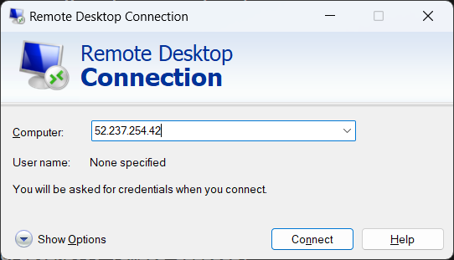

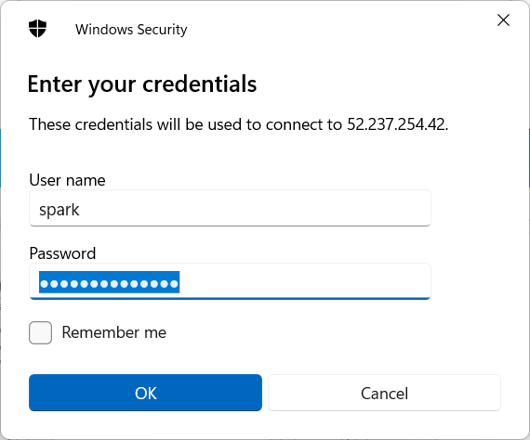

**8. Launch MySQL Workbench**

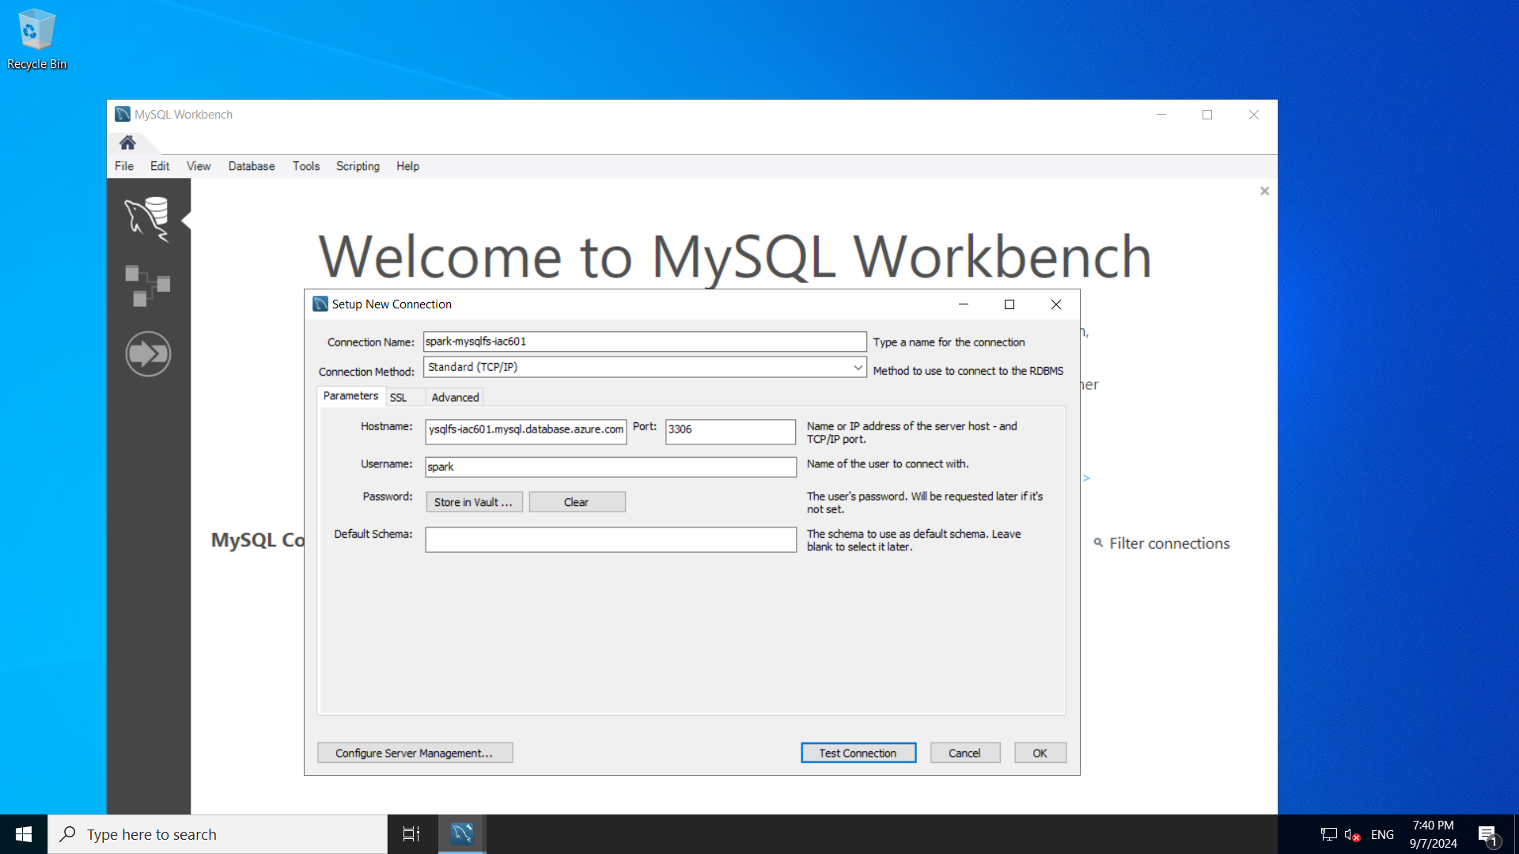

^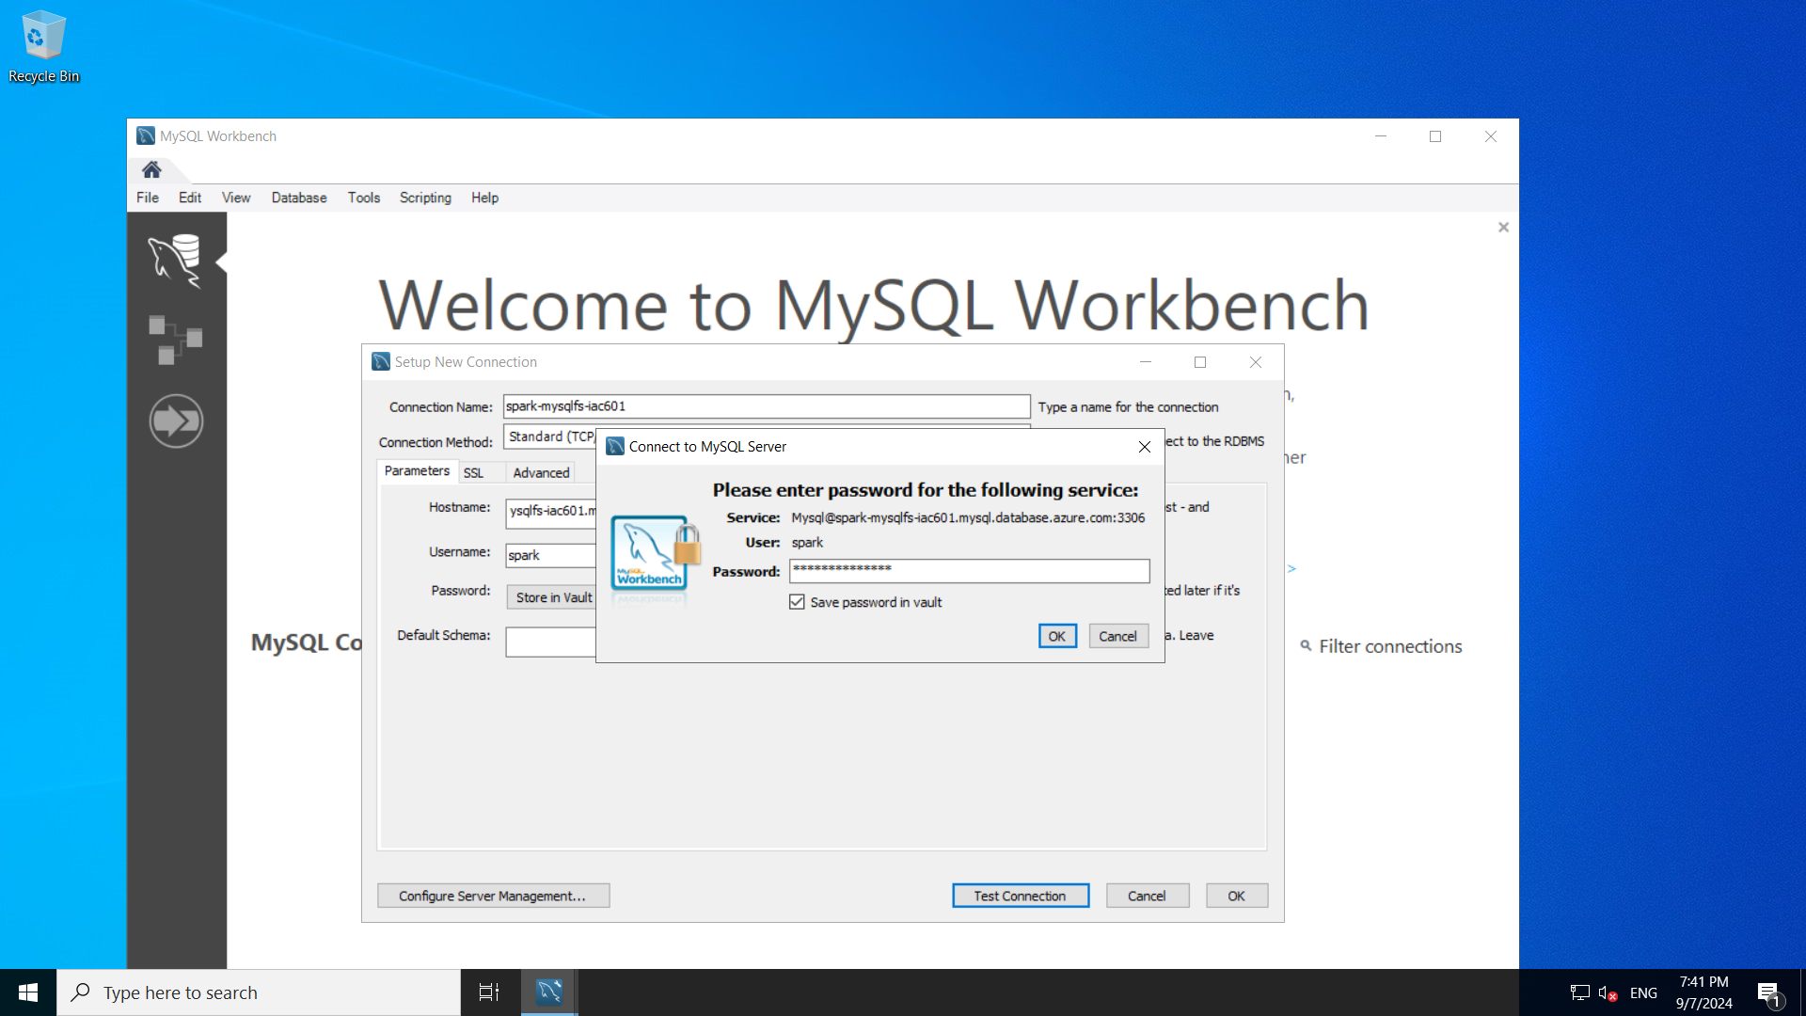

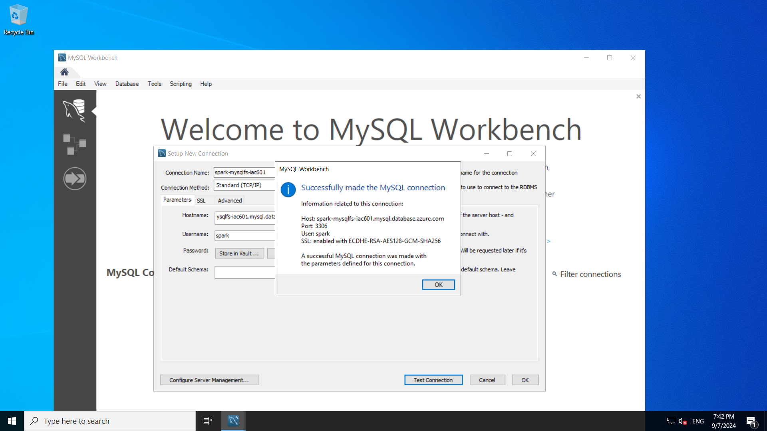

**9. Connect to MySQL Server**

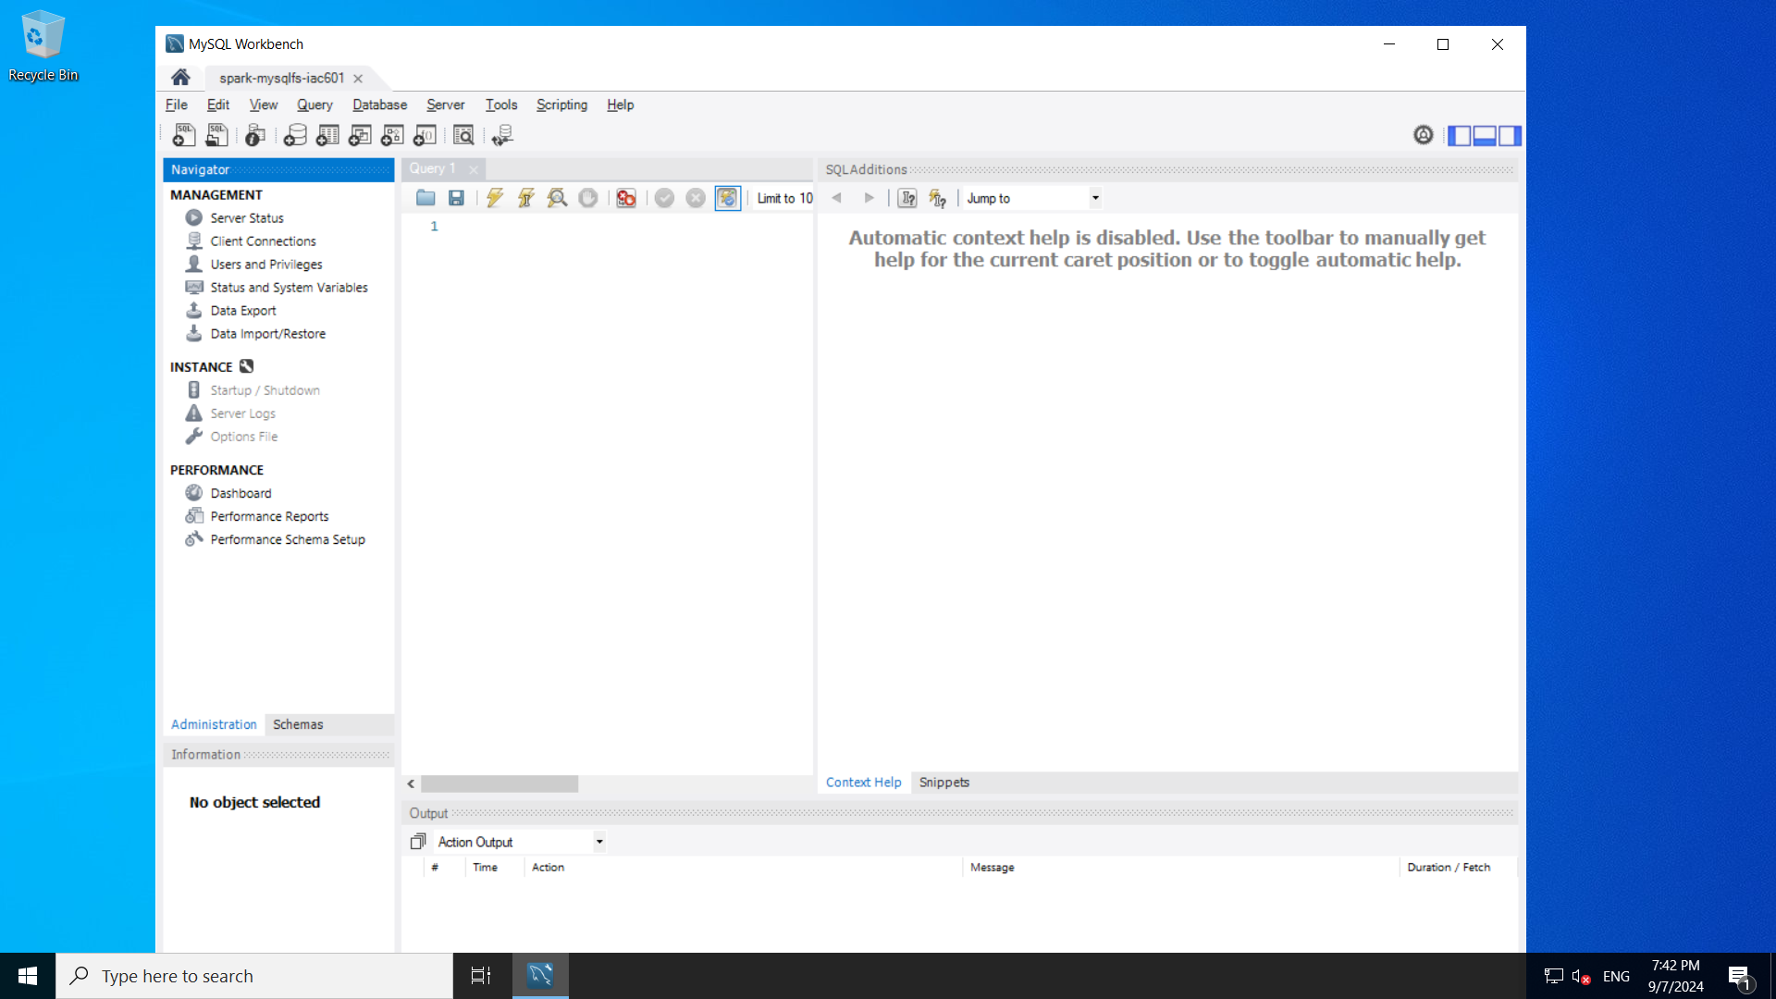

**10. Create a database name MediaLabs.**

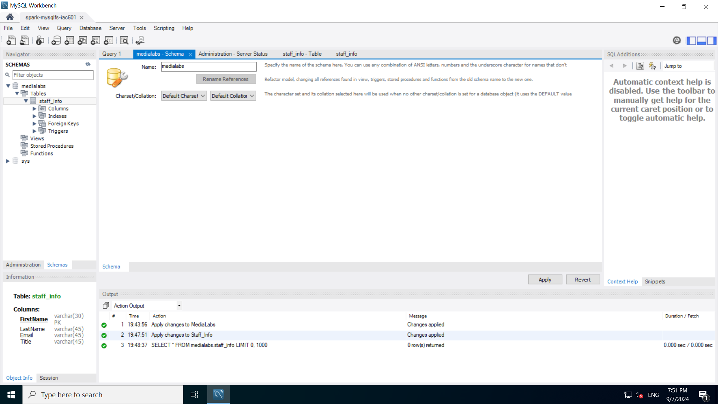

**11. Create a table named Staff_Info**

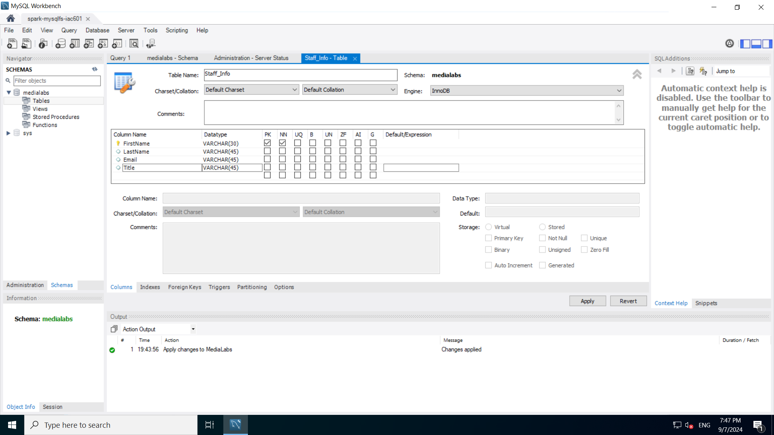



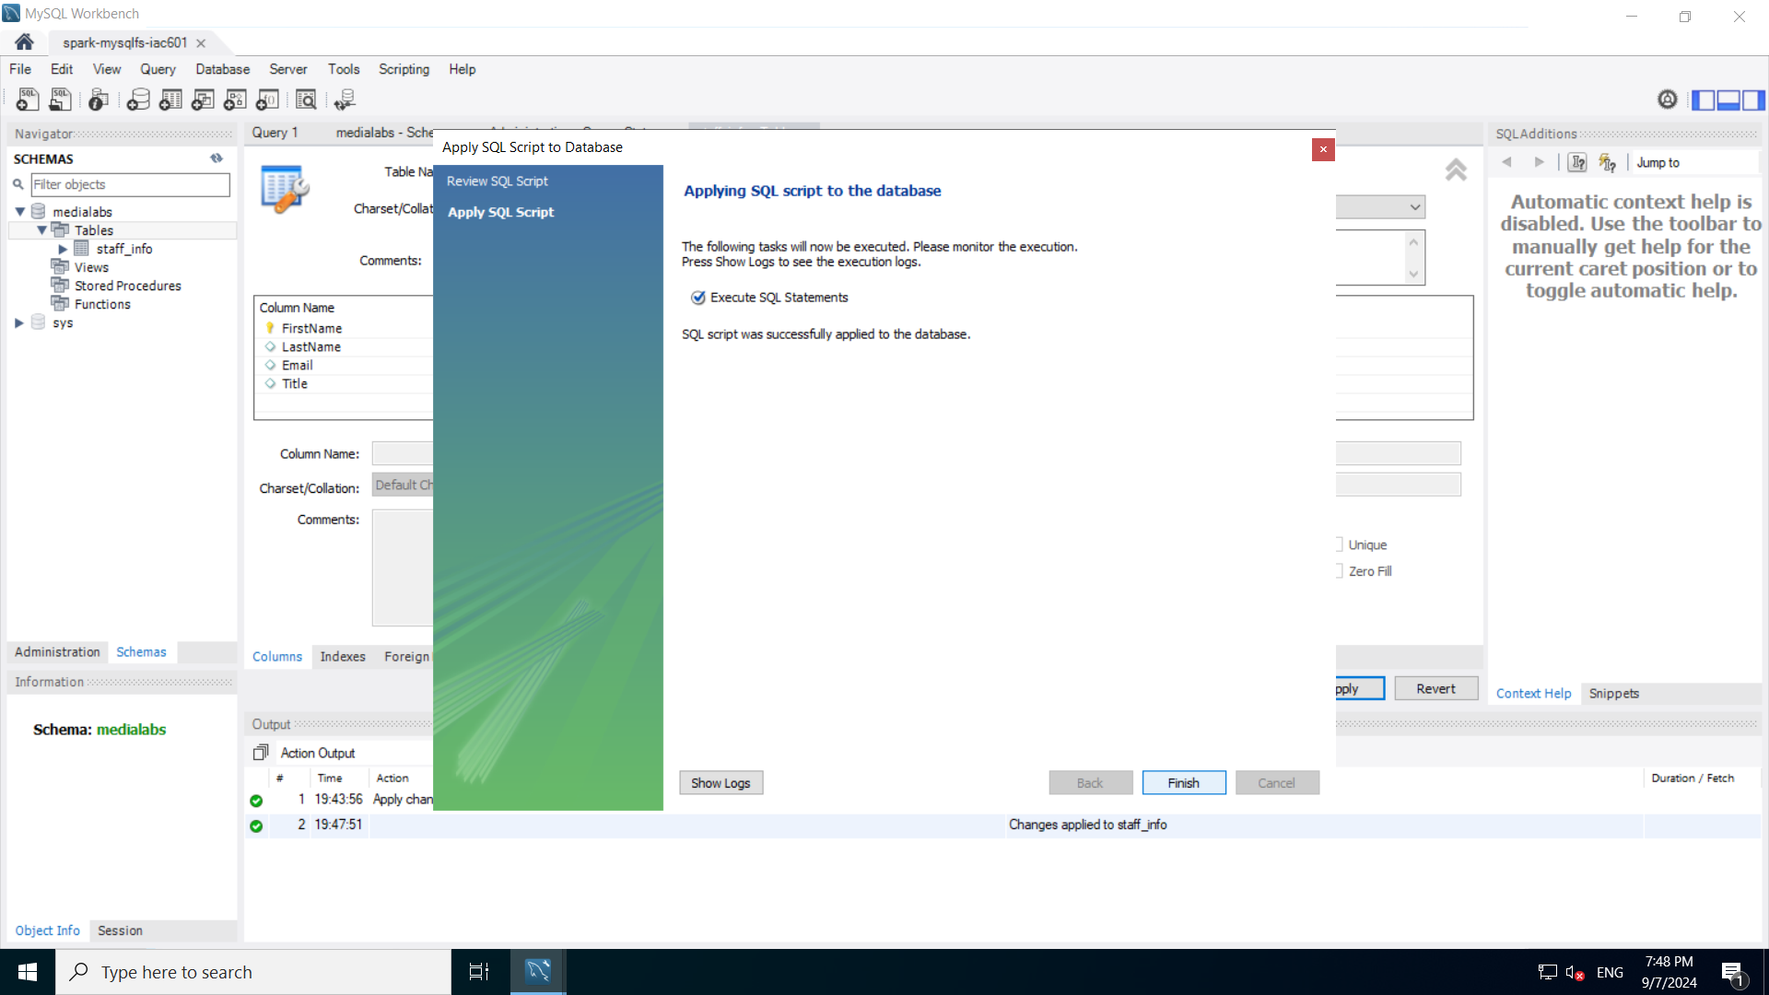

**12. Add records into the table.**

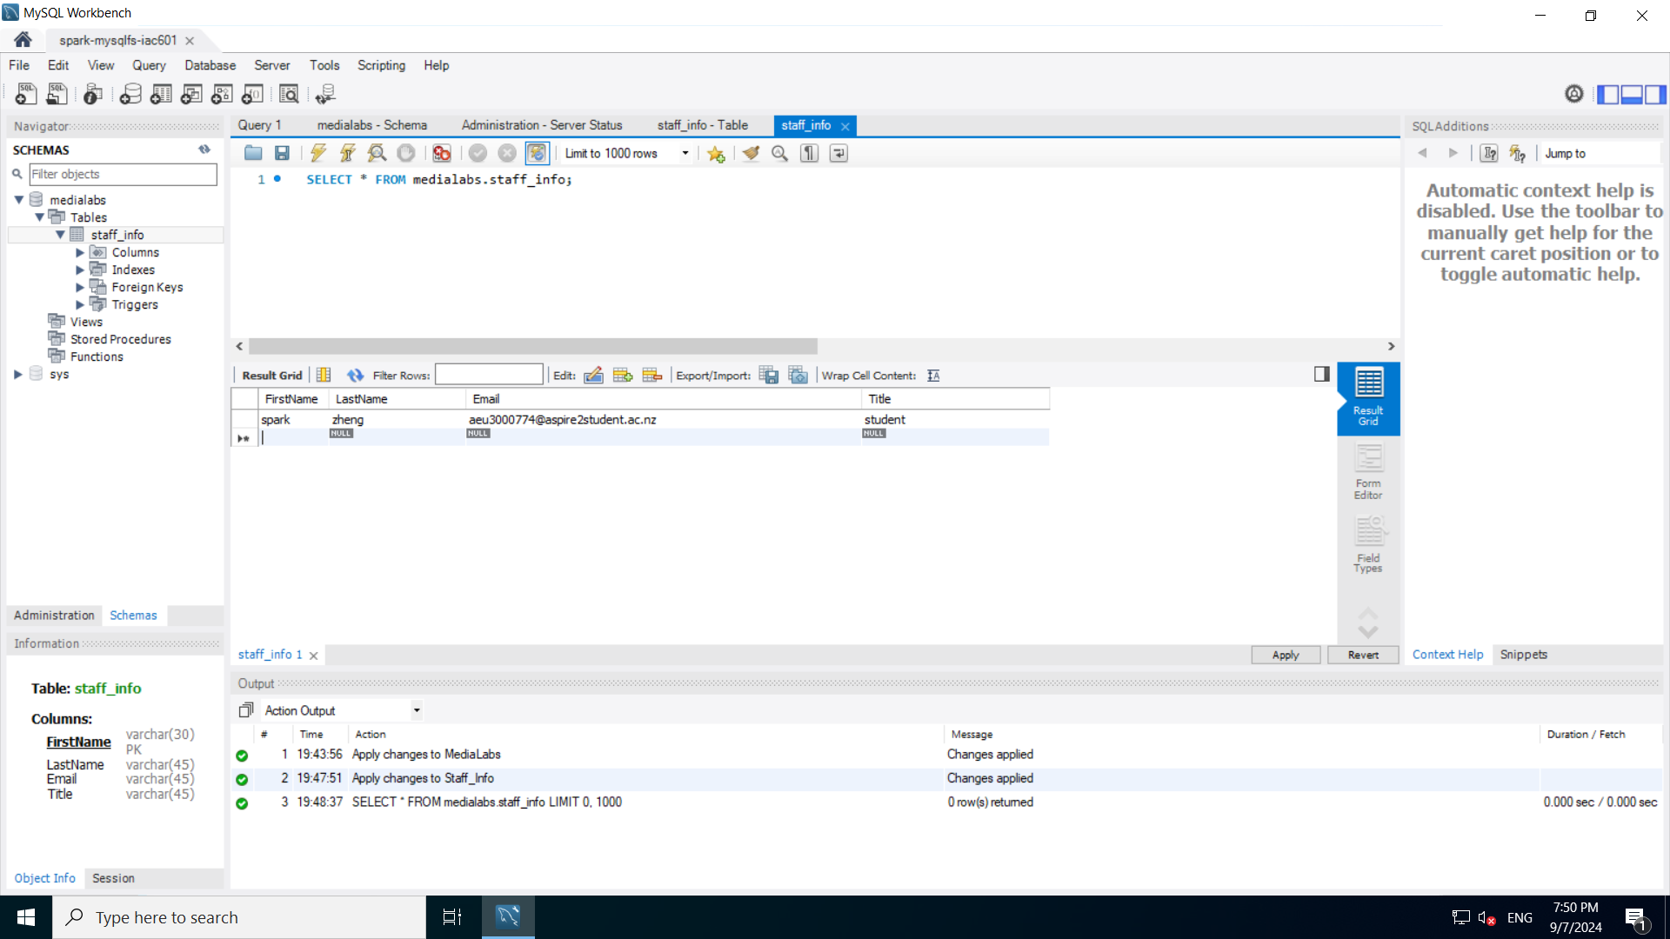

## Task 5: GitHub Repository

**1. add script files to local repository**

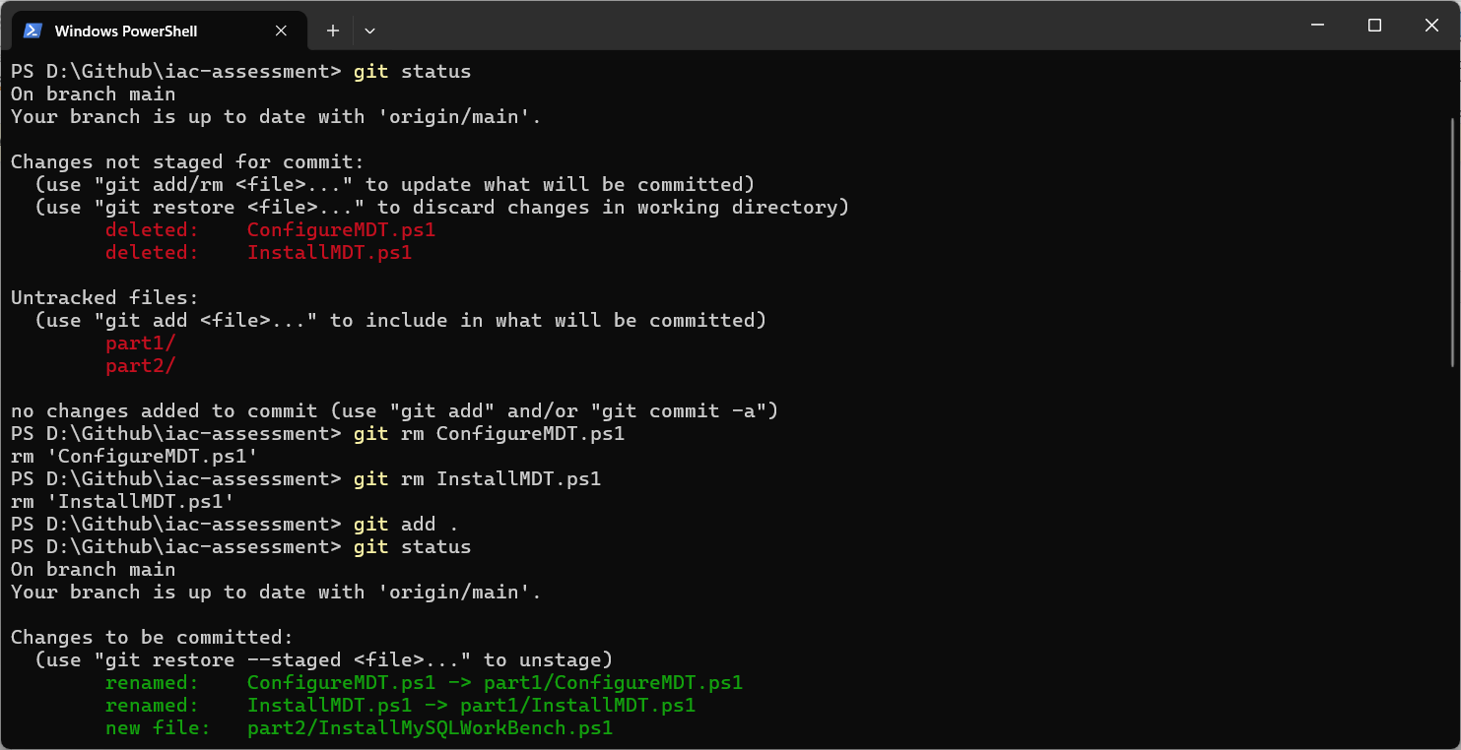

**2. commit files added to local repository**

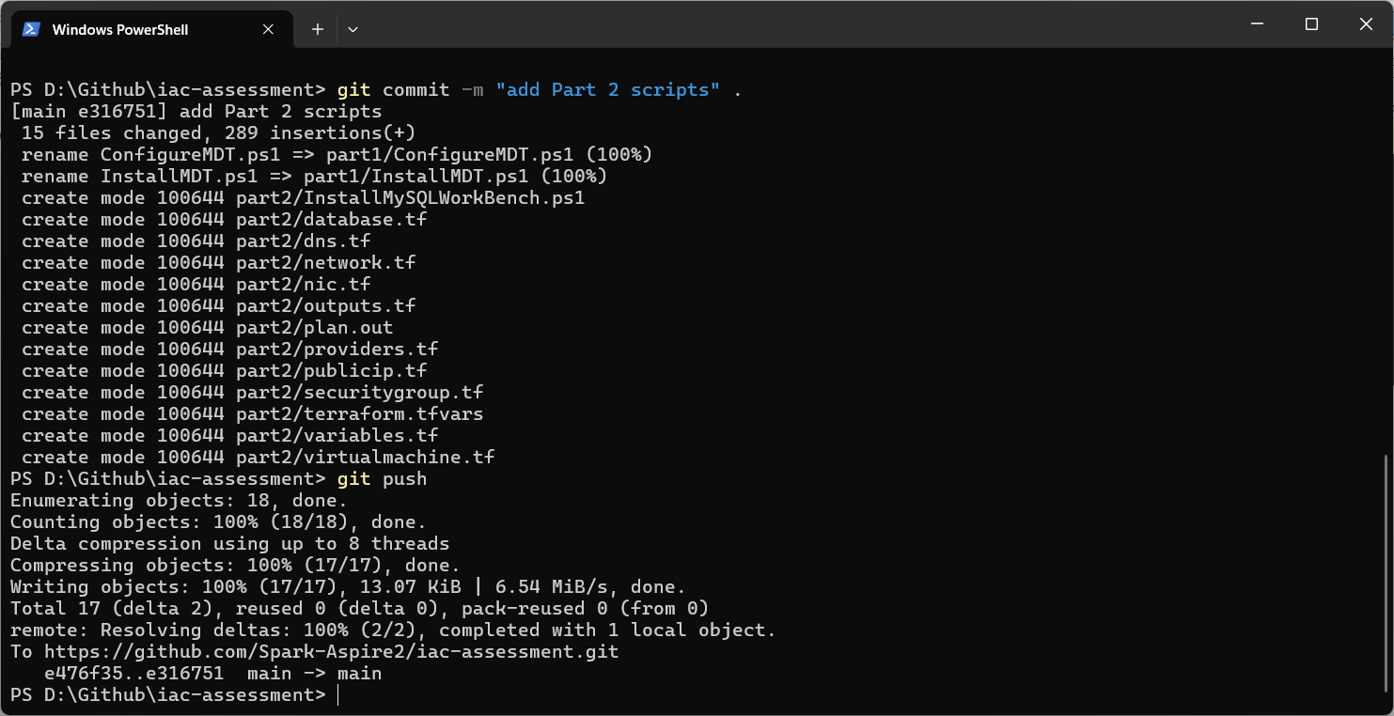

**3. Push local repository to Github**



**4. Check result on Github website**

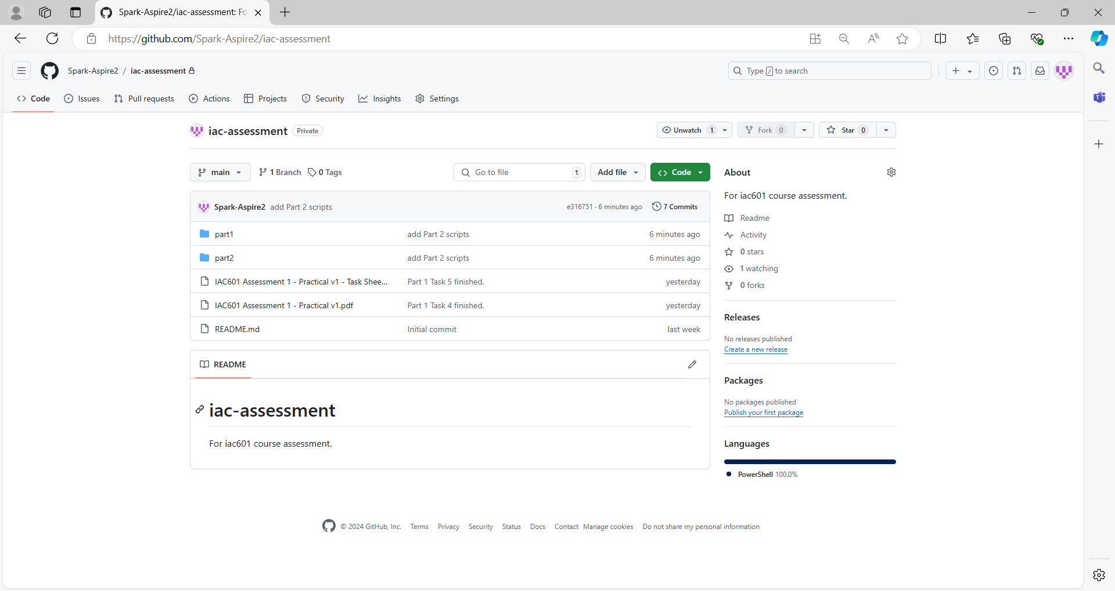

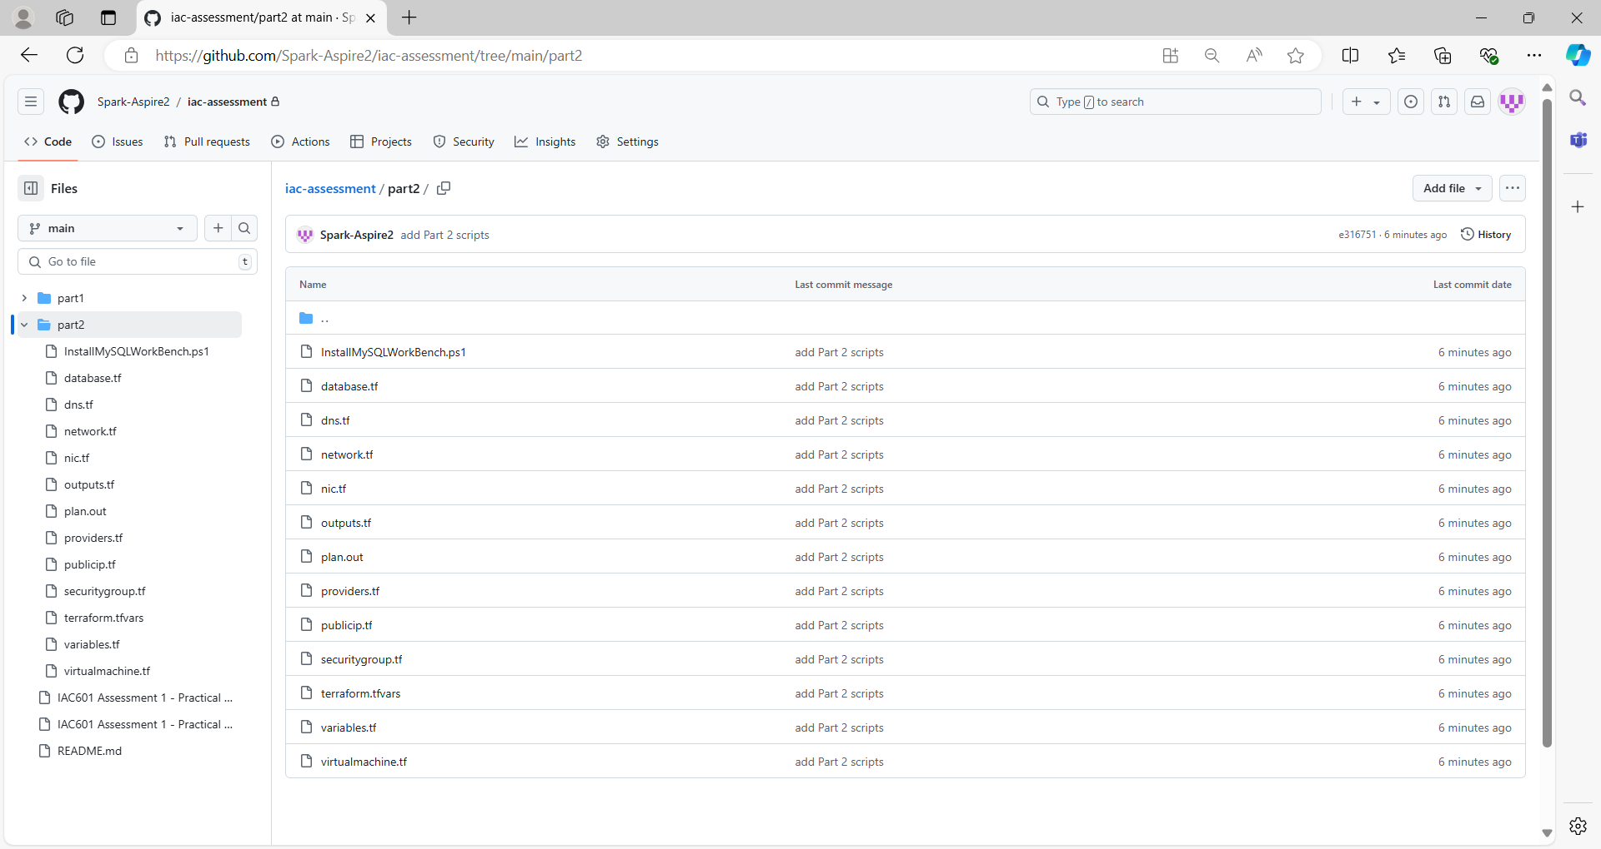

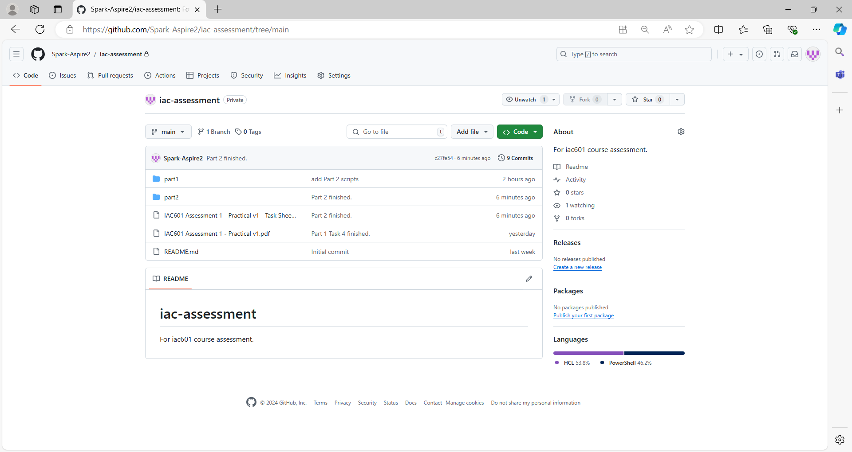

## References

1. Privacy Act 2020. (2024, July 1). https://www.legislation.govt.nz/act/public/2020/0031/latest/LMS23223.html
2. Copyright Act 1994. (2023, May 31). https://www.legislation.govt.nz/act/public/1994/0143/latest/DLM345634.html
3. Fair Trading Act 1986. (2024, July 10). https://www.legislation.govt.nz/act/public/1986/0121/latest/DLM96439.html
4. Health Information Privacy Code 2020. (2022, July 1). https://privacy.org.nz/privacy-act-2020/codes-of-practice/hipc2020/
5. New Zealand Information Security Manual. (2024, September). https://nzism.gcsb.govt.nz/ism-document